

**UNIVERSITI TUNKU ABDUL RAHMAN**

**FACULTY OF INFORMATION AND COMMUNICATION TECHNOLOGY**

**UCCD 2513 Mini Project**

**Project Report**

**Oct 2013**

**Supervisor** : Mr Albert Yong Tien Fui

**Project Title** : Project Charter Development Tool

**Team Name** : Paradise

|  |  |  |
| --- | --- | --- |
| Name | Course | Student ID |
| Ang Fan Yee | IA | 10ACB06936 |
| Brenda Lee Hooi Fern | IB | 11ACB02695 |
| Chan Chee Keen | IA | 10ACB06759 |
| Chin Kian Zhong | IA | 11ACB07146 |
| Foong Wai Lap | IA | 10ACB06711 |

**Project Score Sheet (Team)**

|  |  |
| --- | --- |
| Team Name | Paradise |
| Project Title | Project Charter Development Tool |
| Tutorial Group | T1 |
| Supervisor Name | Mr. Albert Yong Tien Fui |

|  |  |  |  |
| --- | --- | --- | --- |
| **Question** | **5-Point Scale** | **Max Score** | **Score** |
| **Report and documentation (10%)**   * Report quality (cover, table of content, page numbering, formatting consistency, headers/footer, binding, CD) * Grammar and typo | / 5  / 5 | **5**  **5** |  |
| **Presentation and demonstration (5%)**   * Program demo skill * Q&A skill | / 5  / 5 | **2**  **3** |  |
| **Effort and technical capability (10%)**   * General team effort * Technical capability | / 5  / 5 | **5**  **5** |  |
| **Final deliverables (10%)**   * Program operational (how well does it work and look?) * Program functionality (how best can it help users perform work?) | / 5  / 5 | **5**  **5** |  |
| **Innovativeness (5%)**   * How significant is the improvement over benchmarked system/model/algorithm? | / 5 | **5** |  |
| **Total (40% of coursework)** | | **40** |  |

**Project Score Sheet (Individual)**

|  |  |
| --- | --- |
| Module Name | Project Comparison and Selection Methods using Financial Analysis and Weighted Scoring Model |
| Student Name | Ang Fan Yee |
| ID No | 10ACB06936 |
| Declaration of originality | I declare that the assignment is the original work by myself, and if found guilty of plagiarism from any sources, I agree to be awarded **zero mark** for the entire assignment |
| Signature |  |

|  |  |  |  |
| --- | --- | --- | --- |
| **Question** | **5-Point Scale** | **Max Score** | **Score** |
| **Milestone and objectives achievement (10%)**   * Completeness of overall work produced * Objectives achievement | / 5  / 5 | **5**  **5** |  |
| **Final deliverables (10%)**   * Component operational (how well does it work?) * Component functionality (how best can it help users perform work?) | / 5  / 5 | **5**  **5** |  |
| **Total (20% of coursework)** | | **20** |  |

**Project Score Sheet (Individual)**

|  |  |
| --- | --- |
| Module Name | Monte Carlo Simulator for Project Duration and Cost Estimations |
| Student Name | Brenda Lee Hooi Fern |
| ID No | 11ACB02695 |
| Declaration of originality | I declare that the assignment is the original work by myself, and if found guilty of plagiarism from any sources, I agree to be awarded **zero mark** for the entire assignment |
| Signature |  |

|  |  |  |  |
| --- | --- | --- | --- |
| **Question** | **5-Point Scale** | **Max Score** | **Score** |
| **Milestone and objectives achievement (10%)**   * Completeness of overall work produced * Objectives achievement | / 5  / 5 | **5**  **5** |  |
| **Final deliverables (10%)**   * Component operational (how well does it work?) * Component functionality (how best can it help users perform work?) | / 5  / 5 | **5**  **5** |  |
| **Total (20% of coursework)** | | **20** |  |

**Project Score Sheet (Individual)**

|  |  |
| --- | --- |
| Module Name | Project cost budgeting using Activity-Based Costing technique and Earned Value Management |
| Student Name | Chan Chee Keen |
| ID No | 10ACB06759 |
| Declaration of originality | I declare that the assignment is the original work by myself, and if found guilty of plagiarism from any sources, I agree to be awarded **zero mark** for the entire assignment |
| Signature |  |

|  |  |  |  |
| --- | --- | --- | --- |
| **Question** | **5-Point Scale** | **Max Score** | **Score** |
| **Milestone and objectives achievement (10%)**   * Completeness of overall work produced * Objectives achievement | / 5  / 5 | **5**  **5** |  |
| **Final deliverables (10%)**   * Component operational (how well does it work?) * Component functionality (how best can it help users perform work?) | / 5  / 5 | **5**  **5** |  |
| **Total (20% of coursework)** | | **20** |  |

**Project Score Sheet (Individual)**

|  |  |
| --- | --- |
| Module Name | Program Evaluation and Review Technique (PERT) for Critical Path and Slack Analysis |
| Student Name | Chin Kian Zhong |
| ID No | 11ACB07146 |
| Declaration of originality | I declare that the assignment is the original work by myself, and if found guilty of plagiarism from any sources, I agree to be awarded **zero mark** for the entire assignment |
| Signature |  |

|  |  |  |  |
| --- | --- | --- | --- |
| **Question** | **5-Point Scale** | **Max Score** | **Score** |
| **Milestone and objectives achievement (10%)**   * Completeness of overall work produced * Objectives achievement | / 5  / 5 | **5**  **5** |  |
| **Final deliverables (10%)**   * Component operational (how well does it work?) * Component functionality (how best can it help users perform work?) | / 5  / 5 | **5**  **5** |  |
| **Total (20% of coursework)** | | **20** |  |

**Project Score Sheet (Individual)**

|  |  |
| --- | --- |
| Module Name | Work Breakdown Structure (WBS) by Composition and Decomposition Methods, WBS Dictionary, and Activity List Development |
| Student Name | Foong Wai Lap |
| ID No | 10ACB06711 |
| Declaration of originality | I declare that the assignment is the original work by myself, and if found guilty of plagiarism from any sources, I agree to be awarded **zero mark** for the entire assignment |
| Signature |  |

|  |  |  |  |
| --- | --- | --- | --- |
| **Question** | **5-Point Scale** | **Max Score** | **Score** |
| **Milestone and objectives achievement (10%)**   * Completeness of overall work produced * Objectives achievement | / 5  / 5 | **5**  **5** |  |
| **Final deliverables (10%)**   * Component operational (how well does it work?) * Component functionality (how best can it help users perform work?) | / 5  / 5 | **5**  **5** |  |
| **Total (20% of coursework)** | | **20** |  |

Table of contents

***Introduction***Module 1……………………………….………………………………………..……….…1  
Module 2……………………………….…………………………………..…………….…1  
Module 3……………………………….……………………………………..………….…1  
Module 4……………………………….…………………………………..…………….…1  
Module 5………………………….……………………………………..……………….…1  
Objectives achievement indication by component…………………………………….…...2

***Analysis (Literature Review)***Module 1……………………………….………………………………………………….…3  
Module 2……………………………….………………………………………………….…3  
Module 3……………………………….………………………………………………….…4  
Module 4……………………………….………………………………………………….…7  
Module 5……………………………….…………………………………………………...11

***Design***Design diagram of entire project...…….…………………………………………………...12  
Module 1……………………………….………………………………………………...…13  
Module 2……………………………….…………………………………………………...15  
Module 3……………………………….…………………………………………………...16  
Module 4……………………………….…………………………………………………...19  
Module 5……………………………….…………………………………………………...22  
Achieved Innovations………………………………………………………………………23

***Evaluation***Module 1……………………………….………………………………………………...…25  
Module 2……………………………….…………………………………………………...27  
Module 3……………………………….…………………………………………………...28  
Module 4……………………………….…………………………………………………...28  
Module 5……………………………….…………………………………………………...29

***Conclusion***Module 1……………………………….………………………………………………...…30  
Module 2……………………………….…………………………………………………...30  
Module 3……………………………….…………………………………………………...30  
Module 4……………………………….…………………………………………………...30  
Module 5……………………………….…………………………………………………...31

Appendix A…………………………………………………………………………………32

Appendix B………………………………………………………………………………...441

Appendix C………………………………………………………………………………...445

**Introduction**

Project Charter Development Tool is developed to produce basic project management tools to select project, build work breakdown structure (WBS), determine critical path and activity slacks, estimate time and cost of project, and develop project charter with minimal human intervention. This project can be implementing to business area. There are 5 modules in this system. In Module 1 (Project Comparison and Selection Methods), there are 2 method which is financial analysis and weighted scoring model used to compare and selection between projects.

Module 2:

Work Breakdown Structure is a hierarchical and incremental decomposition of the project into phases, deliverables and work packages. The work breakdown structure provides a common framework for the natural development of the overall planning. A work breakdown structure permits summing of subordinate costs for task, materials, etc. into higher level parents tasks.

Module3:

Module 3 is able to perform Three Point Estimation to estimate duration used to calculate the total slack and free slack and also able to determine the critical path given duration. Project Manager just need key in the predecessor and also three point estimation time.

Module4:

Project cost budgeting using Activity-Based Costing technique which is to define the cost of activity deeply and Earned Value Management which is to use the formula to calculate the planned value and earned value. This module is to need create the function that to combine activity-based costing technique (ABC) and earned value management (EVM) in project cost budgeting.

Module5:

Monte Carlo Simulator for Project Duration and Cost Estimation

To estimate the time and cost to complete a given project using the Monte Carlo Simulator.

Firstly, 3 estimated values, namely the most likely, optimistic and pessimistic time or cost for a particular task, as well as its probability distribution is gathered for all the tasks in the whole project. Next, a random value is generated based on the estimates given and its probability distribution for each task, and is summed up to generate the total cost or end date for the entire project. This is repeated for at least 500 times to get the probability of completing the entire project within a certain time period or projected cost. The results obtained will be useful in helping to determine the total cost or time needed to complete the whole project as accurate as possible to reduce risks such as time and cost over-runs.

|  |  |  |  |
| --- | --- | --- | --- |
| Component | Objectives List | Member | 5-point scale objective achievement |
| Module 1 | To enhance the project comparison and project selection method for user’s decision making. | Ang Fan Yee | 3 |
| Module 1 | To make user flexible involve in project selection phase | Ang Fan Yee | 4 |
| Module 2 | Work breakdown structure allow user to breakdown the task into different level | Foong Wai Lap | 3 |
| Module 3 | Determine critical path given duration | Chin Kian Zhong | 3 |
| Module 3 | Determine all possible path | Chin Kian Zhong | 3 |
| Module 3 | Output PERT duration using three point estimate | Chin Kian Zhong | 3 |
| Module 4 | Easy to use for user friendly with less typo error | Chan Chee Keen | 1 |
| Module 4 | Combination of ABC and EVM | Chan Chee Keen | 4 |
| Module 5:  Monte Carlo Simulator | Produce visual statistical results (the graph) to show the feasibility of the project, indirectly increasing stakeholder’s trust in the project team on the duration and cost needed to complete the entire project. | Brenda Lee Hooi Fern | 4 |
| Module 5:  Monte Carlo Simulator | Enable flexibility to the user to select the values most feasible in the eyes of the user. | Brenda Lee Hooi Fern | 4 |

Objectives achievement indication by component:

**Analysis**

**Literature review**

Module 1:

ReadyRatios is a program intended to carry out an intellectual analysis of a company’s financial position based on data from its financial statements. The main feature of the system is that individuals should not take part in the analysis. All that has to be done by consumer is to enter the data of financial reports and to receive the results of the analysis, which does not differ from the analysis made by a professional analyst. The strength of ReadyRatio is knowledge of financial analysis is not required. ReadyRatios makes all the analytical jobs, beginning from the moment when the user enters the data, and finishing when the analytical report is ready. Next strength is it is a highly usable web-interface. The program is based on web-technologies and can be opened with the any browser. It is supported by the following browsers: Internet Explorer 6+, Firefox 3+, Google Chrome 7+ and Opera 9+. Besides that, the program provides the user with a complete report and multiple choice conditional texts, the texts of reports will never be repeated too. Furthermore, a flexible approach to making tables and figures are marked out with colors. It is easy and convenient to enter the initial data. Information can be saved on the database; the user can save the initial data and prepared reports both on their computer and on the server of ReadyRatios. The last variant provides the consumer with fast and convenient access to information for further analysis. To use this feature, the user should log on to the web-site of ReadyRatios imported from XBRL files (IFRS or US GAAP Taxonomy format, 2011). Although this program might be the best solution for consumers, there are still weaknesses. One of the weaknesses is the program is still not user friendly enough. User cannot add more entries at the column of year directly (by a few clicks). In addition, it cannot let user involved in the project selection phase. (Example like user cannot weight their favourite component in project selection phase.

Module 2:

After I review some application about the work breakdown structure e.g. WBS tools, Work Breakdown Structure software, I found that Work Breakdown Structure tools is a powerful tools to help user to separate the task into different level. Work breakdown Structure allow user to key in data into the application and the system will proceed the data to another progress.

After I review the Microsoft excel to create work breakdown structure, I found that there are another way to create work breakdown structure through table instead of hierarchy. Therefore my innovation part is to use this method to key in the data into the system and carry out the function of work breakdown structure to help the system proceed to other function.

Module 3:

**Excel Macros** instalment is using macro to define the programming of CPM calculation, although it is a Microsoft product but it is not easy to install, but requirement is just install Microsoft Excel. Advantage is ease to use after installed, present in graph or even in table. Disadvantage is that not easy to understand because of the excel table got a lot of lines which may get users confuse, and the grouping of data is not well structured.

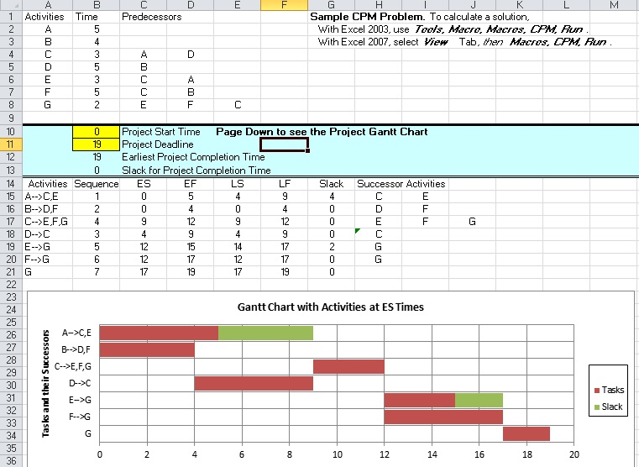

Figure 1

[http://easycalculation.com](http://easycalculation.com/) CPM calculator is a very simple system build by html and JavaScript.

Advantage is easier to learn and use. Disadvantage is did not used PERT to calculate and the graph is kind of weird, user do not know what is the unit of measurement of the statistic graph and the time they set as a project to finish is a constant which is 9999 unit. This value may different from each project, should not use a constant in this calculation.

<http://easycalculation.com/operations-research/pert-cpm-calculator.php>

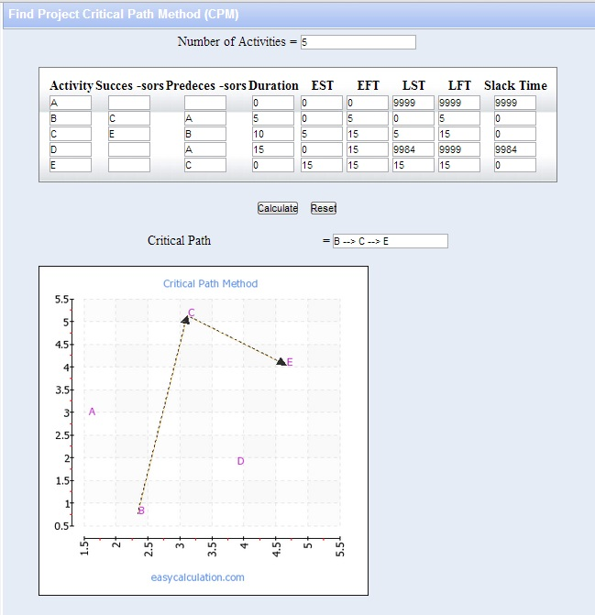

Figure 2

Microsoft Project is a very great powerful software for planning phases of a project ,it can generate a lot of diagram, chart and graph. Advantage is completeness of the software, disadvantage is not easy to learn the software and get use of it. If a user just want a CPM software, user might not need to learn the whole software only to do CPM.

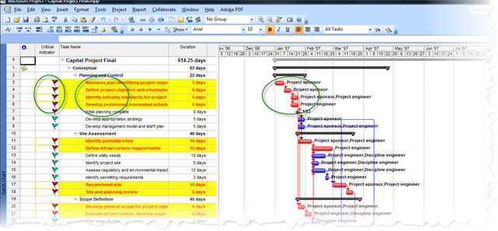

Figure 3

In this review, I found that 2 of them is using Microsoft however some computer might not have the Microsoft installed, so this is a platform dependent software, and I found the HTML version is interesting because is not platform dependent but the disadvantage affect my evaluation of this calculator, which is PERT is not involved and the pre-set project deadline. My opinion is to develop a platform independent calculator like html version, so I would like to choose the Java to develop the calculator.

Module 4:

First literature I reviewed which is the Microsoft Excel. This system is powerful and simple to use which can calculate the ABC and EVM. However, this system is not specific to calculate the ABC and EVM, so it needs to be set up manually to become specific for ABC and EVM, or else it needs to be found the source from internet, such as the excel file name which is “Project Management” (Softnic, n.d.), and it is not free of charge, it costs RM82.31 and trial for 30 days.

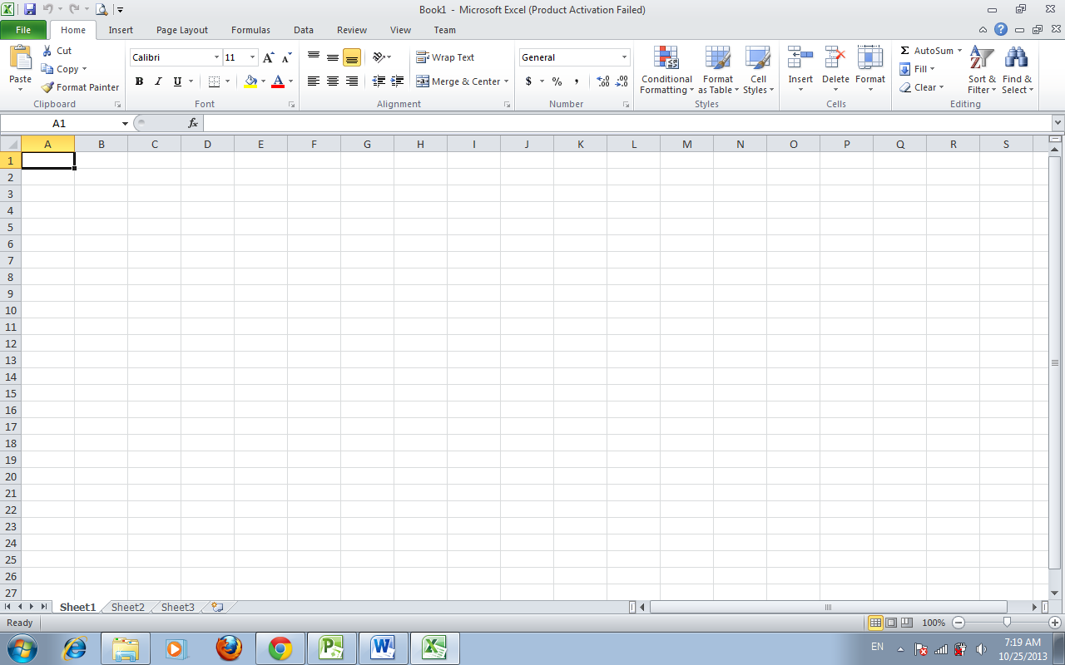

Figure 4: Microsoft Excel

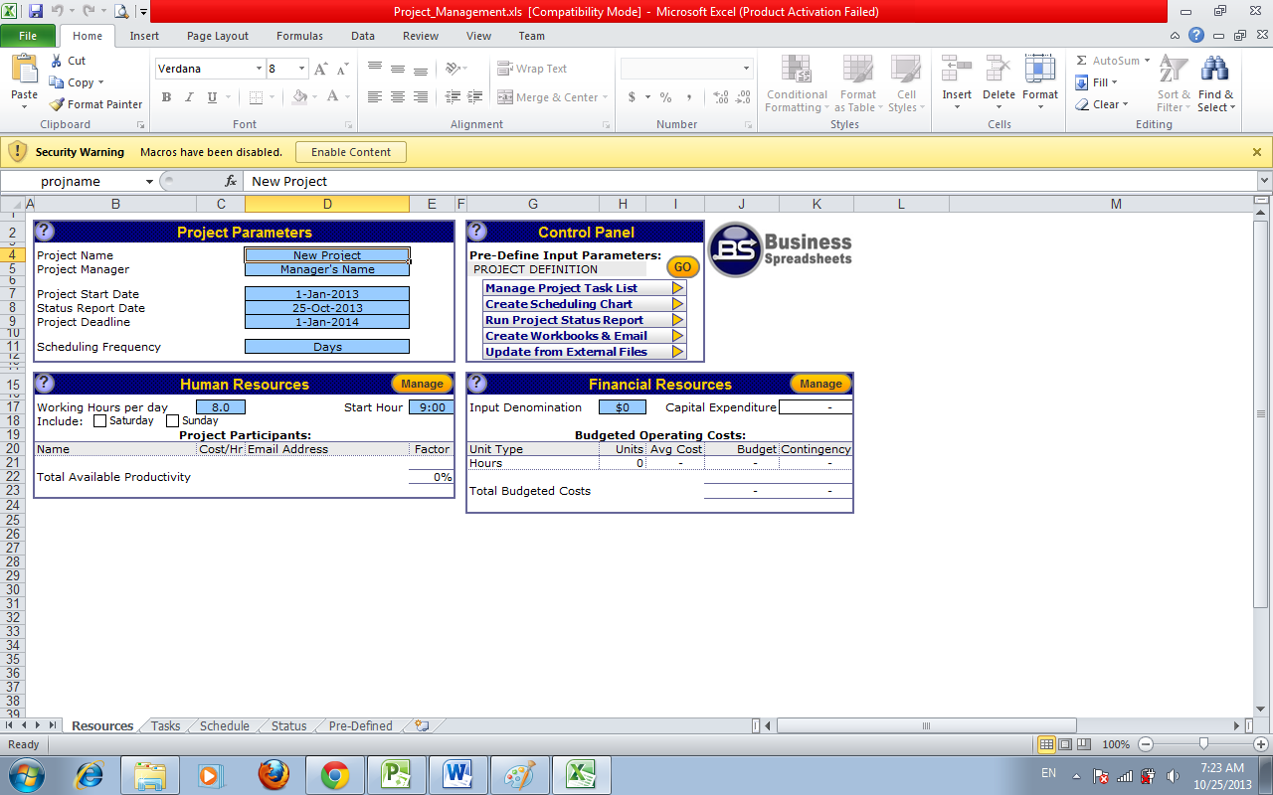

Figure 5: Project Management in Microsoft Excel form

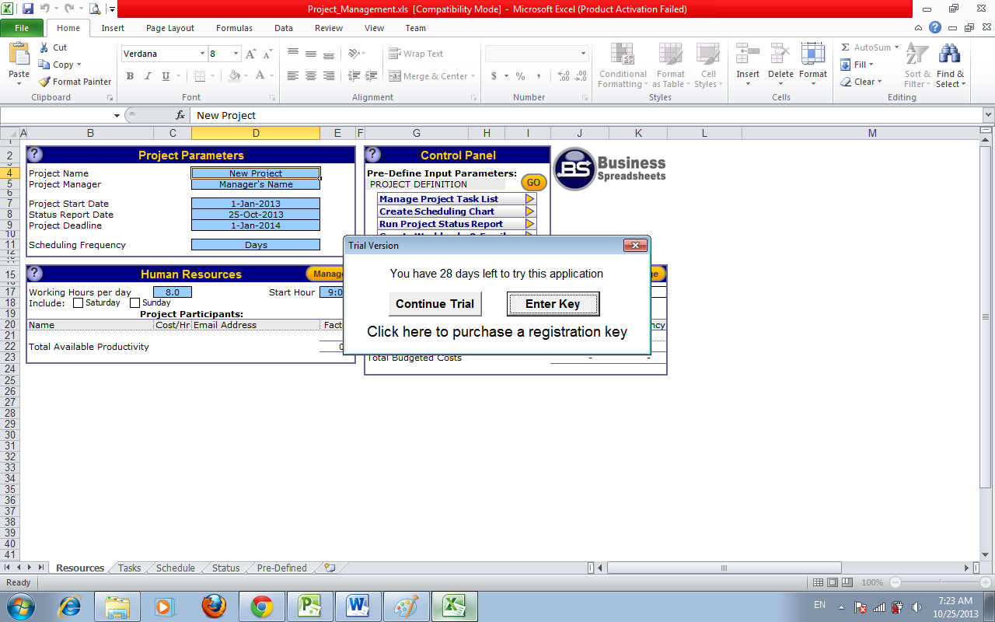

Figure 6: Permission for registration key for Project Management

The second literature I reviewed which is the Milestones Professional (KISASA, n.d.) that one part of the EVM. This system is not free to all, it costs US299 (RM946.78), but still can use for trial version. Furthermore, this system is so many menus to let user choose, it is also can convert file to .mpp, .ppt, and .xls as report. However, it is not familiar for user so it needs time to train user to use this system, and its menu is not clear for user so it needs user manual to refer the menu.

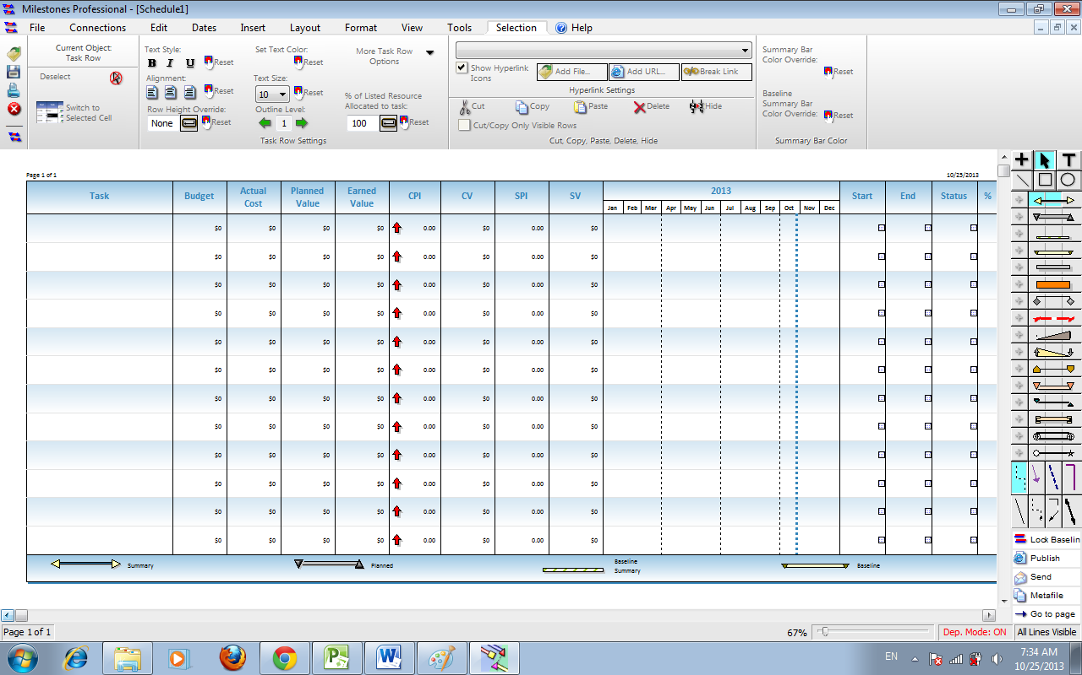

Figure 7: Showing the variable of EVM in Milestones Professional

Lastly, Microsoft Project also is the powerful to calculate the EVM based on creating the project schedule such as Gantt chart. However, this system is not easy to key in data for EVM this is because it needs to be keyed into Resource Sheet to generate the cost to calculate the EVM.

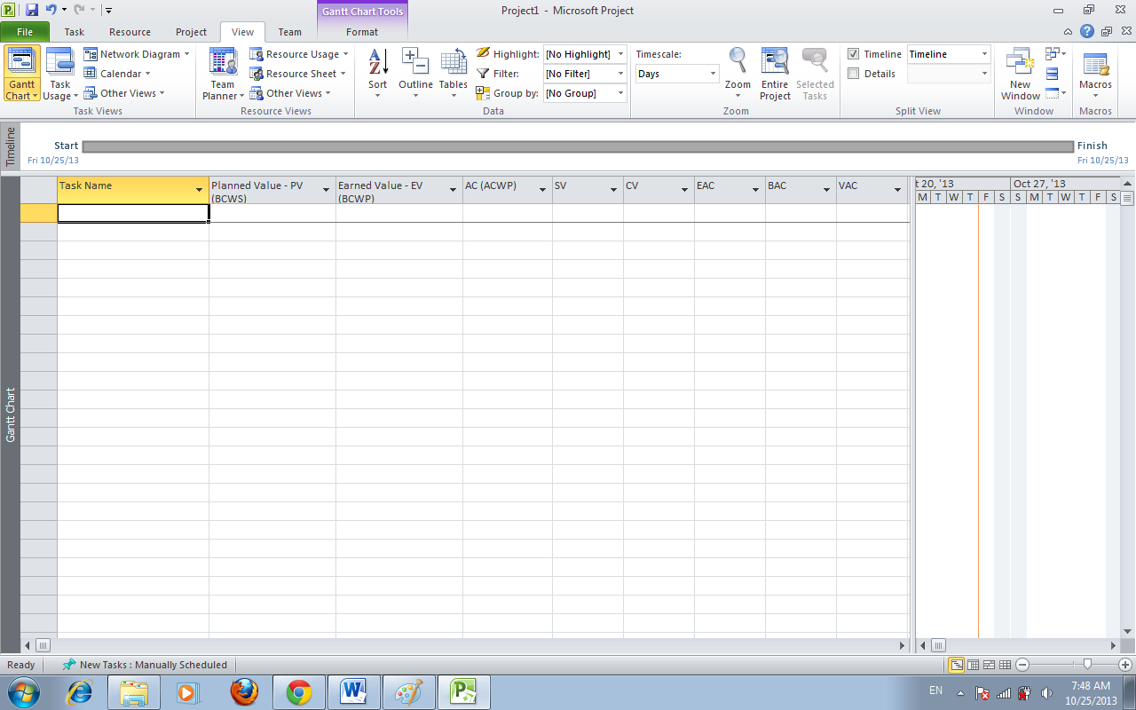

Figure 8: Showing the variable of EVM in Microsoft Project

So, the benchmark system that I choose is the Milestones Professional.

Module 5:

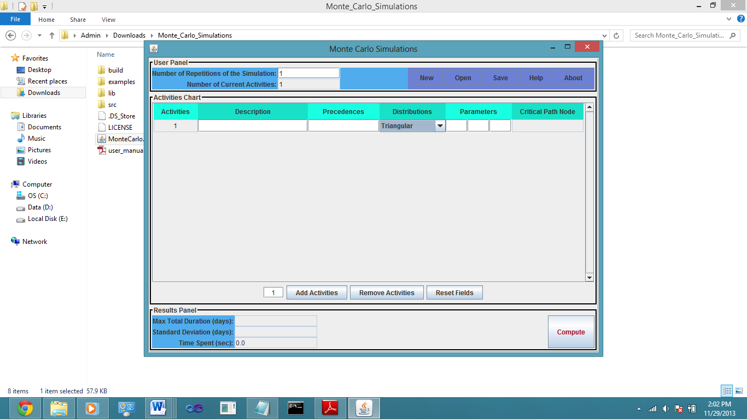Literature review:

Figure 9: Monte Carlo Simulator By [saharkiz](http://www.codeproject.com/script/Membership/View.aspx?mid=3293509)

Monte Carlo Simulator By [saharkiz](http://www.codeproject.com/script/Membership/View.aspx?mid=3293509) (Downloaded from CodeProject.com)

Strengths:

1. Allows user to open and load file or create a new file and save it.
2. It is based on the 5 distributions to calculate: Triangular, Uniform, Beta, Gaussian, Exponential.
3. Allows user to enter the description of the activity.
4. Allows user to enter number of repetitions in the simulation.
5. Allows user to type in the precedence.

Weaknesses:

1. Does not have a minimum number of repetitions for the simulation. Values above 500 are considered the best since it is more accurate.
2. It is not integrated with other related modules like the Work Breakdown Structure and 3-point PERT estimations.
3. Is not able to generate a project charter with the values obtained.
4. It is only for time estimation.

**Design**

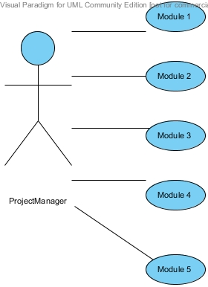

Figure 10: Design diagram of entire project

Module 1:

**Design diagram of the benchmarked system/model/algorithm**

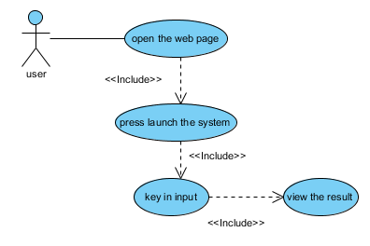

Figure 11: Use-case diagram for Project comparison and selection methods using financial analysis and weighted scoring model

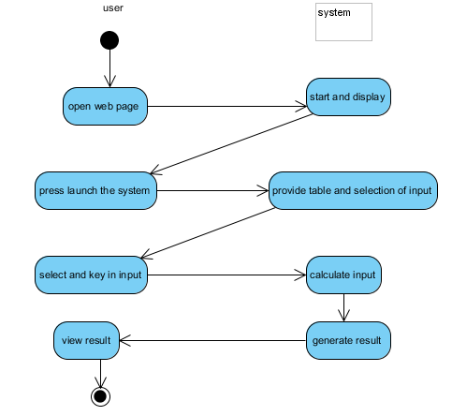

Figure 12: Activity diagram for Project comparison and selection methods using financial analysis and weighted scoring model

**Design diagram of the chosen module**

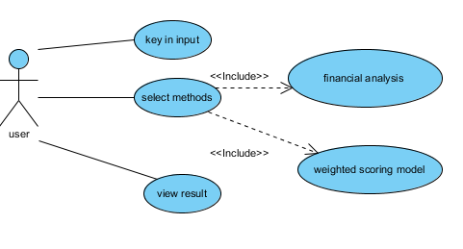

Figure 13: Use-case diagram for Project comparison and selection methods using financial analysis and weighted scoring model

-Able to make the user flexible to weight the percentages in NPV,ROI,IRR,PAYBACK PERIOD, and WEIGHTED SCORING MODEL(project selection.)

Module 2:

Figure 14:

User press save button to save data into the file created

Display button allow user to display the data into table form

User enter Activity No and Activity Name into the row created

User press Add button to add row to insert data

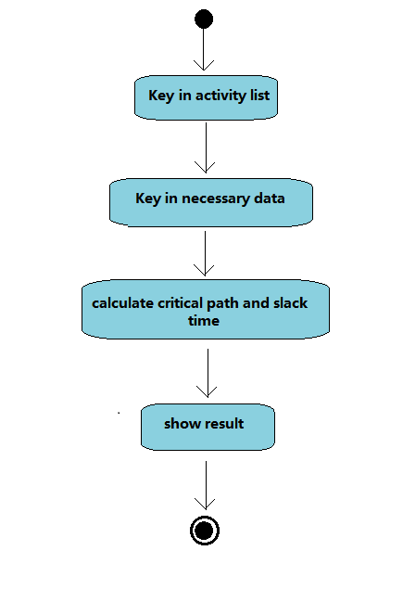Module 3:

Figure 15

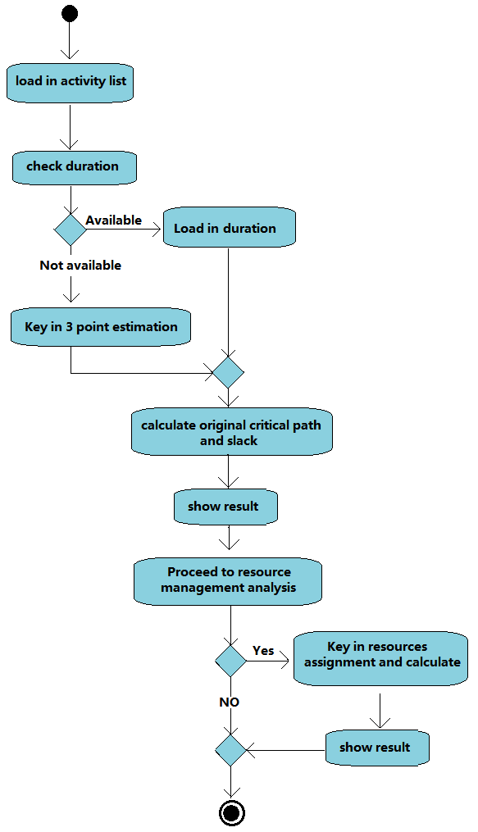Module 3 (cont.):

Figure 16:

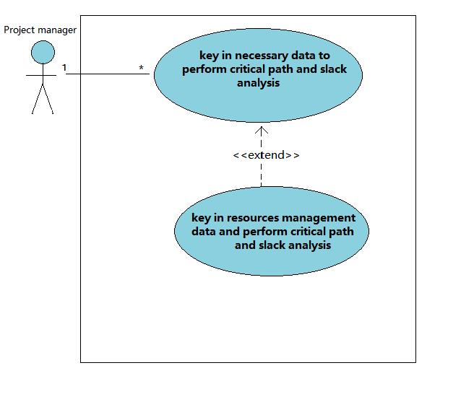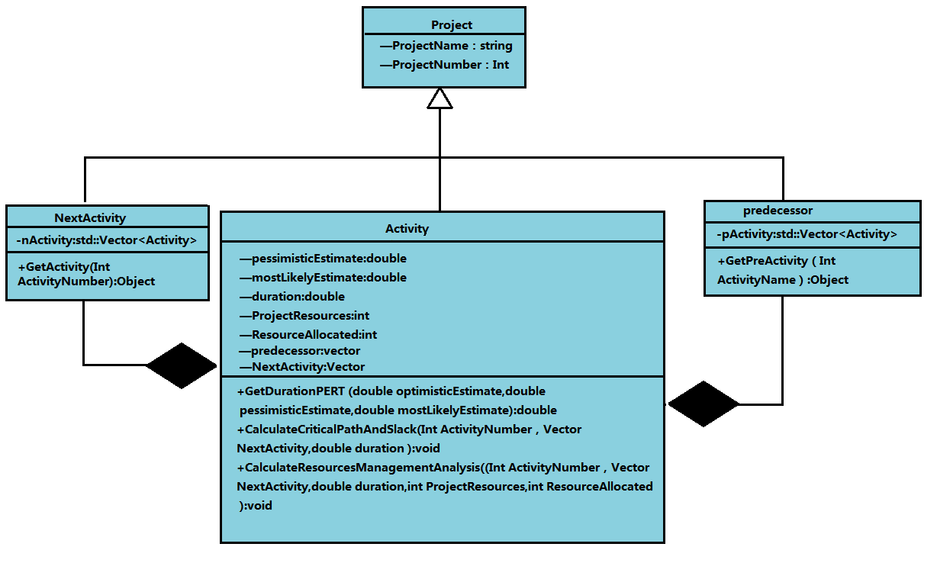Module 3 (cont.):

Figure 17

Figure 18

Module 4:

**Design diagram of the benchmarked system/model/algorithm:**

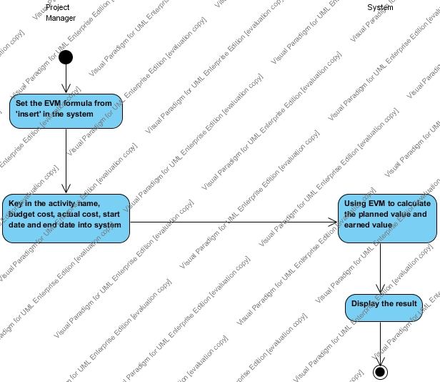

Figure 19: Activity diagram for benchmarked system

**Design diagram of the chosen module:**

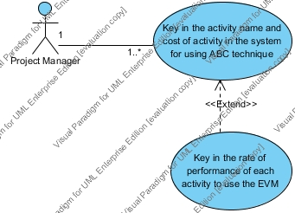

Figure 20: Use-case diagram for Project cost budgeting using Activity-Based Costing technique and Earned Value Management

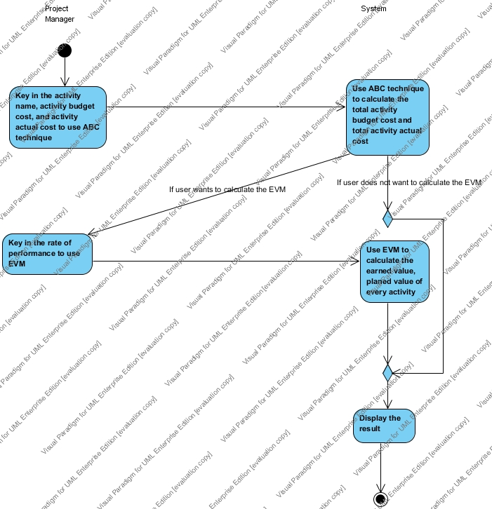

Figure 21: Activity diagram for Project cost budgeting using Activity-Based Costing technique and Earned Value Management

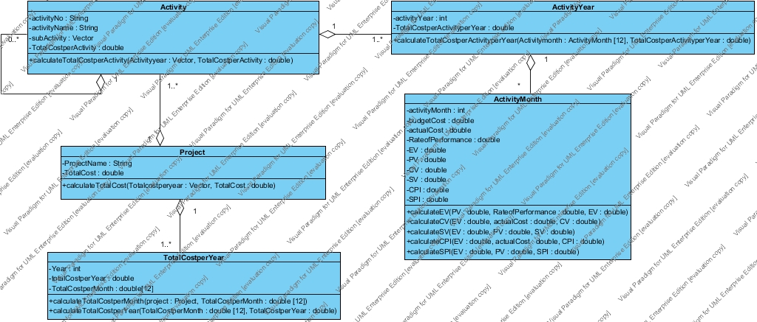

Figure 22: Class diagram for Project cost budgeting using Activity-Based Costing technique and Earned Value Management

Module 5:

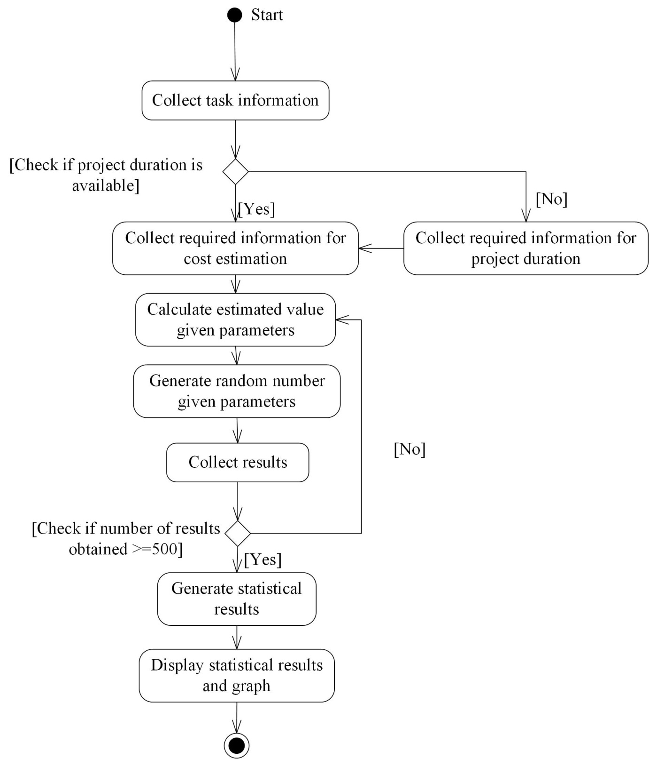**Design diagram of the chosen module**

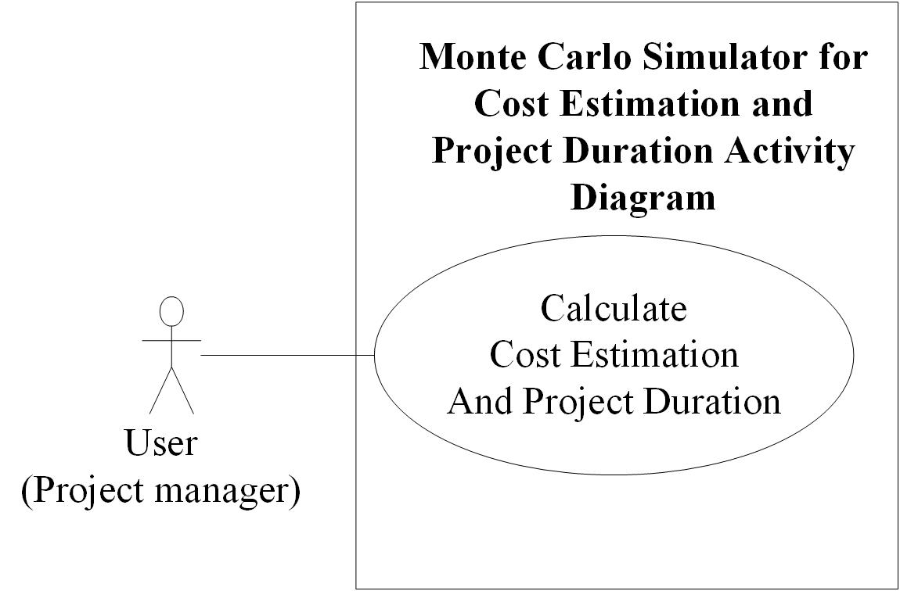

Figure 24: Use case diagram for chosen module

Figure 23: Activity diagram for chosen module

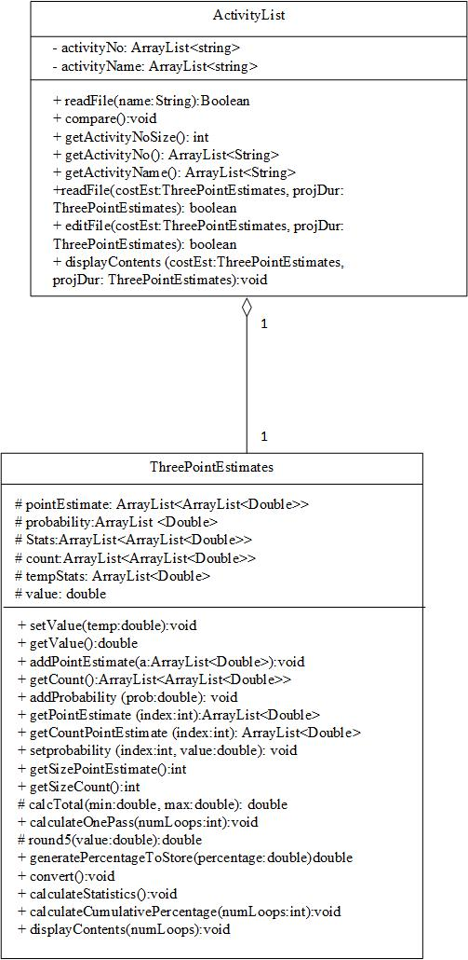

Figure 25: Class diagram for chosen module

**Achieved Innovations**

Module 4: Cost Budgeting

1. Combination of ABC and EVM method

Module 5: Monte Carlo Simulator

1. Creating graphs based on the Monte Carlo Simulation
2. Allowing the user to select if he/she wants to use the values in this module or another module for the project charter
3. Activity list can be obtained from another module without the user needing to retype them out

**Evaluation**

Module 1:

|  |  |  |  |  |
| --- | --- | --- | --- | --- |
| Item to be tested | Input | Expected output | Actual output | Remark |
| Npv | Year:2011  B: 0  C:5000  Year2:2012  B:2000  C:1000  Year:2013  B:3000  C:1000  Year:2014  B:4000  C:1000  Year:2015  B:5000  C:1000  Discountrate:0.1 | Npv:2316.35 | 2316.35 | Round to 2 decimal point |
| Year1 Discount factor | Discountrate:0.1  Year:1 | Discount factor :0.91 | 0.91 | - |
| Year2 Discount factor | Discountrate:0.1  Year:2 | Discount factor :0.83 | 0.83 | - |
| Year3 Discount factor | Discountrate:0.1  Year:3 | Discount factor :0.75 | 0.75 | - |
| Year4 Discount factor | Discountrate:0.1  Year:4 | Discount factor :0.68 | 0.68 | - |
| Year5 Discount factor | Discountrate:0.1  Year:5 | Discount factor :0.62 | 0.62 | - |
| ROI | TotalDiscounted Benefits :9743.5  TotalDiscounted Cost: 7427.15 | Discount factor :0.3119 | 0.3119 | Round to 4 decimal point |
| IRR | NPV:2316.35  Discountrate:0.1 | IRR:0.2726 | 0.2726 | - |
| TotalDiscounted Benefits | Discounted Benefits:  Y1:0  Y2:1653  Y3:2254  Y4:2732  Y5:3105 | TotalDiscounted Benefits:9743.5 | 9743.50 | - |
| TotalDiscounted Costs | Discounted Costs:  Y1:4545  Y2:826  Y3:751  Y4:683  Y5:621 | TotalDiscounted Costs:7427.15 | 7427.15 | - |

-The data will be taken from the Mini project material 1 to make sure the all the calculations are working correctly.

-Through the black-box testing method, the outcomes are approximately correct. Microsoft Excel can be tested compare to the system of this module because Microsoft Excel is easy to key in the input data and calculate accurately.

Module 2:

Blackbox testing has been used to evaluate the system.

|  |  |  |  |  |
| --- | --- | --- | --- | --- |
| Item to be tested | User Input | Expected output | Output | Result |
| Marker put to the child | 1.2.3 | “*” added to 1.2.3 | “*” added to 1.2.3 | passed |
| Marker delete from the parents | 2.1 | “*” deleted from 2.0 | “*” deleted from 2.0 | passed |
| Click on add row button new row added | User clicked on add row button | New row created | New row created | Passed |
| Click on display button, data will be display on pop out screen | User clicked on display button | Pop out activity table | Pop out activity table | passed |
| Click on save button, data will be store on output file | User clicked on save button | File saved in output file | File saved in output file | passed |
| Create hierarchy | Run program | create hierarchy | Unable create hierarchy | failed |

Module 3:

Metric quality and quantity

Black box is being used to testing the data system consistency, all the data has been evaluated before used in black box testing, to test the system whether comes into desired result. 3 set of mutually exclusive black box data will be carried into testing. System design was modified all the time when the desired black box testing result does not meet.

Online critical path example has used in evaluate the system’s critical path determination algorithm correctness,4 set of template has been used to evaluate the algorithm which they are incremental in size and also complexity.

Benchmark system is been refer as the whole module correctness, the expected output is matches with the benchmark system. 3 benchmark systems either online or offline has used in testing the result.

In term of Rapid Application Development (RAD), black box testing is widely used in RAD, because the programmer know their codes, constraint and limitation is different with benchmarked system. With online critical path example, black box testing tests well on the critical path only, others function did not tested. In this case with different system constraint, black box testing is strongly suggested here to test all parts of the system and maintain system consistency and accuracy.

Module 4:

To evaluate this system is to how calculate accurately it is, Microsoft Excel is the best system to test although Excel needs to set the formula manually, it can be tested compare to the system of this module because Microsoft Excel is easy to key in the input data and calculate accurately.

Module 5:

|  |  |  |  |  |
| --- | --- | --- | --- | --- |
| Item to be tested | Input | Output, x | Expected output | Result |
| Random Values between min and max | Min = 1,  Max=6 | 6 | Between 1 to 6 | Pass |
| Convert value to the nearest .5 | Cost=116.6 and interval=0.5 | 116.5 | 116.5 | Pass |
| Convert value to the nearest 1.0 | Cost=116.6 and interval=1.0 | 117 | 117 | pass |
| Does not have values in the text file | null | 0.0 | 0.0 | pass |
| Read in –ve values in table | -2 | Error message | Error message | Pass |
| Value =0 in table | 0 | Error message | Error message | Pass |
| Number of times to repeat>=500 | 400 | Error message | Error message | Pass |
| Calculate rounded percentage | Value=1/num of times=400 | 0% | 0% | Pass |
| Values is in intervals are consistent | 8-24 | 8.0, 8.5…. 24.0 | 8.0, 8.5…. | Pass |
| Values entered are string instead of double | sdas | Error message | Error message | Pass |

For the Monte Carlo Simulator, the evaluation metric used is the Black Box Technique. Below is the conditions tested and their results:

**Conclusion**

However, there are some limitations in this project. The data input in module 1 is fixed. The user input interface still not user friendly example, user input column didn’t have a button as delete button. In future, this project will implement the sound recognition data input. This will help the manager multitasking.

Technical limitation of the system is that this system cannot used the data previously saved, user need to input again the duration and predecessor due to the Java has some bugs occurs in the base defined programming structure. Another technical problem is that insufficient of time to develop this big project that need more communication with all colleague that work with their correspond part. Problem is that communication is not enough to make a combined system. In future works, i personally think that a speaking software will helps the manager a lot when a manager is dueling with chunky work load, the result can directly reached to the user even the user is doing other things. Another future enhancement is that resources management can be deploy into the system, which allow user assign resources into the activity and generate the duration correspond with the resources assigned.

Module 2:

**Technical limitations**

* This system cannot remove the column that created.
* User must key in the data accordingly
* This system unable to create hierarchy.

**Suggestion for future works  
-** Add more function to overcome the limitation.

Module 4:

Cost Estimation:

Limitations:

1. Checking not user friendly.
2. Cannot delete the row.
3. It is not easy to retrieve the data from table, but it’s designed by dynamic text field.
4. It is easy to clash the system if the user is not patient to use this function.

Suggestion for future works:

1. Adding the checking function to make user less typo error
2. Dynamic decrease and increase the row.
3. Try to prevent the clashing of the system such as using another development software to develop.

Module 5:

Technical Limitations:

1. Graph does not appear in the main JFrame.

The graphs are produced after clicking the ‘Generate’ button. However, each graph is produced in a new frame, which is distracting and may irritate the user as he/she has to move it aside after the generation.

1. Graph parameters cannot be changed.

The graph produced does not allow the user to change the range, the colour, or if the user would like the graph to be inserted into the project charter.

Suggestion for future works:

1. Create a module to allow the user to change parameters as he/she see fit.
2. Position the graph within the main jFrame.
3. Separate time and cost so that it is clearer to the user on the function of the module.

**Source Code (Appendix A)**

package projectcharter;

//Contribute By Foong Wai Lap

* @author Foong Wai Lap

import java.awt.BorderLayout;

import java.awt.Dimension;

import java.awt.FlowLayout;

import java.awt.GridLayout;

import java.awt.event.ActionEvent;

import java.awt.event.ActionListener;

import java.util.ArrayList;

import javax.swing.JFrame;

import javax.swing.JPanel;

import javax.swing.JScrollPane;

import javax.swing.JTable;

import javax.swing.JTextField;

import javax.swing.table.AbstractTableModel;

import javax.swing.table.DefaultTableModel;

import javax.swing.JButton;

import javax.swing.JLabel;

////////////////////Display table column////////////////////////////

public class ActivityDisplay extends JPanel

{

JFrame frame = new JFrame();

JPanel panel = new JPanel();

private String[] columnNames = {"Activity No", "Activity Name"};

private DefaultTableModel model = new DefaultTableModel(columnNames, 0);

JTable table = new JTable(model);

//function:the constructor to create the scrollpane

//input:table

//output:table with scrollpane

////////////////////////////////////////////////

public ActivityDisplay()

{

JScrollPane scrollPane = new JScrollPane(table);

panel.add(scrollPane);

add(panel);

}

//function:to add the row into table

//input:activityNo and activityName

//output:display the activityNo and activityName in the table

public void addRow(String activityNo, String activityName)

{

Object [] row = new Object [5];

row[0] = activityNo;

row[1] = activityName;

model.addRow(row);

}

//function:to set the data from table

//input:data that need to set

//output:the original data has been changed

public void setData(Object obj, int row_index, int col_index)

{

table.getModel().setValueAt(obj, row_index, col_index);

}

}

/*

* To change this template, choose Tools | Templates

* and open the template in the editor.

*/

package projectcharter;

import java.io.File;

import java.io.FileNotFoundException;

import java.io.PrintWriter;

import java.text.DecimalFormat;

import java.util.ArrayList;

import java.util.Scanner;

public class ActivityList {

private ArrayList <String> activityNo = new ArrayList<String>();

private ArrayList <String> activityName = new ArrayList<String>();

// private ArrayList <String> neededActivityName= new ArrayList<String>();

private double totalPertDuration;

private double totalAbcCost;

/*

* Contributed by: Brenda Lee Hooi Fern

* Process: To get the ActivityNo size

* Input: none

* Output: size of activityNo (int)

*/

public int getActivityNoSize()

{

return activityNo.size();

}

/*

* Contributed by: Brenda Lee Hooi Fern

* Process: To get the ActivityNo

* Input: none

* Output: the activityNo (ArrayList<String>)

*/

public ArrayList <String> getActivityNo ()

{

return activityNo;

}

/*

* Contributed by: Brenda Lee Hooi Fern

* Process: To get the ActivityName

* Input: none

* Output: list of the ActivityName (ArrayList<String>)

*/

public ArrayList <String> getActivityName ()

{

return activityName;

}

/*

* Contributed by: Brenda Lee Hooi Fern

* Process: To read in textfile into respective containers

* Input:

* - to store the cost values, ThreePointEstimates costEst

* - to store the project duration values, ThreePointEstimates projBur

* Output: boolean value (true/false) if read file is successful or not

*/

public boolean readFile(ThreePointEstimates costEst, ThreePointEstimates projDur) throws FileNotFoundException

{

Scanner keyboard = new Scanner(System.in);

String filename = "wbs.txt";

File file = new File(filename);

Scanner inputFile = new Scanner (file);

Boolean marker = false;

ArrayList<String> activityNo2 = new ArrayList ();

int mark=0;

int mark1=0;

int mark2=0;

while (inputFile.hasNext())

{

String temp = inputFile.next();

if(temp.contains("Module3"))

{

String[] tmpArray=new String[2];

tmpArray=temp.split(":");

projDur.setValue(Double.parseDouble(tmpArray[1]));

temp = inputFile.next();

}

if(temp.contains("Module4:"))

{

String[] tmpArray=new String[2];

tmpArray=temp.split(":");

costEst.setValue(Double.parseDouble(tmpArray[1]));

temp = inputFile.next();

}

if (temp.equals("%%%%%"))

marker=true;

while (marker)

{

temp= inputFile.next();

if (temp.equals("%%%%%")||mark==2)

{

marker=false;

mark++;

break;

}

if (temp.contains("*"))

{

temp = temp.replace("*","");

activityNo.add(temp);

temp= inputFile.nextLine();

activityName.add(temp);

}

else

{

temp= inputFile.nextLine();

}

}

if (temp.equals("$$"))

{

marker=true;

temp= inputFile.next();

if (temp.equals("$$"))

{

for (int a=0; a<activityNo.size(); a++)

{

activityNo2.add(activityNo.get(a));

ArrayList<Double> duration = new ArrayList<Double>();

for (int z=0; z<3; z++)

{

duration.add(0.0);

}

projDur.addPointEstimate(duration);

System.out.println(duration);

projDur.addProbability(0.0);

ArrayList<Double> cost = new ArrayList<Double>();

for (int z=0; z<3; z++)

{

cost.add(0.0);

}

costEst.addPointEstimate(cost);

costEst.addProbability(0.0);

}

}

else

{

while (marker)

{

if (temp.equals("$$")|| mark==2)

{

marker=false;

mark2++;

break;

}

activityNo2.add(temp);

ArrayList<Double> duration = new ArrayList<Double>();

for (int z=0; z<3; z++)

{

temp=inputFile.next();

duration.add(Double.valueOf(temp));

}

projDur.addPointEstimate(duration);

temp=inputFile.next();

projDur.addProbability(Double.valueOf(temp));

ArrayList<Double> cost = new ArrayList<Double>();

for (int a=0; a<=2; a++)

{

temp=inputFile.next();

cost.add(Double.valueOf(temp));

}

costEst.addPointEstimate(cost);

temp=inputFile.next();

costEst.addProbability(Double.valueOf(temp));

temp=inputFile.next();

}

}

}

}

// Close the file.

inputFile.close();

//Show to screen

for (int a=0; a<activityNo.size(); a++)

{

String b = activityNo.get(a);

String c= activityName.get(a);

System.out.print(b);

System.out.println(c);

}

for (int b=0; b<costEst.getSizePointEstimate(); b++)

{

for (int c=0; c<costEst.getPointEstimate(b).size(); c++)

{

System.out.print(costEst.getPointEstimate(b).get(c));

System.out.print(" ");

}

System.out.print(" ");

System.out.println(costEst.getprobability(b));

}

for(int d=0; d<projDur.getSizePointEstimate(); d++)

{

for (int e=0; e<projDur.getPointEstimate(d).size(); e++)

{

System.out.print(projDur.getPointEstimate(d).get(e));

System.out.print(" ");

}

System.out.print(" ");

System.out.println(projDur.getprobability(d));

}

if ((activityNo.size()==activityName.size()) && (activityNo.size()==projDur.getSizePointEstimate()) && (activityNo.size()==costEst.getSizePointEstimate()))

return true;

else

return false;

}

/*

* Contributed by: Brenda Lee Hooi Fern

* Process: To write out from containers into the textfile

* Input:

* - to store the cost values, ThreePointEstimates costEst

* - to store the project duration values, ThreePointEstimates projBur

* Output: boolean value (true/false) if write to file is successful or not

*/

public boolean writeFile(ThreePointEstimates costEst, ThreePointEstimates projDur) throws FileNotFoundException

{

Scanner keyboard2 = new Scanner(System.in);

String filename2 = "wbs.txt";

File file2 = new File(filename2);

Scanner inputFile2 = new Scanner (file2);

boolean mark1 =true;

PrintWriter oFile = new PrintWriter("tmp.txt");

String temp2 = inputFile2.nextLine();

while (inputFile2.hasNext())

{

if (temp2.equals("$$"))

{

oFile.println(temp2);

temp2 = inputFile2.nextLine();

if(temp2.equals("$$"))

{

for (int b=0; b<costEst.getSizePointEstimate(); b++)

{

for (int c=0; c<costEst.getPointEstimate(b).size(); c++)

{

oFile.print(costEst.getPointEstimate(b).get(c));

oFile.print(" ");

}

oFile.print(" ");

oFile.println(costEst.getprobability(b));

}

for(int d=0; d<projDur.getSizePointEstimate(); d++)

{

for (int e=0; e<projDur.getPointEstimate(d).size(); e++)

{

oFile.print(projDur.getPointEstimate(d).get(e));

oFile.print(" ");

}

oFile.print(" ");

oFile.println(projDur.getprobability(d));

}

}

}

oFile.println(temp2);

if (inputFile2.hasNext())

temp2 = inputFile2.nextLine();

}

inputFile2.close();

oFile.close();

File oldName = new File("tmp.txt");

File newName = new File("wbs.txt");

if(oldName.renameTo(newName)) {

//System.out.println("renamed");

} else {

System.out.println("Error");

}

return true;

}

/*

* Contributed by: Brenda Lee Hooi Fern

* Process: To edit textfile

* Input:

* - to store the cost values, ThreePointEstimates costEst

* - to store the project duration values, ThreePointEstimates projBur

* Output: boolean value (true/false) if edit file is successful or not

*/

public boolean editFile(ThreePointEstimates costEst, ThreePointEstimates projDur) throws FileNotFoundException

{

Scanner keyboard2 = new Scanner(System.in);

String filename2 = "wbs.txt";

File file2 = new File(filename2);

Scanner inputFile2 = new Scanner (file2);

boolean mark1 =true;

DecimalFormat numberFormat= new DecimalFormat("##.#");

PrintWriter oFile = new PrintWriter("tmp.txt");

String temp2 = inputFile2.nextLine();

while (inputFile2.hasNext())

{

if (temp2.contains("Module5C:"))

{

String[] tmpArray=new String[2];

tmpArray=temp2.split(":");

tmpArray[1]=String.valueOf(numberFormat.format(costEst.getValue()));

temp2=tmpArray[0]+":"+tmpArray[1];

oFile.println(temp2);

temp2 = inputFile2.nextLine();

}

if (temp2.contains("Module5T:"))

{

String[] tmpArray=new String[2];

tmpArray=temp2.split(":");

tmpArray[1]=String.valueOf(numberFormat.format(projDur.getValue()));

temp2=tmpArray[0]+":"+tmpArray[1];

oFile.println(temp2);

temp2 = inputFile2.nextLine();

}

if (temp2.equals("$$"))

{

oFile.println(temp2);

temp2 = inputFile2.nextLine();

if(temp2.equals("$$"))

{

for (int b=0; b<costEst.getSizePointEstimate(); b++)

{

oFile.print(activityNo.get(b));

oFile.print(" ");

for (int e=0; e<projDur.getPointEstimate(b).size(); e++)

{

oFile.print(projDur.getPointEstimate(b).get(e));

oFile.print(" ");

}

oFile.print(projDur.getprobability(b));

oFile.print(" ");

for (int c=0; c<costEst.getPointEstimate(b).size(); c++)

{

oFile.print(costEst.getPointEstimate(b).get(c));

oFile.print(" ");

}

oFile.print(costEst.getprobability(b));

oFile.println();

}

oFile.println();

}

else

{

while(!temp2.equals("$$"))

{

temp2 = inputFile2.nextLine();

}

for (int b=0; b<costEst.getSizePointEstimate(); b++)

{

oFile.print(activityNo.get(b));

oFile.print(" ");

for (int e=0; e<projDur.getPointEstimate(b).size(); e++)

{

oFile.print(projDur.getPointEstimate(b).get(e));

oFile.print(" ");

}

oFile.print(projDur.getprobability(b));

oFile.print(" ");

for (int c=0; c<costEst.getPointEstimate(b).size(); c++)

{

oFile.print(costEst.getPointEstimate(b).get(c));

oFile.print(" ");

}

oFile.print(costEst.getprobability(b));

oFile.println();

}

}

}

oFile.println(temp2);

if (inputFile2.hasNext())

temp2 = inputFile2.nextLine();

}

// Close the file.

inputFile2.close();

oFile.close();

boolean success = (new File

("wbs.txt")).delete();

if (success)

{

System.out.println("The file has been successfully deleted");

}

File oldName = new File("tmp.txt");

File newName = new File("wbs.txt");

if(oldName.renameTo(newName)) {

System.out.println("renamed");

} else {

System.out.println("Error");

}

return true;

}

/*

* Contributed by: Brenda Lee Hooi Fern

* Process: To display contents in respective containers

* Input:

* - to store the cost values, ThreePointEstimates costEst

* - to store the project duration values, ThreePointEstimates projBur

* Output: none

*/

public void displayContents(ThreePointEstimates costEst, ThreePointEstimates projDur)

{

for (int a=0; a<activityNo.size(); a++)

{

String b = activityNo.get(a);

String c= activityName.get(a);

System.out.print(b);

System.out.println(c);

}

for (int b=0; b<costEst.getSizePointEstimate(); b++)

{

for (int c=0; c<costEst.getPointEstimate(b).size(); c++)

{

System.out.print(costEst.getPointEstimate(b).get(c));

System.out.print(" ");

}

System.out.print(" ");

System.out.println(costEst.getprobability(b));

}

for(int d=0; d<projDur.getSizePointEstimate(); d++)

{

for (int e=0; e<projDur.getPointEstimate(d).size(); e++)

{

System.out.print(projDur.getPointEstimate(d).get(e));

System.out.print(" ");

}

System.out.print(" ");

System.out.println(projDur.getprobability(d));

}

}

}

package projectcharter;

//Contribute By Foong Wai Lap

/**

*

* @author Foong Wai Lap

*/

import java.awt.Component;

import java.awt.FlowLayout;

import java.awt.BorderLayout;

import java.awt.GridLayout;

import java.awt.event.ActionEvent;

import java.awt.event.ActionListener;

import java.util.ArrayList;

import javax.swing.JButton;

import javax.swing.JFrame;

import javax.swing.JOptionPane;

import javax.swing.JPanel;

import javax.swing.JLabel;

import javax.swing.JTextField;

import javax.swing.table.DefaultTableModel;

import javax.swing.JTable;

import javax.swing.JScrollPane;

import java.awt.event.*;

import java.awt.*;

import static projectcharter.InfileOutfile.activityListList;

import static projectcharter.InfileOutfile.allList;

////////////////////create add button, save button and display button GUI/////////////////////////

class Buttons extends JPanel

{

JPanel panel = new JPanel();

JFrame frame = new JFrame();

private JButton addButton = new JButton("Add");

private JButton saveButton = new JButton("Save");

private JButton displayButton = new JButton("Display");

public Buttons()

{

panel.setLayout(new FlowLayout());

panel.add(addButton);

panel.add(saveButton);

panel.add(displayButton);

add(panel);

}

/////////////////////////////create add button listener///////////////////////////////////

//input:listener

//output:the listener is added to button

public void addInfoBtnAddActionListener(ActionListener listener)

{

addButton.addActionListener(listener);

}

/////////////////////////////create save button listener///////////////////////////////////

//input:listener

//output:the listener is added to button

public void addInfoBtnSaveActionListener(ActionListener listener)

{

saveButton.addActionListener(listener);

}

/////////////////////////////create display button listener///////////////////////////////////

//input:listener

//output:the listener is added to button

public void addInfoBtnDisplayActionListener(ActionListener listener)

{

displayButton.addActionListener(listener);

}

}

//Create class to store data into table

////////////////////////////////////////////////////////////////

class ActivityInformation extends JPanel

{

JPanel panel = new JPanel();

// Declare JLabels

private JLabel label1 = new JLabel("Activity No");

private JLabel label2 = new JLabel("Activity Name");

public String ActivityID;

// Declare JTextFields

private JTextField text1 = new JTextField(10);

private JTextField text2 = new JTextField(10);

//function:the constructor is to create the GUI input

//Input:-

//output:Display the GUI input

public ActivityInformation()

{

panel.setLayout( new GridLayout(5, 2));

panel.add(label1);

panel.add(text1);

panel.add(label2);

panel.add(text2);

add(panel);

}

////////////////////////////get data from ActivityNo///////////////////////////////////

//function:to get the ActivityNo

//input:textfield

//output:the ActivityNo data

public String getActivityNo()

{

return text1.getText();

}

////////////////////////////get data from ActivityName///////////////////////////////////

//function:to get the ActivityName

//input:textfield

//output:the ActivityName data

public String getActivityName()

{

return text2.getText();

}

}

//To execute the remove marker and add activity into list

class WBS extends JPanel

{

static ArrayList<String> insert_list = new ArrayList<String>();

Buttons buttons = new Buttons();

ActivityInformation Activity = new ActivityInformation();

ActivityDisplay display = new ActivityDisplay();

//function:the constructor is to create the GUI button

//input:-

//output:Display the GUI button

public WBS()

{

JPanel panel = new JPanel();

panel.setLayout(new BorderLayout());

panel.add(buttons, BorderLayout.NORTH);

panel.add(Activity, BorderLayout.CENTER);

panel.add(display, BorderLayout.SOUTH);

add(panel);

//function:to perform the add button action listener

//input:activityNo, activityName

//output:the activity is added into table

buttons.addInfoBtnAddActionListener(new ActionListener(){

public void actionPerformed(ActionEvent e){

String activityNo = Activity.getActivityNo();

String activityName = Activity.getActivityName();

insert_list.add("*"+activityNo+" "+activityName);

display.addRow(activityNo, activityName);

System.out.println(insert_list);

}

});

//function:to perform the save button action listener

//input:activityList

//output:the file is saved

buttons.addInfoBtnSaveActionListener(new ActionListener(){

public void actionPerformed(ActionEvent e){

removemarker();

try

{

InfileOutfile.OutFile(insert_list);

}

catch(Exception EX)

{

}

}

});

//function:to perform the display button action listener

//input:-

//output:the activity is displayed from table

buttons.addInfoBtnDisplayActionListener(new ActionListener(){

public void actionPerformed(ActionEvent e){

DisplayWBSTable WBST=new DisplayWBSTable(insert_list);

}

});

}

//function:to remove the unnecessary marker

//input:activitylist

//output:the unnecessary marker is removed

public void removemarker() {

for (int b = 0; b < insert_list.size()-1; b++) {

if (((insert_list.get(b).split(" ")[0].length()

- insert_list.get(b).split(" ")[0].replace(".", "").length())

- (insert_list.get(b+1).split(" ")[0].length()

- insert_list.get(b+1).split(" ")[0].replace(".", "").length()) == -1)

)

{

insert_list.set(b, insert_list.get(b).replace("*", ""));

}

}

}

}

**package** projectcharter;

//Contribute by Ang Fan Yee

//class to calculate NPV

**public** **class** CalNPV {

//function to calculate discount factor

//input:discout rate, year

//output:discount factor

**public** **double** Discountfactor(**double** dr, **int** year) {

**return** 1 / Math.*pow*(1 + dr, year);

}

//function to calculate Discounted Cost

//input:discount factor, cost

//output:discount cost

**public** **double** calculateDC(**double** DF, **double** C) {

**return** DF * C;

}

//function to calculate Discounted Benefit

//input:discount factor, benefit

//output:discount benefit

**public** **double** calculateDB(**double** DF, **double** B) {

**return** DF * B;

}

//function to calculate the subtraction Discounted Benefit and Discounted Cost

//input:discounted benefit, discounted cost

//output:the subtraction Discounted Benefit and Discounted Cost

**public** **double** calculateX(**double** DB, **double** DC) {

**return** DB - DC;

}

//function to calculate cumulative total

//input:the original cumulative total,

//the subtraction Discounted Benefit and Discounted Cost

//output:the new cumulative total

**public** **double** calculateCT(**double** CT, **double** X) {

**return** CT + X;

}

}

/*

* To change this template, choose Tools | Templates

* and open the template in the editor.

*/

package projectcharter;

import java.awt.BorderLayout;

import java.awt.event.ActionEvent;

import java.awt.event.ActionListener;

import javax.swing.JComboBox;

import javax.swing.JPanel;

import javax.swing.JTextField;

//Contributed by Brenda Lee Hooi Fern

public class ComboBox extends JPanel

implements ActionListener {

JTextField textfield;

JTextField textfield2;

JTextField textfield3;

JTextField textfield4;

String selectedItem;

int selection;

//public ComboBox(JTextField text,JTextField text2, JTextField text3, JTextField text4) {

public ComboBox() {

super(new BorderLayout());

/*textfield=text;

textfield2=text2;

textfield3=text3;

textfield4=text4;

*/

String[] dropDown = {"days", "hours","years"};

JComboBox dropDownList = new JComboBox(dropDown);

dropDownList.setSelectedIndex(0);

dropDownList.addActionListener(this);

add(dropDownList, BorderLayout.PAGE_START);

}

public void actionPerformed(ActionEvent e) {

JComboBox cb = (JComboBox)e.getSource();

selectedItem = (String)cb.getSelectedItem();

updateLabel(selectedItem);

}

protected void updateLabel(String type) {

/*

textfield.setText(type);

textfield2.setText(type);

double newtime= Double.parseDouble(textfield3.getText());

double newtime2= Double.parseDouble(textfield4.getText());

*/

if (type.equals("hours"))

{

/*

textfield3.setText(String.valueOf(newtime*24));

textfield4.setText(String.valueOf(newtime2*24));

*/

selection=1;

}

else if (type.equals("years"))

{

/*

textfield3.setText(String.valueOf(newtime/365));

textfield4.setText(String.valueOf(newtime2/365));

*/

selection=2;

}

else if (type.equals("days"))

{

/*

textfield3.setText(String.valueOf(newtime));

textfield4.setText(String.valueOf(newtime2));

*/

selection=3;

}

else

selection=1;

}

}

package projectcharter;

//Contribute by Ang Fan Yee

import java.text.DecimalFormat;

import java.util.*;

//class to compare and select different projects

public class comparison {

public double MAX;

public double higher;

public final double maxpercentage = 100;

public project ratio = new project();

public WSM W = new WSM();

DecimalFormat round1 = new DecimalFormat("0.00");

//function to calculate the mark for NPV for all projects

//input:list of project

//output:mark for NPV for all projects

public void compNPV(List<selection> s) {

s.get(0).F.calculateCT(s.get(0).F.dr);

MAX = s.get(0).F.currentNPV;

for (int a = 1; a < s.size(); a++) {

s.get(a).F.calculateCT(s.get(a).F.dr);

if (MAX < s.get(a).F.currentNPV) {

MAX = s.get(a).F.currentNPV;

}

}

ratio.setNPV(MAX / maxpercentage);

for (int a = 0; a < s.size(); a++) {

s.get(a).F.calculateCT(s.get(a).F.dr);

s.get(a).P.valueNPV = Math.abs(s.get(a).F.currentNPV / ratio.getNPV());

s.get(a).P.sumNPV = s.get(a).P.valueNPV * (s.get(a).P.getNPV() / 100);

//System.out.println(s.get(a).P.sumNPV);

}

}

//function to calculate the mark for ROI for all projects

//input:list of project

//output:mark for ROI for all projects

public void compROI(List<selection> s) {

MAX = s.get(0).F.calculateROI();

for (int a = 1; a < s.size(); a++) {

if (MAX < s.get(a).F.calculateROI()) {

MAX = s.get(a).F.calculateROI();

}

}

ratio.setROI(MAX / maxpercentage);

for (int a = 0; a < s.size(); a++) {

s.get(a).P.valueROI = Math.abs(s.get(a).F.calculateROI() / ratio.getROI());

s.get(a).P.sumROI = s.get(a).P.valueROI * (s.get(a).P.getROI() / 100);

//System.out.println(s.get(a).P.sumROI);

}

}

//function to calculate the mark for IRR for all projects

//input:list of project

//output:mark for IRR for all projects

public void compIRR(List<selection> s) {

s.get(0).F.calculateCT(s.get(0).F.dr);

s.get(0).F.calculateIRR();

MAX = s.get(0).F.IRR;

//System.out.println(MAX);

for (int a = 1; a < s.size(); a++) {

s.get(a).F.calculateCT(s.get(a).F.dr);

s.get(a).F.calculateIRR();

if (MAX < s.get(a).F.IRR) {

MAX = s.get(a).F.IRR;

}

}

ratio.setIRR(MAX / maxpercentage);

for (int a = 0; a < s.size(); a++) {

s.get(a).F.calculateCT(s.get(a).F.dr);

s.get(a).F.calculateIRR();

s.get(a).P.valueIRR = Math.abs(s.get(a).F.IRR / ratio.getIRR());

s.get(a).P.sumIRR = s.get(a).P.valueIRR * (s.get(a).P.getIRR() / 100);

//System.out.println(s.get(a).P.sumIRR);

}

}

//function to calculate the mark for payback for all projects

//input:list of project

//output:mark for payback for all projects

public void compPAYBACK(List<selection> s) {

s.get(0).F.calculatePayBack();

MAX = s.get(0).F.payback;

for (int a = 1; a < s.size(); a++) {

s.get(a).F.calculatePayBack();

if (MAX < s.get(a).F.payback) {

MAX = s.get(a).F.payback;

}

}

ratio.setPAYBACK(MAX / maxpercentage);

for (int a = 0; a < s.size(); a++) {

s.get(a).F.calculatePayBack();

s.get(a).P.valuePAYBACK = Math.abs(s.get(a).F.payback / ratio.getPAYBACK());

s.get(a).P.sumPAYBACK = s.get(a).P.valuePAYBACK * (s.get(a).P.getPAYBACK() / 100);

//System.out.println(s.get(a).P.sumPAYBACK);

}

}

//function to calculate the mark for WSM for all projects

//input:list of project

//output:mark for WSM for all projects

public void compWSM(List<selection> s) {

W.wsm(s.get(0).W);

MAX = W.total;

for (int a = 1; a < s.size(); a++) {

W = new WSM();

W.wsm(s.get(a).W);

if (MAX < W.total) {

MAX = W.total;

}

}

ratio.setPWSM(MAX / maxpercentage);

for (int a = 0; a < s.size(); a++) {

W = new WSM();

W.wsm(s.get(a).W);

s.get(a).P.valueWSM = Math.abs(W.total / ratio.getPWSM());

s.get(a).P.sumWSM = s.get(a).P.valueWSM * (s.get(a).P.getPWSM() / 100);

//System.out.println(s.get(a).P.sumWSM);

}

}

//function to calculate all the mark inside the project and compare the highest mark

//and then store into file

//input:list of project

//output:the highest mark of the project

public void addMark(List<selection> s) {

selection SUPERHIGH=new selection();

for (int a = 0; a < s.size(); a++) {

s.get(a).P.totalmark = s.get(a).P.sumNPV + s.get(a).P.sumROI + s.get(a).P.sumIRR + s.get(a).P.sumPAYBACK + s.get(a).P.sumWSM;

//System.out.println(s.get(a).P.totalmark);

if (higher < s.get(a).P.totalmark) {

higher = s.get(a).P.totalmark;

SUPERHIGH=s.get(a);

//System.out.println(s.get(a).P.totalmark);

}

}

WriteFile WTF = new WriteFile();

try {

WTF.write(SUPERHIGH);

} catch (Exception e) {

//System.out.println(e.getMessage());

}

}

}

/*

* To change this template, choose Tools | Templates

* and open the template in the editor.

*/

package projectcharter;

//Contributed by Brenda Lee Hooi Fern

//class for costestimate

public class CostEstimate extends ThreePointEstimates{

public boolean userInputCostPEst()

{

return true;

}

}

package projectcharter;

//Contribute By Foong Wai Lap

/**

*

* @author Foong Wai Lap

*/

import javax.swing.*;

import java.awt.*;

import java.util.ArrayList;

//To create the GUI to add the activitiy

public class CreateAndShowUI {

//function:the constructor is to create the main GUI for WBS

//input:table GUI

//output:display the table GUI

private static void createAndShowUI()

{

JPanel panel = new JPanel();

WBS Workbreakdown = new WBS();

JTabbedPane tab = new JTabbedPane();

Container cont= new Container();

JFrame frame = new JFrame("WBS");

tab.add("Work Breakdown Structure", Workbreakdown);

frame.add(tab, BorderLayout.CENTER);

frame.setSize(800,500);

frame.setVisible(true);

}

//function:the main function for module2

//input:-

//output:execute the module2

public void main2()

{

java.util.List<savestring> activity = new ArrayList();

InfileOutfile I = new InfileOutfile();

insertdata ID = new insertdata();

try {

I.InFile(activity);

} catch (Exception e) {

}

ID.insert();

java.awt.EventQueue.invokeLater(new Runnable() {

public void run() {

createAndShowUI();

}

});

WBS B= new WBS();

B.removemarker();

}

}

package projectcharter;

import java.util.List;

import javax.swing.JOptionPane;

import java.text.DecimalFormat;

//Contribute by Ang Fan Yee

//class to display results

public class DisplayResult extends javax.swing.JFrame {

private selection s1;

private List<selection> LS1;

//constructor to display result

public DisplayResult(selection s, List<selection> LS) {

s1=s;

LS1=LS;

initComponents(s1);

}

//function to add the component for GUI

//input:project

//output:display the result of the project

private void initComponents(selection s) {

DecimalFormat round = new DecimalFormat("0.00");

DecimalFormat roundd = new DecimalFormat("0.0000");

jPanel1 = new javax.swing.JPanel();

jLabel1 = new javax.swing.JLabel();

jLabel2 = new javax.swing.JLabel();

jLabel3 = new javax.swing.JLabel();

jLabel4 = new javax.swing.JLabel();

jLabel5 = new javax.swing.JLabel();

jLabel6 = new javax.swing.JLabel();

jLabel7 = new javax.swing.JLabel();

jLabel8 = new javax.swing.JLabel();

jLabel9 = new javax.swing.JLabel();

jLabel10 = new javax.swing.JLabel();

jButton1 = new javax.swing.JButton();

jLabel1.setText("NPV:");

jLabel2.setText("ROI:");

jLabel3.setText("IRR:");

jLabel4.setText("PAYBACK PERIOD:");

jLabel5.setText("WEIGHTED SCORING MODEL:");

jButton1.setText("Generate");

jButton1.addActionListener(new java.awt.event.ActionListener() {

public void actionPerformed(java.awt.event.ActionEvent evt) {

jButton1ActionPerformed(evt);

}

});

javax.swing.GroupLayout jPanel1Layout = new javax.swing.GroupLayout(jPanel1);

jPanel1.setLayout(jPanel1Layout);

jPanel1Layout.setHorizontalGroup(

jPanel1Layout.createParallelGroup(javax.swing.GroupLayout.Alignment.LEADING)

.addGroup(jPanel1Layout.createSequentialGroup()

.addContainerGap()

.addGroup(jPanel1Layout.createParallelGroup(javax.swing.GroupLayout.Alignment.LEADING)

.addGroup(jPanel1Layout.createSequentialGroup()

.addComponent(jLabel5)

.addGap(36, 36, 36)

.addComponent(jLabel10))

.addGroup(jPanel1Layout.createSequentialGroup()

.addGroup(jPanel1Layout.createParallelGroup(javax.swing.GroupLayout.Alignment.TRAILING, false)

.addGroup(javax.swing.GroupLayout.Alignment.LEADING, jPanel1Layout.createSequentialGroup()

.addComponent(jLabel3)

.addPreferredGap(javax.swing.LayoutStyle.ComponentPlacement.RELATED, javax.swing.GroupLayout.DEFAULT_SIZE, Short.MAX_VALUE)

.addComponent(jLabel8))

.addGroup(javax.swing.GroupLayout.Alignment.LEADING, jPanel1Layout.createSequentialGroup()

.addComponent(jLabel2)

.addPreferredGap(javax.swing.LayoutStyle.ComponentPlacement.RELATED, javax.swing.GroupLayout.DEFAULT_SIZE, Short.MAX_VALUE)

.addComponent(jLabel7))

.addGroup(javax.swing.GroupLayout.Alignment.LEADING, jPanel1Layout.createSequentialGroup()

.addComponent(jLabel1)

.addPreferredGap(javax.swing.LayoutStyle.ComponentPlacement.RELATED, javax.swing.GroupLayout.DEFAULT_SIZE, Short.MAX_VALUE)

.addComponent(jLabel6))

.addComponent(jLabel4, javax.swing.GroupLayout.Alignment.LEADING))

.addGap(28, 28, 28)

.addComponent(jLabel9)))

.addContainerGap(151, Short.MAX_VALUE))

.addGroup(javax.swing.GroupLayout.Alignment.TRAILING, jPanel1Layout.createSequentialGroup()

.addContainerGap(javax.swing.GroupLayout.DEFAULT_SIZE, Short.MAX_VALUE)

.addComponent(jButton1)

.addGap(34, 34, 34)));

jPanel1Layout.setVerticalGroup(

jPanel1Layout.createParallelGroup(javax.swing.GroupLayout.Alignment.LEADING)

.addGroup(jPanel1Layout.createSequentialGroup()

.addGap(41, 41, 41)

.addGroup(jPanel1Layout.createParallelGroup(javax.swing.GroupLayout.Alignment.BASELINE)

.addComponent(jLabel1)

.addComponent(jLabel6))

.addGap(26, 26, 26)

.addGroup(jPanel1Layout.createParallelGroup(javax.swing.GroupLayout.Alignment.BASELINE)

.addComponent(jLabel2)

.addComponent(jLabel7))

.addGap(26, 26, 26)

.addGroup(jPanel1Layout.createParallelGroup(javax.swing.GroupLayout.Alignment.BASELINE)

.addComponent(jLabel3)

.addComponent(jLabel8))

.addGap(18, 18, 18)

.addGroup(jPanel1Layout.createParallelGroup(javax.swing.GroupLayout.Alignment.BASELINE)

.addComponent(jLabel4)

.addComponent(jLabel9))

.addGap(18, 18, 18)

.addGroup(jPanel1Layout.createParallelGroup(javax.swing.GroupLayout.Alignment.BASELINE)

.addComponent(jLabel5)

.addComponent(jLabel10))

.addPreferredGap(javax.swing.LayoutStyle.ComponentPlacement.RELATED, 31, Short.MAX_VALUE)

.addComponent(jButton1)

.addGap(25, 25, 25)));

javax.swing.GroupLayout layout = new javax.swing.GroupLayout(getContentPane());

getContentPane().setLayout(layout);

layout.setHorizontalGroup(

layout.createParallelGroup(javax.swing.GroupLayout.Alignment.LEADING)

.addGroup(layout.createSequentialGroup()

.addContainerGap()

.addComponent(jPanel1, javax.swing.GroupLayout.DEFAULT_SIZE, javax.swing.GroupLayout.DEFAULT_SIZE, Short.MAX_VALUE)

.addContainerGap()));

layout.setVerticalGroup(

layout.createParallelGroup(javax.swing.GroupLayout.Alignment.LEADING)

.addGroup(layout.createSequentialGroup()

.addContainerGap()

.addComponent(jPanel1, javax.swing.GroupLayout.DEFAULT_SIZE, javax.swing.GroupLayout.DEFAULT_SIZE, Short.MAX_VALUE)

.addContainerGap()));

pack();

}// </editor-fold>

//function:to perform the button action perform

//input:project

//output:the project is written in the file

private void jButton1ActionPerformed(java.awt.event.ActionEvent evt) {

s1.F.discountfactor();

s1.F.calculateX();

s1.F.calculateCT(s1.F.dr);

jLabel6.setText(Double.toString(s1.F.currentNPV));

s1.F.calculateROI();

jLabel7.setText(Double.toString(s1.F.ROI));

s1.F.calculateIRR();

jLabel8.setText(Double.toString(s1.F.IRR));

s1.F.calculatePayBack();

jLabel9.setText(Double.toString(s1.F.payback));

s1.sco.wsm(s1.W);

jLabel10.setText(Double.toString(s1.sco.total));

WriteInput WI = new WriteInput();

LS1.add(s1);

try

{

WI.write(LS1);

}

catch(Exception e)

{

}

comparison com=new comparison();

com.compNPV(LS1);

com.compROI(LS1);

com.compIRR(LS1);

com.compPAYBACK(LS1);

com.compWSM(LS1);

com.addMark(LS1);

}

//function:the main function for this class

//input:-

//output:to execute the main class

public void main8() {

java.awt.EventQueue.invokeLater(new Runnable() {

public void run() {

setVisible(true);

}

});

}

// Variables declaration - do not modify

private javax.swing.JButton jButton1;

private javax.swing.JLabel jLabel1;

private javax.swing.JLabel jLabel10;

private javax.swing.JLabel jLabel2;

private javax.swing.JLabel jLabel3;

private javax.swing.JLabel jLabel4;

private javax.swing.JLabel jLabel5;

private javax.swing.JLabel jLabel6;

private javax.swing.JLabel jLabel7;

private javax.swing.JLabel jLabel8;

private javax.swing.JLabel jLabel9;

private javax.swing.JPanel jPanel1;

// End of variables declaration

}

package projectcharter;

//Contribute By Foong Wai Lap

/**

*

* @author Foong Wai Lap

*/

import java.awt.*;

import java.util.*;

import javax.swing.*;

import javax.swing.table.*;

//To display the activity list

public class DisplayWBSTable extends JFrame

{

DefaultTableModel DTM=new DefaultTableModel();

JTable T=new JTable(DTM);

Container C;

JScrollPane P=new JScrollPane(T);

//function:the constructor is to create the table that to display the activity list

//input:list of activity

//output:display the activity list

public DisplayWBSTable(ArrayList<String> WBSList)

{

C=this.getContentPane();

C.add(P);

String[] ArrayWBS=new String[WBSList.size()];

for(int a=0;a<WBSList.size();a++)

{

ArrayWBS[a]=WBSList.get(a).replace("*", "");

}

DTM.addColumn("Activity", ArrayWBS);

this.setVisible(true);

pack();

}

}

package projectcharter;

//Contribute by Ang Fan Yee

import java.util.*;

import java.text.DecimalFormat;

//class to Store the data for financial analysis

public class FA {

public double dr = 0;

public List<YearList> YL = new ArrayList();

public CalNPV CAL = new CalNPV();

public double initialNPV = 0.0;

public double TotalDB = 0.0;

public double TotalDC = 0.0;

public double ROI = 0.0;

public double IRR = 0.0;

public double currentNPV = 0.0;

public double payback = 0.0;

DecimalFormat round1 = new DecimalFormat("0.00");

DecimalFormat round11 = new DecimalFormat("0.0000");

//function:calculate the discount factor

//input:discount rate, year

//output:discount factor

public void discountfactor() {

for (int a = 0; a < YL.size(); a++) {

YL.get(a).DF = CAL.Discountfactor(dr, a + 1);

}

}

//function:calculate the total discount cost

//input:all of cost

//output:total discount cost

public double calculateTotalDC() {

TotalDC = 0;

for (int a = 0; a < YL.size(); a++) {

YL.get(a).DC = CAL.calculateDC(CAL.Discountfactor(dr, a + 1), YL.get(a).getc());

TotalDC = TotalDC + YL.get(a).DC;

}

return TotalDC;

}

//function:calculate the total discount benefit

//input:all of benefit

//output:total discount benefit

public double calculateTotalDB() {

TotalDB = 0;

for (int a = 0; a < YL.size(); a++) {

YL.get(a).DB = CAL.calculateDB(CAL.Discountfactor(dr, a + 1), YL.get(a).getb());

TotalDB = TotalDB + YL.get(a).DB;

}

return TotalDB;

}

//function:calculate the subtraction for discount benefit and discount cost

//input:all of discount benefit and discount cost

//output:the subtraction for discount benefit and discount cost

public void calculateX() {

for (int a = 0; a < YL.size(); a++) {

YL.get(a).X = CAL.calculateX(CAL.calculateDB(CAL.Discountfactor(dr, a + 1), YL.get(a).getb()), CAL.calculateDC(CAL.Discountfactor(dr, a + 1), YL.get(a).getc()));

//System.out.println(round1.format(YL.get(a).X));

}

}

//function:calculate the cumulative total

//input:discount rate, year

//output:cumulative total, NPV

public void calculateCT(double R) {

YL.get(0).CT = CAL.calculateX(CAL.calculateDB(CAL.Discountfactor(R, 1), YL.get(0).getb()), CAL.calculateDC(CAL.Discountfactor(R, 1), YL.get(0).getc()));

//System.out.println(round1.format(YL.get(0).CT));

for (int a = 1; a < YL.size(); a++) {

YL.get(a).CT = CAL.calculateCT(YL.get(a - 1).CT,

CAL.calculateX(CAL.calculateDB(CAL.Discountfactor(R, a + 1), YL.get(a).getb()),

CAL.calculateDC(CAL.Discountfactor(R, a + 1), YL.get(a).getc())));

//System.out.println(round1.format(YL.get(a).CT));

}

currentNPV = YL.get(YL.size() - 1).CT;

//System.out.println(round1.format(currentNPV));

}

//function:calculate the ROI

//input:total discount benefit, discount cost

//output:ROI

public double calculateROI() {

ROI = (calculateTotalDB() - calculateTotalDC()) / calculateTotalDC();

return ROI;

}

//function:calculate the IRR

//input:NPV, change or discount rate

//output:IRR

public void calculateIRR() {

IRR = dr;

initialNPV = currentNPV;

if (currentNPV <=0 || currentNPV >=0) {

while (currentNPV > 1) {

IRR = IRR + 0.00001;

calculateCT(IRR);

}

} else {

while (currentNPV < -1) {

IRR = IRR - 0.00001;

}

}

//System.out.println("IRR: "+round11.format(IRR));

}

//function:calculate the payback period

//input:all of cash flow

//output:payback period

public void calculatePayBack() {

for (int a = 0; a < YL.size(); a++) {

YL.get(a).calculateCF();

}

YL.get(0).CCF = YL.get(0).CF;

for (int a = 1; a < YL.size(); a++) {

YL.get(a).CCF = YL.get(a - 1).CCF + YL.get(a).CF;

}

for (int a = 0; a < YL.size(); a++) {

if (YL.get(a).CCF > 0) {

payback=(a)+ Math.abs(YL.get(a-1).CCF/YL.get(a).CF);

//System.out.println(YL.get(a-1).CCF);

//System.out.println(YL.get(a).CF);

//System.out.println("Payback period: "+round1.format(payback));

break;

}

}

}

}

package projectcharter;

//Contribute by All

import com.itextpdf.text.pdf.*;

import java.io.*;

import java.util.*;

import java.util.List;

import com.itextpdf.text.*;

import java.text.*;

import javax.swing.JOptionPane;

//To generate the PDF output file

public class finalOutFile extends PdfWriter

{

private String ProjectName=new String();

private String ProjectID=new String();

private String ManagerName=new String();

private String ContactNo=new String();

private String CustomerName=new String();

private String CustomerNo=new String();

private String tmp=new String();

private String Module3Time=new String();

private String Module4Cost=new String();

private String Module5Cost=new String();

private String Module5Time=new String();

private List<String> Activity=new ArrayList();

//function:to generate the PDF file

//input:filename

//output:PDF file

public void FOF(String ProjectFile) throws Exception

{

CustomerName=JOptionPane.showInputDialog("Please key in the customer name");

CustomerNo=JOptionPane.showInputDialog("Please key in the customer contact");

this.inputInfo(ProjectFile);

this.writePDF(ProjectFile);

}

//function:to read the information from input text file

//input:input text file

//output:all the information

private void inputInfo(String ProjectFile) throws Exception

{

File Info=new File(ProjectFile);

Scanner InfoIn=new Scanner(Info);

int marker=0;

ProjectID=InfoIn.nextLine();

ProjectName=InfoIn.nextLine();

ManagerName=InfoIn.nextLine();

ContactNo=InfoIn.nextLine();

tmp=InfoIn.nextLine();

Module3Time=InfoIn.nextLine().split(":")[1];

Module4Cost=InfoIn.nextLine().split(":")[1];

Module5Cost=InfoIn.nextLine().split(":")[1];

Module5Time=InfoIn.nextLine().split(":")[1];

while(InfoIn.hasNextLine() && marker<2)

{

tmp=InfoIn.nextLine();

if(tmp.equals("%%%%%"))

{

marker++;

tmp=InfoIn.nextLine();

tmp=InfoIn.nextLine();

}

if(marker==1)

{

Activity.add(tmp.replace("*", ""));

}

}

InfoIn.close();

}

//function:to generate the PDF file

//input:filename, all of information

//output:PDF file

private void writePDF(String ProjectFile) throws Exception

{

File tmpF=new File("templateWithmarker.txt");

Scanner Input=new Scanner(tmpF);

String OutFile=ProjectFile.replace(".txt", ".pdf");

Document D=new Document();

PdfWriter.getInstance(D, new FileOutputStream(OutFile));

Font normalfont=new Font(Font.FontFamily.TIMES_ROMAN,12,Font.NORMAL);

Font boldfont=new Font(Font.FontFamily.TIMES_ROMAN,12,Font.BOLD);

Font italicfont=new Font(Font.FontFamily.TIMES_ROMAN,12,Font.ITALIC);

Paragraph G1=new Paragraph();

Paragraph G2=new Paragraph();

Paragraph G3=new Paragraph();

G1.setFont(normalfont);

G3.setFont(normalfont);

Paragraph GALL=new Paragraph();

D.open();

Image img=Image.getInstance("Paradise.png");

img.scaleAbsolute(100, 100);

img.setAbsolutePosition(200f, 750f);

D.add(img);

D.add(new Paragraph("\n"));

String line=new String();

for(int a=0;a<70;a++)

{

line=line+"_";

}

D.add(new Paragraph(line));

while(Input.hasNextLine())

{

tmp=Input.nextLine();

if(tmp.contains("<Project_Name>"))

tmp=tmp.replace("<Project_Name>", ProjectName);

else if(tmp.contains("<Project_ID>"))

tmp=tmp.replace("<Project_ID>", ProjectID);

else if(tmp.contains("<Start_Date>"))

{

DateFormat DF=new SimpleDateFormat("dd/MM/yyyy");

tmp=tmp.replace("<Start_Date>", DF.format(new Date()));

}

else if(tmp.contains("<End_Date>"))

{

Date EndDate=new Date();

DateFormat DF=new SimpleDateFormat("dd/MM/yyyy");

Calendar c = Calendar.getInstance();

c.setTime(EndDate);

c.add(Calendar.DATE, Integer.parseInt(Module3Time));

EndDate = c.getTime();

tmp=tmp.replace("<End_Date>", DF.format(EndDate));

}

else if(tmp.contains("<Project_Scope>"))

{

tmp="";

for(int a=0;a<Activity.size();a++)

tmp=tmp+"\n"+Activity.get(a);

tmp=tmp+"\n"+"\n";

normalfont=new Font(Font.FontFamily.TIMES_ROMAN,10,Font.NORMAL);

}

else if(tmp.contains("<Estimated_Cost>"))

tmp=tmp.replace("<Estimated_Cost>", "RM "+Module4Cost);

else if(tmp.contains("<Estimated_Duration>"))

tmp=tmp.replace("<Estimated_Duration>", Module3Time+" days")+"\n"+"\n";

if(tmp.contains("<Manager_Name>"))

tmp=tmp.replace("<Manager_Name>", ManagerName);

if(tmp.contains("<Manager_Contact>"))

tmp=tmp.replace("<Manager_Contact>", ContactNo);

if(tmp.contains("<Customer_Name>"))

tmp=tmp.replace("<Customer_Name>", CustomerName);

if(tmp.contains("<Customer_Contact>"))

tmp=tmp.replace("<Customer_Contact>", CustomerNo);

if(tmp.contains("<i>"))

{

for(int a=0;a<tmp.split("<i>").length;a++)

{

if(a==1)

D.add(new Chunk(tmp.split("<i>")[1],italicfont));

else if(a!=1)

D.add(new Chunk(tmp.split("<i>")[a],normalfont));

}

}

else if(tmp.contains("<b>"))

{

Paragraph P=new Paragraph();

P.setAlignment(Element.ALIGN_CENTER);

for(int a=0;a<tmp.split("<b>").length;a++)

{

if(a==1)

P.add(new Chunk(tmp.split("<b>")[1],boldfont));

else if(a!=1)

P.add(new Chunk(tmp.split("<b>")[a],normalfont));

}

D.add(P);

D.add(new Paragraph("\n"));

}

else

D.add(new Paragraph(tmp, normalfont));

normalfont=new Font(Font.FontFamily.TIMES_ROMAN,12,Font.NORMAL);

}

D.close();

Input.close();

JOptionPane.showMessageDialog(null, "The Project Charter is printed already");

}

}

package projectcharter;

//Contribute by Chin Kian Zhong

import java.awt.*;

import java.awt.event.ActionEvent;

import java.awt.event.ActionListener;

import java.util.*;

import javax.swing.*;

import javax.swing.table.*;

public class first extends JFrame implements ActionListener {

protected static ArrayList<PERT> P_list = new ArrayList<>();

ArrayList<JTextField> TextList = new ArrayList();

ArrayList<JTextField> TextAreaList = new ArrayList();

JTextField Text;

JTextField TextArea;

JButton generate = new JButton("Generate");

JLabel precedence = new JLabel("Precedence ");

JLabel activity = new JLabel("Activities ");

JLabel condition = new JLabel("Ps: used \"/\" to seperate");

JPanel P1 = new JPanel();

JPanel P2 = new JPanel();

JPanel P3 = new JPanel();

JPanel P4 = new JPanel();

Container C;

public first() {

PERT.InFile();

C = this.getContentPane();

C.setLayout(new BoxLayout(C, BoxLayout.Y_AXIS));

P3.setLayout(new FlowLayout(10));

P4.setLayout(new BoxLayout(P4, BoxLayout.Y_AXIS));

P1.setLayout(new BoxLayout(P1, BoxLayout.Y_AXIS));

P2.setLayout(new BoxLayout(P2, BoxLayout.Y_AXIS));

P2.add(precedence);

P1.add(activity);

for (int a = 0; a < PERT.A_list.size(); a++) {

Text = new JTextField();

Text.setText(PERT.A_list.get(a));

Text.setEditable(false);

TextArea = new JTextField(15);

TextArea.setEditable(true);

TextList.add(Text);

TextAreaList.add(TextArea);

P1.add(Text);

P2.add(TextArea);

}

TextAreaList.get(0).setEditable(false);

generate.addActionListener(this);

P3.add(P1);

P3.add(P2);

P4.add(P3);

P4.add(condition);

P4.add(generate);

C.add(P4);

this.setVisible(true);

pack();

}

//function:to generate the precedence list

//input:-

//output:precedence list

public boolean generatePrecedencelist() {

boolean cnt = false;

for (int a = 0; a < TextAreaList.size(); a++) {

if (!TextAreaList.get(a).getText().isEmpty()) {

PERT.Precedence_list.add(TextAreaList.get(a).getText().trim());

}

if(a==TextAreaList.size()-1&&PERT.Precedence_list.size()==TextAreaList.size()-1)

PERT.Precedence_list.add(0,"null");

}

if (PERT.Precedence_list.size() == TextAreaList.size()) {

cnt = true;

}

return cnt;

}

//function:to perform action perform for generate result

//input:button

//output:all the result

@Override

public void actionPerformed(ActionEvent e) {

if (e.getSource() == generate) {

PERT p = new PERT();

generatePrecedencelist();

if (PERT.Precedence_list.size() == 0) {

JOptionPane.showMessageDialog(null, "No precedence is set");

} else {

p.GeneratePath_list();

second S = new second();

}

}

}

}

/*

* To change this template, choose Tools | Templates

* and open the template in the editor.

*/

package projectcharter;

import java.awt.BorderLayout;

import java.awt.Container;

import java.awt.Dimension;

import java.awt.event.ActionEvent;

import java.awt.event.ActionListener;

import javax.swing.JButton;

import javax.swing.JOptionPane;

import javax.swing.JPanel;

import javax.swing.JTextField;

import org.jfree.ui.RefineryUtilities;

public class GenerateGraph extends JPanel

implements ActionListener {

JButton button;

int numofloops;

//ActivityList list;

ThreePointEstimates cost ;

ThreePointEstimates time;

//JFrame temp;

Container temp;

boolean flg;

JTextField textfield;

/*

* Contributed by: Brenda Lee Hooi Fern

* Process: Initialize GenerateGraph

* Input:

*- textfield that have the number of loops, JTextField text

* - list for cost, ThreePointEstimates newCost

* - list for time, ThreePointEstimtates newTime

* Output: none

*/

public GenerateGraph(JTextField text, ThreePointEstimates newCost, ThreePointEstimates newTime) {

super(new BorderLayout());

textfield=text;

cost=newCost;

time=newTime;

// temp=tmp;

//flg=flag;

button = new JButton("Generate");

button.setPreferredSize(new Dimension(100, 20));

add(button, BorderLayout.CENTER);

// numofloops=num;

button.addActionListener(this);

}

/*

* Contributed by: Brenda Lee Hooi Fern

* Process:

* - validate number of loops textfield

* - create cost estimation and project duration graphs

* Input: action event (click button)

* Output: none

*/

public void actionPerformed(ActionEvent e) {

// numofloops=Integer.parseInt(textfield.getText());

try {

numofloops = Integer.parseInt(textfield.getText());

textfield.requestFocusInWindow();

} catch (Exception z) {

JOptionPane.showMessageDialog(this, "Please enter integer values for number of loops",

"Error Message", JOptionPane.ERROR_MESSAGE);

textfield.setText("");

textfield.requestFocusInWindow();

return;

}

if (numofloops<500)

{

JOptionPane.showMessageDialog(this, "Please enter a value more than 500",

"Error Message", JOptionPane.ERROR_MESSAGE);

textfield.setText("");

textfield.requestFocusInWindow();

return;

}

cost.displayContents(numofloops);

time.displayContents(numofloops);

SimpleBar demo = new SimpleBar(cost.getCount(), "Cost Estimation Probability Distribution","Estimated Cost");

demo.pack();

demo.setVisible(true);

SimpleBar demo2 = new SimpleBar(time.getCount(),"Project Duration Probability Distribution","Estimated Time");

demo2.pack();

RefineryUtilities.centerFrameOnScreen(demo2);

demo2.setVisible(true);

}

}

package projectcharter;

//Contribute By Foong Wai Lap

/**

*

* @author Foong Wai Lap

*/

import java.util.*;

import java.io.*;

//import static projectcharter.WBS.insert_list;

//Create class to execute the file function

public class InfileOutfile {

static ArrayList<String> W_list = new ArrayList<String>();

public static List<List<savestring>> activityListList = new ArrayList();

public List<savestring> activityList = new ArrayList();

public static List<savestring> allList = new ArrayList();

public savestring Activity;

String tmp;

String str;

//function:To store the file into program

//input:input text file

//output:activity list

public void InFile(List<savestring> AV) {

File WBS = new File("wbs.txt");

try {

Scanner in = new Scanner(WBS);

while(in.hasNextLine())

{

tmp=in.nextLine();

if (tmp.equals( "%%%%%"))

{

str= in.nextLine();

int number = Integer.parseInt(str);

for (int a = 0; a < number; a++) {

W_list.add(in.nextLine());

}

}

in.close();

//////////////////////////////////////

for (int i = 0; i < W_list.size(); i++) {

String kstr = W_list.get(i);

Activity = new savestring();

Activity.ActivityID = kstr;

addlist(Activity);

}

savelist();

}

} catch (FileNotFoundException e) {

System.out.println("File not found");

}

}

//functionTo execute adding activity into list

//input:every activity

//output:the activity is added according the sequence

public void addlist(savestring activity) {

if (activityListList.isEmpty()) {

activityList = new ArrayList();

activityList.add(activity);

activityListList.add(activityList);

} else if (activity.ActivityID.split("\\.")[1].charAt(0)=='0') {

activityListList.get(0).add(activity);

} else {

activityList = new ArrayList();

activityList.add(activity);

activityListList.add(activityList);

}

}

//functionTo manage the activityList

//input:all the activity list haven't put into activity group

//output:the activity list has been put into activity group

public void savelist() {

for(int a=0;a<activityListList.size();a++)

{

allList=activityListList.get(0);

}

for (int b = 1; b < activityListList.size() - 1; b++) {

if ((activityListList.get(b).get(0).ActivityID.length()

- activityListList.get(b).get(0).ActivityID.replace(".", "").length())

- (activityListList.get(b + 1).get(0).ActivityID.length()

- activityListList.get(b + 1).get(0).ActivityID.replace(".", "").length())

== -1) {

activityListList.get(b).get(0).subActivity.add(activityListList.get(b + 1).get(0));

activityListList.remove(b + 1);

b--;

}

}

for (int b = 0; b < activityListList.get(0).size(); b++) {

for (int c = 1; c < activityListList.size(); c++) {

if (((activityListList.get(0).get(b).ActivityID.length()

- activityListList.get(0).get(b).ActivityID.replace(".", "").length())

- (activityListList.get(c).get(0).ActivityID.length()

- activityListList.get(c).get(0).ActivityID.replace(".", "").length()) == 0)

&& activityListList.get(0).get(b).ActivityID.split("\\.")[0].replace("*", "")

.equals(activityListList.get(c).get(0).ActivityID.split("\\.")[0].replace("*", ""))) {

activityListList.get(0).get(b).subActivity.add(activityListList.get(c).get(0));

activityListList.remove(c);

c--;

}

}

}

}

//function:To store the system into file

//input:activity list

//output:the text file

public static void OutFile(ArrayList<String> insert_list) throws IOException {

File F = new File("1.txt");

Scanner in;

in = new Scanner(F);

PrintWriter outputFile;

outputFile = new PrintWriter("tmp.txt");

int marker = 0;

String tmp = new String();

while (in.hasNext()) {

if(tmp.equals("%%%%%"))

marker++;

if(marker==1)

{

outputFile.println(insert_list.size());

for(int a=0;a<insert_list.size();a++)

{

outputFile.println(insert_list.get(a));

}

tmp=in.nextLine();

while(!tmp.equals("%%%%%"))

tmp=in.nextLine();

outputFile.println("%%%%%");

}

else if(marker!=1)

{

tmp=in.nextLine();

outputFile.println(tmp);

}

}

in.close();

outputFile.close();

boolean success = (new File("1.txt")).delete();

if (success) {

System.out.println("The file has been successfully deleted");

}

File oldName = new File("tmp.txt");

File newName = new File("1.txt");

if (oldName.renameTo(newName)) {

System.out.println("renamed");

} else {

System.out.println("Error");

}

}}

package projectcharter;

//Contribute by Ang Fan Yee

import java.io.IOException;

import java.util.*;

public class InputInterface extends javax.swing.JFrame {

private List<selection> ss = new ArrayList();

private selection s1 = new selection();

private YearList YL;

private WSMList W;

public InputInterface(List<selection> s) {

ss = s;

for(int a=0;a<5;a++)

{

YL=new YearList();

s1.F.YL.add(YL);

W=new WSMList();

s1.W.add(W);

}

initComponents(ss);

}

//function:to display all of result

//input:project list

//output:result

@SuppressWarnings("unchecked")

// <editor-fold defaultstate="collapsed" desc="Generated Code">

private void initComponents(List<selection> s) {

jLabel1 = new javax.swing.JLabel();

jLabel2 = new javax.swing.JLabel();

jScrollPane1 = new javax.swing.JScrollPane();

jTable1 = new javax.swing.JTable();

jPanel1 = new javax.swing.JPanel();

jLabel3 = new javax.swing.JLabel();

jLabel4 = new javax.swing.JLabel();

jLabel5 = new javax.swing.JLabel();

jLabel6 = new javax.swing.JLabel();

jTextField1 = new javax.swing.JTextField();

jTextField2 = new javax.swing.JTextField();

jTextField3 = new javax.swing.JTextField();

jLabel7 = new javax.swing.JLabel();

jLabel8 = new javax.swing.JLabel();

jLabel9 = new javax.swing.JLabel();

jLabel10 = new javax.swing.JLabel();

jLabel11 = new javax.swing.JLabel();

jLabel12 = new javax.swing.JLabel();

jTextField4 = new javax.swing.JTextField();

jTextField5 = new javax.swing.JTextField();

jTextField6 = new javax.swing.JTextField();

jTextField7 = new javax.swing.JTextField();

jTextField8 = new javax.swing.JTextField();

jLabel13 = new javax.swing.JLabel();

jLabel14 = new javax.swing.JLabel();

jLabel15 = new javax.swing.JLabel();

jLabel16 = new javax.swing.JLabel();

jTextField9 = new javax.swing.JTextField();

jTextField10 = new javax.swing.JTextField();

jTextField11 = new javax.swing.JTextField();

jTextField12 = new javax.swing.JTextField();

jTextField13 = new javax.swing.JTextField();

jTextField14 = new javax.swing.JTextField();

jTextField15 = new javax.swing.JTextField();

jTextField16 = new javax.swing.JTextField();

jTextField17 = new javax.swing.JTextField();

jTextField18 = new javax.swing.JTextField();

jTextField19 = new javax.swing.JTextField();

jTextField20 = new javax.swing.JTextField();

jTextField21 = new javax.swing.JTextField();

jTextField22 = new javax.swing.JTextField();

jTextField23 = new javax.swing.JTextField();

jLabel17 = new javax.swing.JLabel();

jLabel18 = new javax.swing.JLabel();

jLabel19 = new javax.swing.JLabel();

jLabel20 = new javax.swing.JLabel();

jLabel21 = new javax.swing.JLabel();

jTextField24 = new javax.swing.JTextField();

jTextField25 = new javax.swing.JTextField();

jTextField26 = new javax.swing.JTextField();

jTextField27 = new javax.swing.JTextField();

jTextField28 = new javax.swing.JTextField();

jTextField29 = new javax.swing.JTextField();

jTextField30 = new javax.swing.JTextField();

jTextField31 = new javax.swing.JTextField();

jTextField32 = new javax.swing.JTextField();

jTextField33 = new javax.swing.JTextField();

jTextField34 = new javax.swing.JTextField();

jTextField35 = new javax.swing.JTextField();

jTextField36 = new javax.swing.JTextField();

jTextField37 = new javax.swing.JTextField();

jTextField38 = new javax.swing.JTextField();

jTextField39 = new javax.swing.JTextField();

jButton1 = new javax.swing.JButton();

jLabel1.setText("jLabel1");

jLabel2.setText("jLabel2");

jTable1.setModel(new javax.swing.table.DefaultTableModel(

new Object[][]{

{null, null, null, null},

{null, null, null, null},

{null, null, null, null},

{null, null, null, null}

},

new String[]{

"Title 1", "Title 2", "Title 3", "Title 4"

}));

jScrollPane1.setViewportView(jTable1);

jLabel3.setText("InputData");

jLabel4.setText("Manager Name:");

jLabel5.setText("Contact NUmber:");

jLabel6.setText("Email:");

jLabel7.setText("Weight Of Project(Max 100%)");

jLabel8.setText("NPV weight:");

jLabel9.setText("ROI weight:");

jLabel10.setText("IRR weight:");

jLabel11.setText("PAYBACK weight:");

jLabel12.setText("WSM weight:");

jLabel13.setText("Financial Analysis");

jLabel14.setText("Year");

jLabel15.setText("Benefit");

jLabel16.setText("Cost");

jLabel17.setText("Weighted Scoring Model");

jLabel18.setText("Criteria");

jLabel19.setText("Weight");

jLabel20.setText("Mark");

jLabel21.setText("Discount Rate");

jButton1.setText("Next");

jButton1.addActionListener(new java.awt.event.ActionListener() {

public void actionPerformed(java.awt.event.ActionEvent evt) {

try {

jButton1ActionPerformed(evt);

} catch (Exception e) {

}

}

});

jTextField1.addActionListener(new java.awt.event.ActionListener() {

public void actionPerformed(java.awt.event.ActionEvent evt) {

jTextField1ActionPerformed(evt);

}

});

jTextField2.addActionListener(new java.awt.event.ActionListener() {

public void actionPerformed(java.awt.event.ActionEvent evt) {

jTextField2ActionPerformed(evt);

}

});

jTextField3.addActionListener(new java.awt.event.ActionListener() {

public void actionPerformed(java.awt.event.ActionEvent evt) {

jTextField3ActionPerformed(evt);

}

});

jTextField4.addActionListener(new java.awt.event.ActionListener() {

public void actionPerformed(java.awt.event.ActionEvent evt) {

jTextField4ActionPerformed(evt);

}

});

jTextField5.addActionListener(new java.awt.event.ActionListener() {

public void actionPerformed(java.awt.event.ActionEvent evt) {

jTextField5ActionPerformed(evt);

}

});

jTextField6.addActionListener(new java.awt.event.ActionListener() {

public void actionPerformed(java.awt.event.ActionEvent evt) {

jTextField6ActionPerformed(evt);

}

});

jTextField7.addActionListener(new java.awt.event.ActionListener() {

public void actionPerformed(java.awt.event.ActionEvent evt) {

jTextField7ActionPerformed(evt);

}

});

jTextField8.addActionListener(new java.awt.event.ActionListener() {

public void actionPerformed(java.awt.event.ActionEvent evt) {

jTextField8ActionPerformed(evt);

}

});

jTextField9.addActionListener(new java.awt.event.ActionListener() {

public void actionPerformed(java.awt.event.ActionEvent evt) {

jTextField9ActionPerformed(evt);

}

});

jTextField10.addActionListener(new java.awt.event.ActionListener() {

public void actionPerformed(java.awt.event.ActionEvent evt) {

jTextField10ActionPerformed(evt);

}

});

jTextField11.addActionListener(new java.awt.event.ActionListener() {

public void actionPerformed(java.awt.event.ActionEvent evt) {

jTextField11ActionPerformed(evt);

}

});

jTextField12.addActionListener(new java.awt.event.ActionListener() {

public void actionPerformed(java.awt.event.ActionEvent evt) {

jTextField12ActionPerformed(evt);

}

});

jTextField13.addActionListener(new java.awt.event.ActionListener() {

public void actionPerformed(java.awt.event.ActionEvent evt) {

jTextField13ActionPerformed(evt);

}

});

jTextField14.addActionListener(new java.awt.event.ActionListener() {

public void actionPerformed(java.awt.event.ActionEvent evt) {

jTextField14ActionPerformed(evt);

}

});

jTextField15.addActionListener(new java.awt.event.ActionListener() {

public void actionPerformed(java.awt.event.ActionEvent evt) {

jTextField15ActionPerformed(evt);

}

});

jTextField16.addActionListener(new java.awt.event.ActionListener() {

public void actionPerformed(java.awt.event.ActionEvent evt) {

jTextField16ActionPerformed(evt);

}

});

jTextField17.addActionListener(new java.awt.event.ActionListener() {

public void actionPerformed(java.awt.event.ActionEvent evt) {

jTextField17ActionPerformed(evt);

}

});

jTextField18.addActionListener(new java.awt.event.ActionListener() {

public void actionPerformed(java.awt.event.ActionEvent evt) {

jTextField18ActionPerformed(evt);

}

});

jTextField19.addActionListener(new java.awt.event.ActionListener() {

public void actionPerformed(java.awt.event.ActionEvent evt) {

jTextField19ActionPerformed(evt);

}

});

jTextField20.addActionListener(new java.awt.event.ActionListener() {

public void actionPerformed(java.awt.event.ActionEvent evt) {

jTextField20ActionPerformed(evt);

}

});

jTextField21.addActionListener(new java.awt.event.ActionListener() {

public void actionPerformed(java.awt.event.ActionEvent evt) {

jTextField21ActionPerformed(evt);

}

});

jTextField22.addActionListener(new java.awt.event.ActionListener() {

public void actionPerformed(java.awt.event.ActionEvent evt) {

jTextField22ActionPerformed(evt);

}

});

jTextField23.addActionListener(new java.awt.event.ActionListener() {

public void actionPerformed(java.awt.event.ActionEvent evt) {

jTextField23ActionPerformed(evt);

}

});

jTextField24.addActionListener(new java.awt.event.ActionListener() {

public void actionPerformed(java.awt.event.ActionEvent evt) {

jTextField24ActionPerformed(evt);

}

});

jTextField25.addActionListener(new java.awt.event.ActionListener() {

public void actionPerformed(java.awt.event.ActionEvent evt) {

jTextField25ActionPerformed(evt);

}

});

jTextField26.addActionListener(new java.awt.event.ActionListener() {

public void actionPerformed(java.awt.event.ActionEvent evt) {

jTextField26ActionPerformed(evt);

}

});

jTextField27.addActionListener(new java.awt.event.ActionListener() {

public void actionPerformed(java.awt.event.ActionEvent evt) {

jTextField27ActionPerformed(evt);

}

});

jTextField28.addActionListener(new java.awt.event.ActionListener() {

public void actionPerformed(java.awt.event.ActionEvent evt) {

jTextField28ActionPerformed(evt);

}

});

jTextField29.addActionListener(new java.awt.event.ActionListener() {

public void actionPerformed(java.awt.event.ActionEvent evt) {

jTextField29ActionPerformed(evt);

}

});

jTextField30.addActionListener(new java.awt.event.ActionListener() {

public void actionPerformed(java.awt.event.ActionEvent evt) {

jTextField30ActionPerformed(evt);

}

});

jTextField31.addActionListener(new java.awt.event.ActionListener() {

public void actionPerformed(java.awt.event.ActionEvent evt) {

jTextField31ActionPerformed(evt);

}

});

jTextField32.addActionListener(new java.awt.event.ActionListener() {

public void actionPerformed(java.awt.event.ActionEvent evt) {

jTextField32ActionPerformed(evt);

}

});

jTextField33.addActionListener(new java.awt.event.ActionListener() {

public void actionPerformed(java.awt.event.ActionEvent evt) {

jTextField33ActionPerformed(evt);

}

});

jTextField34.addActionListener(new java.awt.event.ActionListener() {

public void actionPerformed(java.awt.event.ActionEvent evt) {

jTextField34ActionPerformed(evt);

}

});

jTextField35.addActionListener(new java.awt.event.ActionListener() {

public void actionPerformed(java.awt.event.ActionEvent evt) {

jTextField35ActionPerformed(evt);

}

});

jTextField36.addActionListener(new java.awt.event.ActionListener() {

public void actionPerformed(java.awt.event.ActionEvent evt) {

jTextField36ActionPerformed(evt);

}

});

jTextField37.addActionListener(new java.awt.event.ActionListener() {

public void actionPerformed(java.awt.event.ActionEvent evt) {

jTextField37ActionPerformed(evt);

}

});

jTextField38.addActionListener(new java.awt.event.ActionListener() {

public void actionPerformed(java.awt.event.ActionEvent evt) {

jTextField38ActionPerformed(evt);

}

});

jTextField39.addActionListener(new java.awt.event.ActionListener() {

public void actionPerformed(java.awt.event.ActionEvent evt) {

jTextField39ActionPerformed(evt);

}

});

javax.swing.GroupLayout jPanel1Layout = new javax.swing.GroupLayout(jPanel1);

jPanel1.setLayout(jPanel1Layout);

jPanel1Layout.setHorizontalGroup(

jPanel1Layout.createParallelGroup(javax.swing.GroupLayout.Alignment.LEADING)

.addGroup(jPanel1Layout.createSequentialGroup()

.addContainerGap()

.addGroup(jPanel1Layout.createParallelGroup(javax.swing.GroupLayout.Alignment.LEADING)

.addGroup(jPanel1Layout.createSequentialGroup()

.addGroup(jPanel1Layout.createParallelGroup(javax.swing.GroupLayout.Alignment.TRAILING)

.addComponent(jLabel10)

.addComponent(jLabel9)

.addComponent(jLabel8))

.addGap(85, 85, 85)

.addGroup(jPanel1Layout.createParallelGroup(javax.swing.GroupLayout.Alignment.LEADING)

.addGroup(jPanel1Layout.createSequentialGroup()

.addComponent(jTextField6, javax.swing.GroupLayout.PREFERRED_SIZE, 52, javax.swing.GroupLayout.PREFERRED_SIZE)

.addGroup(jPanel1Layout.createParallelGroup(javax.swing.GroupLayout.Alignment.LEADING)

.addGroup(jPanel1Layout.createSequentialGroup()

.addPreferredGap(javax.swing.LayoutStyle.ComponentPlacement.RELATED, javax.swing.GroupLayout.DEFAULT_SIZE, Short.MAX_VALUE)

.addGroup(jPanel1Layout.createParallelGroup(javax.swing.GroupLayout.Alignment.TRAILING)

.addComponent(jTextField27, javax.swing.GroupLayout.Alignment.LEADING)

.addComponent(jTextField24)

.addComponent(jTextField25)

.addComponent(jTextField26)

.addComponent(jTextField28, javax.swing.GroupLayout.Alignment.LEADING))

.addGap(57, 57, 57))

.addGroup(javax.swing.GroupLayout.Alignment.TRAILING, jPanel1Layout.createSequentialGroup()

.addPreferredGap(javax.swing.LayoutStyle.ComponentPlacement.RELATED, 15, Short.MAX_VALUE)

.addComponent(jLabel18)

.addGap(89, 89, 89)))

.addComponent(jLabel19)

.addGap(104, 104, 104)

.addComponent(jLabel20)

.addGap(55, 55, 55))

.addGroup(jPanel1Layout.createSequentialGroup()

.addGroup(jPanel1Layout.createParallelGroup(javax.swing.GroupLayout.Alignment.LEADING)

.addComponent(jTextField5, javax.swing.GroupLayout.PREFERRED_SIZE, 52, javax.swing.GroupLayout.PREFERRED_SIZE)

.addComponent(jTextField4, javax.swing.GroupLayout.PREFERRED_SIZE, 52, javax.swing.GroupLayout.PREFERRED_SIZE))

.addGap(0, 0, Short.MAX_VALUE))))

.addGroup(jPanel1Layout.createSequentialGroup()

.addGroup(jPanel1Layout.createParallelGroup(javax.swing.GroupLayout.Alignment.LEADING)

.addComponent(jLabel12)

.addComponent(jLabel11))

.addGap(59, 59, 59)

.addGroup(jPanel1Layout.createParallelGroup(javax.swing.GroupLayout.Alignment.TRAILING)

.addComponent(jTextField7, javax.swing.GroupLayout.PREFERRED_SIZE, 52, javax.swing.GroupLayout.PREFERRED_SIZE)

.addComponent(jTextField8, javax.swing.GroupLayout.PREFERRED_SIZE, 52, javax.swing.GroupLayout.PREFERRED_SIZE))

.addContainerGap())))

.addGroup(javax.swing.GroupLayout.Alignment.TRAILING, jPanel1Layout.createSequentialGroup()

.addGroup(jPanel1Layout.createParallelGroup(javax.swing.GroupLayout.Alignment.TRAILING)

.addGroup(jPanel1Layout.createSequentialGroup()

.addGroup(jPanel1Layout.createParallelGroup(javax.swing.GroupLayout.Alignment.LEADING)

.addGroup(jPanel1Layout.createSequentialGroup()

.addGroup(jPanel1Layout.createParallelGroup(javax.swing.GroupLayout.Alignment.LEADING)

.addGroup(jPanel1Layout.createSequentialGroup()

.addGap(18, 18, 18)

.addGroup(jPanel1Layout.createParallelGroup(javax.swing.GroupLayout.Alignment.TRAILING)

.addComponent(jLabel5)

.addComponent(jLabel4)

.addComponent(jLabel6))

.addGap(18, 18, 18)

.addGroup(jPanel1Layout.createParallelGroup(javax.swing.GroupLayout.Alignment.LEADING, false)

.addComponent(jTextField2)

.addComponent(jTextField1)

.addComponent(jTextField3, javax.swing.GroupLayout.PREFERRED_SIZE, 107, javax.swing.GroupLayout.PREFERRED_SIZE)))

.addGroup(jPanel1Layout.createSequentialGroup()

.addGap(50, 50, 50)

.addComponent(jLabel7)))

.addGap(35, 35, 35)

.addGroup(jPanel1Layout.createParallelGroup(javax.swing.GroupLayout.Alignment.LEADING, false)

.addComponent(jTextField9, javax.swing.GroupLayout.DEFAULT_SIZE, 54, Short.MAX_VALUE)

.addComponent(jTextField10)

.addComponent(jTextField11)

.addComponent(jTextField12)

.addComponent(jTextField13)

.addGroup(jPanel1Layout.createSequentialGroup()

.addGap(13, 13, 13)

.addComponent(jLabel14))))

.addGroup(jPanel1Layout.createSequentialGroup()

.addGap(82, 82, 82)

.addComponent(jLabel3)))

.addGap(40, 40, 40)

.addGroup(jPanel1Layout.createParallelGroup(javax.swing.GroupLayout.Alignment.LEADING)

.addGroup(jPanel1Layout.createSequentialGroup()

.addGroup(jPanel1Layout.createParallelGroup(javax.swing.GroupLayout.Alignment.LEADING)

.addComponent(jLabel13)

.addComponent(jLabel17)

.addGroup(javax.swing.GroupLayout.Alignment.TRAILING, jPanel1Layout.createParallelGroup(javax.swing.GroupLayout.Alignment.LEADING)

.addComponent(jTextField30, javax.swing.GroupLayout.Alignment.TRAILING, javax.swing.GroupLayout.PREFERRED_SIZE, 70, javax.swing.GroupLayout.PREFERRED_SIZE)

.addComponent(jTextField29, javax.swing.GroupLayout.Alignment.TRAILING, javax.swing.GroupLayout.PREFERRED_SIZE, 70, javax.swing.GroupLayout.PREFERRED_SIZE)

.addGroup(jPanel1Layout.createSequentialGroup()

.addGap(33, 33, 33)

.addGroup(jPanel1Layout.createParallelGroup(javax.swing.GroupLayout.Alignment.LEADING, false)

.addComponent(jTextField32, javax.swing.GroupLayout.DEFAULT_SIZE, 70, Short.MAX_VALUE)

.addComponent(jTextField31)

.addComponent(jTextField33)))))

.addGap(18, 18, Short.MAX_VALUE)

.addGroup(jPanel1Layout.createParallelGroup(javax.swing.GroupLayout.Alignment.TRAILING)

.addComponent(jTextField34, javax.swing.GroupLayout.Alignment.LEADING, javax.swing.GroupLayout.PREFERRED_SIZE, 65, javax.swing.GroupLayout.PREFERRED_SIZE)

.addComponent(jTextField35, javax.swing.GroupLayout.Alignment.LEADING, javax.swing.GroupLayout.PREFERRED_SIZE, 65, javax.swing.GroupLayout.PREFERRED_SIZE)

.addComponent(jTextField36, javax.swing.GroupLayout.Alignment.LEADING, javax.swing.GroupLayout.PREFERRED_SIZE, 65, javax.swing.GroupLayout.PREFERRED_SIZE)

.addComponent(jTextField37, javax.swing.GroupLayout.Alignment.LEADING, javax.swing.GroupLayout.PREFERRED_SIZE, 65, javax.swing.GroupLayout.PREFERRED_SIZE)

.addComponent(jTextField38, javax.swing.GroupLayout.Alignment.LEADING, javax.swing.GroupLayout.PREFERRED_SIZE, 65, javax.swing.GroupLayout.PREFERRED_SIZE)))

.addGroup(jPanel1Layout.createSequentialGroup()

.addGroup(jPanel1Layout.createParallelGroup(javax.swing.GroupLayout.Alignment.LEADING)

.addGroup(jPanel1Layout.createParallelGroup(javax.swing.GroupLayout.Alignment.LEADING)

.addComponent(jTextField18, javax.swing.GroupLayout.Alignment.TRAILING, javax.swing.GroupLayout.PREFERRED_SIZE, 65, javax.swing.GroupLayout.PREFERRED_SIZE)

.addGroup(jPanel1Layout.createParallelGroup(javax.swing.GroupLayout.Alignment.TRAILING)

.addComponent(jTextField14, javax.swing.GroupLayout.PREFERRED_SIZE, 65, javax.swing.GroupLayout.PREFERRED_SIZE)

.addComponent(jTextField15, javax.swing.GroupLayout.PREFERRED_SIZE, 65, javax.swing.GroupLayout.PREFERRED_SIZE)

.addComponent(jTextField16, javax.swing.GroupLayout.PREFERRED_SIZE, 65, javax.swing.GroupLayout.PREFERRED_SIZE)

.addComponent(jTextField17, javax.swing.GroupLayout.PREFERRED_SIZE, 65, javax.swing.GroupLayout.PREFERRED_SIZE)))

.addGroup(jPanel1Layout.createSequentialGroup()

.addGap(19, 19, 19)

.addComponent(jLabel15)))

.addGroup(jPanel1Layout.createParallelGroup(javax.swing.GroupLayout.Alignment.LEADING)

.addGroup(jPanel1Layout.createSequentialGroup()

.addGap(61, 61, 61)

.addComponent(jLabel16)

.addPreferredGap(javax.swing.LayoutStyle.ComponentPlacement.RELATED, javax.swing.GroupLayout.DEFAULT_SIZE, Short.MAX_VALUE)

.addComponent(jLabel21))

.addGroup(jPanel1Layout.createSequentialGroup()

.addGap(45, 45, 45)

.addGroup(jPanel1Layout.createParallelGroup(javax.swing.GroupLayout.Alignment.LEADING)

.addGroup(jPanel1Layout.createSequentialGroup()

.addGroup(jPanel1Layout.createParallelGroup(javax.swing.GroupLayout.Alignment.LEADING)

.addComponent(jTextField20, javax.swing.GroupLayout.PREFERRED_SIZE, 56, javax.swing.GroupLayout.PREFERRED_SIZE)

.addComponent(jTextField23, javax.swing.GroupLayout.PREFERRED_SIZE, 56, javax.swing.GroupLayout.PREFERRED_SIZE)

.addComponent(jTextField21, javax.swing.GroupLayout.PREFERRED_SIZE, 56, javax.swing.GroupLayout.PREFERRED_SIZE)

.addComponent(jTextField22, javax.swing.GroupLayout.PREFERRED_SIZE, 56, javax.swing.GroupLayout.PREFERRED_SIZE))

.addGap(24, 24, 24))

.addGroup(jPanel1Layout.createSequentialGroup()

.addComponent(jTextField19, javax.swing.GroupLayout.PREFERRED_SIZE, 56, javax.swing.GroupLayout.PREFERRED_SIZE)

.addGap(18, 18, 18)

.addComponent(jTextField39))))))))

.addGroup(jPanel1Layout.createSequentialGroup()

.addGap(0, 0, Short.MAX_VALUE)

.addComponent(jButton1, javax.swing.GroupLayout.PREFERRED_SIZE, 65, javax.swing.GroupLayout.PREFERRED_SIZE)))

.addGap(21, 21, 21))

);

jPanel1Layout.setVerticalGroup(

jPanel1Layout.createParallelGroup(javax.swing.GroupLayout.Alignment.LEADING)

.addGroup(jPanel1Layout.createSequentialGroup()

.addContainerGap()

.addGroup(jPanel1Layout.createParallelGroup(javax.swing.GroupLayout.Alignment.BASELINE)

.addComponent(jLabel3)

.addComponent(jLabel13))

.addGroup(jPanel1Layout.createParallelGroup(javax.swing.GroupLayout.Alignment.LEADING)

.addGroup(jPanel1Layout.createSequentialGroup()

.addGap(18, 18, 18)

.addGroup(jPanel1Layout.createParallelGroup(javax.swing.GroupLayout.Alignment.BASELINE)

.addComponent(jLabel4)

.addComponent(jTextField1, javax.swing.GroupLayout.PREFERRED_SIZE, javax.swing.GroupLayout.DEFAULT_SIZE, javax.swing.GroupLayout.PREFERRED_SIZE))

.addGap(18, 18, 18)

.addGroup(jPanel1Layout.createParallelGroup(javax.swing.GroupLayout.Alignment.BASELINE)

.addComponent(jLabel5)

.addComponent(jTextField2, javax.swing.GroupLayout.PREFERRED_SIZE, javax.swing.GroupLayout.DEFAULT_SIZE, javax.swing.GroupLayout.PREFERRED_SIZE))

.addGap(18, 18, 18)

.addGroup(jPanel1Layout.createParallelGroup(javax.swing.GroupLayout.Alignment.BASELINE)

.addComponent(jLabel6)

.addComponent(jTextField3, javax.swing.GroupLayout.PREFERRED_SIZE, javax.swing.GroupLayout.DEFAULT_SIZE, javax.swing.GroupLayout.PREFERRED_SIZE))

.addGap(18, 18, 18)

.addComponent(jLabel7)

.addPreferredGap(javax.swing.LayoutStyle.ComponentPlacement.UNRELATED)

.addGroup(jPanel1Layout.createParallelGroup(javax.swing.GroupLayout.Alignment.BASELINE)

.addComponent(jLabel8)

.addComponent(jTextField4, javax.swing.GroupLayout.PREFERRED_SIZE, javax.swing.GroupLayout.DEFAULT_SIZE, javax.swing.GroupLayout.PREFERRED_SIZE))

.addPreferredGap(javax.swing.LayoutStyle.ComponentPlacement.UNRELATED)

.addGroup(jPanel1Layout.createParallelGroup(javax.swing.GroupLayout.Alignment.BASELINE)

.addComponent(jLabel9)

.addComponent(jTextField5, javax.swing.GroupLayout.PREFERRED_SIZE, javax.swing.GroupLayout.DEFAULT_SIZE, javax.swing.GroupLayout.PREFERRED_SIZE))

.addPreferredGap(javax.swing.LayoutStyle.ComponentPlacement.UNRELATED)

.addGroup(jPanel1Layout.createParallelGroup(javax.swing.GroupLayout.Alignment.BASELINE)

.addComponent(jLabel10)

.addComponent(jTextField6, javax.swing.GroupLayout.PREFERRED_SIZE, javax.swing.GroupLayout.DEFAULT_SIZE, javax.swing.GroupLayout.PREFERRED_SIZE))

.addPreferredGap(javax.swing.LayoutStyle.ComponentPlacement.UNRELATED)

.addGroup(jPanel1Layout.createParallelGroup(javax.swing.GroupLayout.Alignment.BASELINE)

.addComponent(jLabel11)

.addComponent(jTextField7, javax.swing.GroupLayout.PREFERRED_SIZE, javax.swing.GroupLayout.DEFAULT_SIZE, javax.swing.GroupLayout.PREFERRED_SIZE))

.addPreferredGap(javax.swing.LayoutStyle.ComponentPlacement.UNRELATED)

.addGroup(jPanel1Layout.createParallelGroup(javax.swing.GroupLayout.Alignment.BASELINE)

.addComponent(jLabel12)

.addComponent(jTextField8, javax.swing.GroupLayout.PREFERRED_SIZE, javax.swing.GroupLayout.DEFAULT_SIZE, javax.swing.GroupLayout.PREFERRED_SIZE)))

.addGroup(jPanel1Layout.createSequentialGroup()

.addGap(10, 10, 10)

.addGroup(jPanel1Layout.createParallelGroup(javax.swing.GroupLayout.Alignment.BASELINE)

.addComponent(jLabel14)

.addComponent(jLabel15)

.addComponent(jLabel16)

.addComponent(jLabel21))

.addPreferredGap(javax.swing.LayoutStyle.ComponentPlacement.RELATED)

.addGroup(jPanel1Layout.createParallelGroup(javax.swing.GroupLayout.Alignment.BASELINE)

.addComponent(jTextField9, javax.swing.GroupLayout.PREFERRED_SIZE, javax.swing.GroupLayout.DEFAULT_SIZE, javax.swing.GroupLayout.PREFERRED_SIZE)

.addComponent(jTextField14, javax.swing.GroupLayout.PREFERRED_SIZE, javax.swing.GroupLayout.DEFAULT_SIZE, javax.swing.GroupLayout.PREFERRED_SIZE)

.addComponent(jTextField19, javax.swing.GroupLayout.PREFERRED_SIZE, javax.swing.GroupLayout.DEFAULT_SIZE, javax.swing.GroupLayout.PREFERRED_SIZE)

.addComponent(jTextField39, javax.swing.GroupLayout.PREFERRED_SIZE, javax.swing.GroupLayout.DEFAULT_SIZE, javax.swing.GroupLayout.PREFERRED_SIZE))

.addPreferredGap(javax.swing.LayoutStyle.ComponentPlacement.RELATED)

.addGroup(jPanel1Layout.createParallelGroup(javax.swing.GroupLayout.Alignment.BASELINE)

.addComponent(jTextField10, javax.swing.GroupLayout.PREFERRED_SIZE, javax.swing.GroupLayout.DEFAULT_SIZE, javax.swing.GroupLayout.PREFERRED_SIZE)

.addComponent(jTextField15, javax.swing.GroupLayout.PREFERRED_SIZE, javax.swing.GroupLayout.DEFAULT_SIZE, javax.swing.GroupLayout.PREFERRED_SIZE)

.addComponent(jTextField20, javax.swing.GroupLayout.PREFERRED_SIZE, javax.swing.GroupLayout.DEFAULT_SIZE, javax.swing.GroupLayout.PREFERRED_SIZE))

.addPreferredGap(javax.swing.LayoutStyle.ComponentPlacement.RELATED)

.addGroup(jPanel1Layout.createParallelGroup(javax.swing.GroupLayout.Alignment.BASELINE)

.addComponent(jTextField11, javax.swing.GroupLayout.PREFERRED_SIZE, javax.swing.GroupLayout.DEFAULT_SIZE, javax.swing.GroupLayout.PREFERRED_SIZE)

.addComponent(jTextField16, javax.swing.GroupLayout.PREFERRED_SIZE, javax.swing.GroupLayout.DEFAULT_SIZE, javax.swing.GroupLayout.PREFERRED_SIZE)

.addComponent(jTextField21, javax.swing.GroupLayout.PREFERRED_SIZE, javax.swing.GroupLayout.DEFAULT_SIZE, javax.swing.GroupLayout.PREFERRED_SIZE))

.addPreferredGap(javax.swing.LayoutStyle.ComponentPlacement.RELATED)

.addGroup(jPanel1Layout.createParallelGroup(javax.swing.GroupLayout.Alignment.BASELINE)

.addComponent(jTextField12, javax.swing.GroupLayout.PREFERRED_SIZE, javax.swing.GroupLayout.DEFAULT_SIZE, javax.swing.GroupLayout.PREFERRED_SIZE)

.addComponent(jTextField17, javax.swing.GroupLayout.PREFERRED_SIZE, javax.swing.GroupLayout.DEFAULT_SIZE, javax.swing.GroupLayout.PREFERRED_SIZE)

.addComponent(jTextField22, javax.swing.GroupLayout.PREFERRED_SIZE, javax.swing.GroupLayout.DEFAULT_SIZE, javax.swing.GroupLayout.PREFERRED_SIZE))

.addPreferredGap(javax.swing.LayoutStyle.ComponentPlacement.RELATED)

.addGroup(jPanel1Layout.createParallelGroup(javax.swing.GroupLayout.Alignment.BASELINE)

.addComponent(jTextField13, javax.swing.GroupLayout.PREFERRED_SIZE, javax.swing.GroupLayout.DEFAULT_SIZE, javax.swing.GroupLayout.PREFERRED_SIZE)

.addComponent(jTextField18, javax.swing.GroupLayout.PREFERRED_SIZE, javax.swing.GroupLayout.DEFAULT_SIZE, javax.swing.GroupLayout.PREFERRED_SIZE)

.addComponent(jTextField23, javax.swing.GroupLayout.PREFERRED_SIZE, javax.swing.GroupLayout.DEFAULT_SIZE, javax.swing.GroupLayout.PREFERRED_SIZE))

.addGap(27, 27, 27)

.addComponent(jLabel17)

.addGap(18, 18, 18)

.addGroup(jPanel1Layout.createParallelGroup(javax.swing.GroupLayout.Alignment.BASELINE)

.addComponent(jLabel19)

.addComponent(jLabel18)

.addComponent(jLabel20))

.addPreferredGap(javax.swing.LayoutStyle.ComponentPlacement.UNRELATED)

.addGroup(jPanel1Layout.createParallelGroup(javax.swing.GroupLayout.Alignment.BASELINE)

.addComponent(jTextField24, javax.swing.GroupLayout.PREFERRED_SIZE, javax.swing.GroupLayout.DEFAULT_SIZE, javax.swing.GroupLayout.PREFERRED_SIZE)

.addComponent(jTextField29, javax.swing.GroupLayout.PREFERRED_SIZE, javax.swing.GroupLayout.DEFAULT_SIZE, javax.swing.GroupLayout.PREFERRED_SIZE)

.addComponent(jTextField34, javax.swing.GroupLayout.PREFERRED_SIZE, javax.swing.GroupLayout.DEFAULT_SIZE, javax.swing.GroupLayout.PREFERRED_SIZE))

.addPreferredGap(javax.swing.LayoutStyle.ComponentPlacement.RELATED)

.addGroup(jPanel1Layout.createParallelGroup(javax.swing.GroupLayout.Alignment.BASELINE)

.addComponent(jTextField25, javax.swing.GroupLayout.PREFERRED_SIZE, javax.swing.GroupLayout.DEFAULT_SIZE, javax.swing.GroupLayout.PREFERRED_SIZE)

.addComponent(jTextField30, javax.swing.GroupLayout.PREFERRED_SIZE, javax.swing.GroupLayout.DEFAULT_SIZE, javax.swing.GroupLayout.PREFERRED_SIZE)

.addComponent(jTextField35, javax.swing.GroupLayout.PREFERRED_SIZE, javax.swing.GroupLayout.DEFAULT_SIZE, javax.swing.GroupLayout.PREFERRED_SIZE))

.addPreferredGap(javax.swing.LayoutStyle.ComponentPlacement.RELATED)

.addGroup(jPanel1Layout.createParallelGroup(javax.swing.GroupLayout.Alignment.BASELINE)

.addComponent(jTextField26, javax.swing.GroupLayout.PREFERRED_SIZE, javax.swing.GroupLayout.DEFAULT_SIZE, javax.swing.GroupLayout.PREFERRED_SIZE)

.addComponent(jTextField31, javax.swing.GroupLayout.PREFERRED_SIZE, javax.swing.GroupLayout.DEFAULT_SIZE, javax.swing.GroupLayout.PREFERRED_SIZE)

.addComponent(jTextField36, javax.swing.GroupLayout.PREFERRED_SIZE, javax.swing.GroupLayout.DEFAULT_SIZE, javax.swing.GroupLayout.PREFERRED_SIZE))))

.addPreferredGap(javax.swing.LayoutStyle.ComponentPlacement.RELATED)

.addGroup(jPanel1Layout.createParallelGroup(javax.swing.GroupLayout.Alignment.BASELINE)

.addComponent(jTextField27, javax.swing.GroupLayout.PREFERRED_SIZE, javax.swing.GroupLayout.DEFAULT_SIZE, javax.swing.GroupLayout.PREFERRED_SIZE)

.addComponent(jTextField32, javax.swing.GroupLayout.PREFERRED_SIZE, javax.swing.GroupLayout.DEFAULT_SIZE, javax.swing.GroupLayout.PREFERRED_SIZE)

.addComponent(jTextField37, javax.swing.GroupLayout.PREFERRED_SIZE, javax.swing.GroupLayout.DEFAULT_SIZE, javax.swing.GroupLayout.PREFERRED_SIZE))

.addPreferredGap(javax.swing.LayoutStyle.ComponentPlacement.RELATED)

.addGroup(jPanel1Layout.createParallelGroup(javax.swing.GroupLayout.Alignment.BASELINE)

.addComponent(jTextField28, javax.swing.GroupLayout.PREFERRED_SIZE, javax.swing.GroupLayout.DEFAULT_SIZE, javax.swing.GroupLayout.PREFERRED_SIZE)

.addComponent(jTextField33, javax.swing.GroupLayout.PREFERRED_SIZE, javax.swing.GroupLayout.DEFAULT_SIZE, javax.swing.GroupLayout.PREFERRED_SIZE)

.addComponent(jTextField38, javax.swing.GroupLayout.PREFERRED_SIZE, javax.swing.GroupLayout.DEFAULT_SIZE, javax.swing.GroupLayout.PREFERRED_SIZE))

.addPreferredGap(javax.swing.LayoutStyle.ComponentPlacement.RELATED, 16, Short.MAX_VALUE)

.addComponent(jButton1)

.addContainerGap())

);

javax.swing.GroupLayout layout = new javax.swing.GroupLayout(getContentPane());

getContentPane().setLayout(layout);

layout.setHorizontalGroup(

layout.createParallelGroup(javax.swing.GroupLayout.Alignment.LEADING)

.addGroup(layout.createSequentialGroup()

.addContainerGap()

.addComponent(jPanel1, javax.swing.GroupLayout.DEFAULT_SIZE, javax.swing.GroupLayout.DEFAULT_SIZE, Short.MAX_VALUE)

.addGap(29, 29, 29))

);

layout.setVerticalGroup(

layout.createParallelGroup(javax.swing.GroupLayout.Alignment.LEADING)

.addGroup(javax.swing.GroupLayout.Alignment.TRAILING, layout.createSequentialGroup()

.addGap(0, 22, Short.MAX_VALUE)

.addComponent(jPanel1, javax.swing.GroupLayout.PREFERRED_SIZE, javax.swing.GroupLayout.DEFAULT_SIZE, javax.swing.GroupLayout.PREFERRED_SIZE))

);

pack();

}// </editor-fold>

//function:to get the text field to store into variable

//input:text field

//output:variable

private void jTextField1ActionPerformed(java.awt.event.ActionEvent evt) {

s1.Yuser.setMan(jTextField1.getText());

}

//function:to get the text field to store into variable

//input:text field

//output:variable

private void jTextField2ActionPerformed(java.awt.event.ActionEvent evt) {

s1.Yuser.sethp(jTextField2.getText());

}

//function:to get the text field to store into variable

//input:text field

//output:variable

private void jTextField3ActionPerformed(java.awt.event.ActionEvent evt) {

s1.Yuser.setEmail(jTextField3.getText());

}

//function:to get the text field to store into variable

//input:text field

//output:variable

private void jTextField4ActionPerformed(java.awt.event.ActionEvent evt) {

s1.P.setNPV(Double.parseDouble(jTextField4.getText()));

}

//function:to get the text field to store into variable

//input:text field

//output:variable

private void jTextField5ActionPerformed(java.awt.event.ActionEvent evt) {

s1.P.setROI(Double.parseDouble(jTextField5.getText()));

}

//function:to get the text field to store into variable

//input:text field

//output:variable

private void jTextField6ActionPerformed(java.awt.event.ActionEvent evt) {

s1.P.setIRR(Double.parseDouble(jTextField6.getText()));

}

//function:to get the text field to store into variable

//input:text field

//output:variable

private void jTextField7ActionPerformed(java.awt.event.ActionEvent evt) {

s1.P.setPAYBACK(Double.parseDouble(jTextField7.getText()));

}

//function:to get the text field to store into variable

//input:text field

//output:variable

private void jTextField8ActionPerformed(java.awt.event.ActionEvent evt) {

s1.P.setPWSM(Double.parseDouble(jTextField8.getText()));

}

//function:to get the text field to store into variable

//input:text field

//output:variable

private void jTextField9ActionPerformed(java.awt.event.ActionEvent evt) {

s1.F.YL.get(0).setsy(Integer.parseInt(jTextField9.getText()));

}

//function:to get the text field to store into variable

//input:text field

//output:variable

private void jTextField10ActionPerformed(java.awt.event.ActionEvent evt) {

s1.F.YL.get(1).setsy(Integer.parseInt(jTextField10.getText()));

}

//function:to get the text field to store into variable

//input:text field

//output:variable

private void jTextField11ActionPerformed(java.awt.event.ActionEvent evt) {

s1.F.YL.get(2).setsy(Integer.parseInt(jTextField11.getText()));

}

//function:to get the text field to store into variable

//input:text field

//output:variable

private void jTextField12ActionPerformed(java.awt.event.ActionEvent evt) {

s1.F.YL.get(3).setsy(Integer.parseInt(jTextField12.getText()));

}

//function:to get the text field to store into variable

//input:text field

//output:variable

private void jTextField13ActionPerformed(java.awt.event.ActionEvent evt) {

s1.F.YL.get(4).setsy(Integer.parseInt(jTextField13.getText()));

}

//function:to get the text field to store into variable

//input:text field

//output:variable

private void jTextField14ActionPerformed(java.awt.event.ActionEvent evt) {

s1.F.YL.get(0).setb(Double.parseDouble(jTextField14.getText()));

}

//function:to get the text field to store into variable

//input:text field

//output:variable

private void jTextField15ActionPerformed(java.awt.event.ActionEvent evt) {

s1.F.YL.get(1).setb(Double.parseDouble(jTextField15.getText()));

}

//function:to get the text field to store into variable

//input:text field

//output:variable

private void jTextField16ActionPerformed(java.awt.event.ActionEvent evt) {

s1.F.YL.get(2).setb(Double.parseDouble(jTextField16.getText()));

}

//function:to get the text field to store into variable

//input:text field

//output:variable

private void jTextField17ActionPerformed(java.awt.event.ActionEvent evt) {

s1.F.YL.get(3).setb(Double.parseDouble(jTextField17.getText()));

}

//function:to get the text field to store into variable

//input:text field

//output:variable

private void jTextField18ActionPerformed(java.awt.event.ActionEvent evt) {

s1.F.YL.get(4).setb(Double.parseDouble(jTextField18.getText()));

}

//function:to get the text field to store into variable

//input:text field

//output:variable

private void jTextField19ActionPerformed(java.awt.event.ActionEvent evt) {

s1.F.YL.get(0).setc(Double.parseDouble(jTextField19.getText()));

}

//function:to get the text field to store into variable

//input:text field

//output:variable

private void jTextField20ActionPerformed(java.awt.event.ActionEvent evt) {

s1.F.YL.get(1).setc(Double.parseDouble(jTextField20.getText()));

}

//function:to get the text field to store into variable

//input:text field

//output:variable

private void jTextField21ActionPerformed(java.awt.event.ActionEvent evt) {

s1.F.YL.get(2).setc(Double.parseDouble(jTextField21.getText()));

}

//function:to get the text field to store into variable

//input:text field

//output:variable

private void jTextField22ActionPerformed(java.awt.event.ActionEvent evt) {

s1.F.YL.get(3).setc(Double.parseDouble(jTextField22.getText()));

}

//function:to get the text field to store into variable

//input:text field

//output:variable

private void jTextField23ActionPerformed(java.awt.event.ActionEvent evt) {

s1.F.YL.get(4).setc(Double.parseDouble(jTextField23.getText()));

}

//function:to get the text field to store into variable

//input:text field

//output:variable

private void jTextField24ActionPerformed(java.awt.event.ActionEvent evt) {

s1.W.get(0).setcri(jTextField24.getText());

}

//function:to get the text field to store into variable

//input:text field

//output:variable

private void jTextField25ActionPerformed(java.awt.event.ActionEvent evt) {

s1.W.get(1).setcri(jTextField25.getText());

}

//function:to get the text field to store into variable

//input:text field

//output:variable

private void jTextField26ActionPerformed(java.awt.event.ActionEvent evt) {

s1.W.get(2).setcri(jTextField26.getText());

}

//function:to get the text field to store into variable

//input:text field

//output:variable

private void jTextField27ActionPerformed(java.awt.event.ActionEvent evt) {

s1.W.get(3).setcri(jTextField27.getText());

}

//function:to get the text field to store into variable

//input:text field

//output:variable

private void jTextField28ActionPerformed(java.awt.event.ActionEvent evt) {

s1.W.get(4).setcri(jTextField28.getText());

}

//function:to get the text field to store into variable

//input:text field

//output:variable

private void jTextField29ActionPerformed(java.awt.event.ActionEvent evt) {

s1.W.get(0).setwei(Double.parseDouble(jTextField29.getText()));

}

//function:to get the text field to store into variable

//input:text field

//output:variable

private void jTextField30ActionPerformed(java.awt.event.ActionEvent evt) {

s1.W.get(1).setwei(Double.parseDouble(jTextField30.getText()));

}

//function:to get the text field to store into variable

//input:text field

//output:variable

private void jTextField31ActionPerformed(java.awt.event.ActionEvent evt) {

s1.W.get(2).setwei(Double.parseDouble(jTextField31.getText()));

}

//function:to get the text field to store into variable

//input:text field

//output:variable

private void jTextField32ActionPerformed(java.awt.event.ActionEvent evt) {

s1.W.get(3).setwei(Double.parseDouble(jTextField32.getText()));

}

//function:to get the text field to store into variable

//input:text field

//output:variable

private void jTextField33ActionPerformed(java.awt.event.ActionEvent evt) {

s1.W.get(4).setwei(Double.parseDouble(jTextField33.getText()));

}

//function:to get the text field to store into variable

//input:text field

//output:variable

private void jTextField34ActionPerformed(java.awt.event.ActionEvent evt) {

s1.W.get(0).setm(Double.parseDouble(jTextField34.getText()));

}

//function:to get the text field to store into variable

//input:text field

//output:variable

private void jTextField35ActionPerformed(java.awt.event.ActionEvent evt) {

s1.W.get(1).setm(Double.parseDouble(jTextField35.getText()));

}

//function:to get the text field to store into variable

//input:text field

//output:variable

private void jTextField36ActionPerformed(java.awt.event.ActionEvent evt) {

s1.W.get(2).setm(Double.parseDouble(jTextField36.getText()));

}

//function:to get the text field to store into variable

//input:text field

//output:variable

private void jTextField37ActionPerformed(java.awt.event.ActionEvent evt) {

s1.W.get(3).setm(Double.parseDouble(jTextField37.getText()));

}

//function:to get the text field to store into variable

//input:text field

//output:variable

private void jTextField38ActionPerformed(java.awt.event.ActionEvent evt) {

s1.W.get(4).setm(Double.parseDouble(jTextField38.getText()));

}

//function:to get the text field to store into variable

//input:text field

//output:variable

private void jTextField39ActionPerformed(java.awt.event.ActionEvent evt) {

s1.F.dr=Double.parseDouble(jTextField39.getText());

}

//function:to perform the action for button

//input:list of project

//output:to show the result of the project

private void jButton1ActionPerformed(java.awt.event.ActionEvent evt) throws IOException {

List<selection> s = new ArrayList();

DisplayResult ii = new DisplayResult(s1, ss);

ii.main8();

}

//function:to execute the main function for this class

//input:-

//output:display the main function

public void main9() {

/* Set the Nimbus look and feel */

//<editor-fold defaultstate="collapsed" desc=" Look and feel setting code (optional) ">

/* If Nimbus (introduced in Java SE 6) is not available, stay with the default look and feel.

* For details see http://download.oracle.com/javase/tutorial/uiswing/lookandfeel/plaf.html

*/

try {

for (javax.swing.UIManager.LookAndFeelInfo info : javax.swing.UIManager.getInstalledLookAndFeels()) {

if ("Nimbus".equals(info.getName())) {

javax.swing.UIManager.setLookAndFeel(info.getClassName());

break;

}

}

} catch (ClassNotFoundException ex) {

java.util.logging.Logger.getLogger(InputInterface.class.getName()).log(java.util.logging.Level.SEVERE, null, ex);

} catch (InstantiationException ex) {

java.util.logging.Logger.getLogger(InputInterface.class.getName()).log(java.util.logging.Level.SEVERE, null, ex);

} catch (IllegalAccessException ex) {

java.util.logging.Logger.getLogger(InputInterface.class.getName()).log(java.util.logging.Level.SEVERE, null, ex);

} catch (javax.swing.UnsupportedLookAndFeelException ex) { java.util.logging.Logger.getLogger(InputInterface.class.getName()).log(java.util.logging.Level.SEVERE, null, ex);

}

//</editor-fold>

/* Create and display the form */

java.awt.EventQueue.invokeLater(new Runnable() {

public void run() {

setVisible(true);

}

});

}

// Variables declaration - do not modify

private javax.swing.JButton jButton1;

private javax.swing.JLabel jLabel1;

private javax.swing.JLabel jLabel10;

private javax.swing.JLabel jLabel11;

private javax.swing.JLabel jLabel12;

private javax.swing.JLabel jLabel13;

private javax.swing.JLabel jLabel14;

private javax.swing.JLabel jLabel15;

private javax.swing.JLabel jLabel16;

private javax.swing.JLabel jLabel17;

private javax.swing.JLabel jLabel18;

private javax.swing.JLabel jLabel19;

private javax.swing.JLabel jLabel2;

private javax.swing.JLabel jLabel20;

private javax.swing.JLabel jLabel3;

private javax.swing.JLabel jLabel4;

private javax.swing.JLabel jLabel5;

private javax.swing.JLabel jLabel6;

private javax.swing.JLabel jLabel7;

private javax.swing.JLabel jLabel8;

private javax.swing.JLabel jLabel9;

private javax.swing.JPanel jPanel1;

private javax.swing.JLabel jLabel21;

private javax.swing.JScrollPane jScrollPane1;

private javax.swing.JTable jTable1;

private javax.swing.JTextField jTextField1;

private javax.swing.JTextField jTextField10;

private javax.swing.JTextField jTextField11;

private javax.swing.JTextField jTextField12;

private javax.swing.JTextField jTextField13;

private javax.swing.JTextField jTextField14;

private javax.swing.JTextField jTextField15;

private javax.swing.JTextField jTextField16;

private javax.swing.JTextField jTextField17;

private javax.swing.JTextField jTextField18;

private javax.swing.JTextField jTextField19;

private javax.swing.JTextField jTextField2;

private javax.swing.JTextField jTextField20;

private javax.swing.JTextField jTextField21;

private javax.swing.JTextField jTextField22;

private javax.swing.JTextField jTextField23;

private javax.swing.JTextField jTextField24;

private javax.swing.JTextField jTextField25;

private javax.swing.JTextField jTextField26;

private javax.swing.JTextField jTextField27;

private javax.swing.JTextField jTextField28;

private javax.swing.JTextField jTextField29;

private javax.swing.JTextField jTextField3;

private javax.swing.JTextField jTextField30;

private javax.swing.JTextField jTextField31;

private javax.swing.JTextField jTextField32;

private javax.swing.JTextField jTextField33;

private javax.swing.JTextField jTextField34;

private javax.swing.JTextField jTextField35;

private javax.swing.JTextField jTextField36;

private javax.swing.JTextField jTextField37;

private javax.swing.JTextField jTextField38;

private javax.swing.JTextField jTextField39;

private javax.swing.JTextField jTextField4;

private javax.swing.JTextField jTextField5;

private javax.swing.JTextField jTextField6;

private javax.swing.JTextField jTextField7;

private javax.swing.JTextField jTextField8;

private javax.swing.JTextField jTextField9;

// End of variables declaration

}

package projectcharter;

//Contribute By Foong Wai Lap

* @author Foong Wai Lap

/////////////////////////////insredata into string/////////////////////////////

import java.util.Scanner;

import java.io.*;

public class insertdata {

String tmp;

//function:to display all of result

//input:project list

//output:result

public void insert() {

Scanner I = new Scanner(System.in);

InfileOutfile insert=new InfileOutfile();

System.out.println("select for the parents");

for (int a=0; a<insert.allList.size(); a++){

System.out.println(insert.allList.get(a).ActivityID);

}

}

}

/*

* To change this template, choose Tools | Templates

* and open the template in the editor.

*/

package projectcharter;

//Contributed by Brenda Lee Hooi Fern

import java.awt.BorderLayout;

import java.awt.Container;

import java.awt.Dimension;

import java.awt.GridLayout;

import java.awt.event.ActionEvent;

import java.awt.event.ActionListener;

import java.io.FileNotFoundException;

import java.util.ArrayList;

import java.util.logging.Level;

import java.util.logging.Logger;

import javax.swing.BorderFactory;

import javax.swing.BoxLayout;

import javax.swing.ButtonGroup;

import javax.swing.DefaultCellEditor;

import javax.swing.InputVerifier;

import javax.swing.JApplet;

import javax.swing.JComponent;

import javax.swing.JFrame;

import javax.swing.JLabel;

import javax.swing.JOptionPane;

import javax.swing.JPanel;

import javax.swing.JRadioButton;

import javax.swing.JScrollPane;

import javax.swing.JTable;

import javax.swing.JTextArea;

import javax.swing.JTextField;

import javax.swing.SpringLayout;

import javax.swing.event.TableModelEvent;

import javax.swing.event.TableModelListener;

import javax.swing.table.AbstractTableModel;

import javax.swing.table.DefaultTableCellRenderer;

import static projectcharter.JTableMain.time;

public class JTableMain extends JApplet {

private JTextArea txt = new JTextArea(4, 20);

static ActivityList list = new ActivityList();

static ThreePointEstimates cost ;

static ThreePointEstimates time;

static boolean flag=true;

static int numofloops;

static int countcheck;

static double storedCost;

static double storedTime;

static int selection=1;

// The TableModel controls all the data:

class DataModel extends AbstractTableModel {

Object[][] data;

/*

* Contributed by: Brenda Lee Hooi Fern

* Process:

* - saves changed data into the container

* Input: table content is changed

* Output: none

*/

class TML implements TableModelListener {

public void tableChanged(TableModelEvent e)

{

for (int i = 0; i < data.length; i++)

{

time.getPointEstimate(i).set(0, Double.parseDouble(String.valueOf(data[i][2])));

time.getPointEstimate(i).set(1, Double.parseDouble(String.valueOf(data[i][3])));

time.getPointEstimate(i).set(2, Double.parseDouble(String.valueOf(data[i][4])));

time.setprobability(i, Double.parseDouble(String.valueOf(data[i][5])));

cost.getPointEstimate(i).set(0, Double.parseDouble(String.valueOf(data[i][6])));

cost.getPointEstimate(i).set(1, Double.parseDouble(String.valueOf(data[i][7])));

cost.getPointEstimate(i).set(2, Double.parseDouble(String.valueOf(data[i][8])));

cost.setprobability(i, Double.parseDouble(String.valueOf(data[i][9])));

}

}

}

public DataModel(Object[][] input) {

data=input;

addTableModelListener(new TML());

}

private final String[] tableHeaders = {

"Activity No",

"Activity Name",

"Best Time",

"Most Likely Time",

"Worst Time",

"Time Probability, x%",

"Best Cost",

"Most Likely Cost",

"Worst Cost",

"Cost Probability, x%"

};

/*

* Contributed by: Brenda Lee Hooi Fern

* Process:get column name

* Input: the location of the column

* Output: header name of the column

*/

@Override

public String getColumnName(int columnIndex) {

return tableHeaders[columnIndex];

}

/*

* Contributed by: Brenda Lee Hooi Fern

* Process:get number of columns

* Input: none

* Output: number of columns

*/

public int getColumnCount() {

return data[0].length;

}

/*

* Contributed by: Brenda Lee Hooi Fern

* Process:get number of rows

* Input: none

* Output: number of rows

*/

public int getRowCount() {

return data.length;

}

/*

* Contributed by: Brenda Lee Hooi Fern

* Process:get value at a location

* Input: row and column to get the value from

* Output: value at the specified location

*/

public Object getValueAt(int row, int col) {

return data[row][col];

}

/*

* Contributed by: Brenda Lee Hooi Fern

* Process:get the class of the column

* Input: the column to get the class from

* Output: the class of the column

*/

public Class getColumnClass(int c) {

return getValueAt(0, c).getClass();

}

/*

* Contributed by: Brenda Lee Hooi Fern

* Process:validate if cell is editable

* Input: row and column to edit

* Output: if cell is editable

*/

public boolean isCellEditable(int row, int col) {

if (col < 2) {

return false;

} else {

return true;

}

}

/*

* Contributed by: Brenda Lee Hooi Fern

* Process:set value at s specified location

* Input: the new value, the row and column of the cell to be changed

* Output: none

*/

public void setValueAt(Object value, int row, int col) {

if ((col>2&&col<=4)|| (col>5&&col<=8))

{

if (Double.parseDouble(String.valueOf(value))<=Double.parseDouble(String.valueOf(data[row][col-1])))

{

JOptionPane.showMessageDialog(null, "Please enter a larger value");

return;

}

}

data[row][col] = value;

fireTableCellUpdated(row, col);

}

}

/*

* Contributed by: Brenda Lee Hooi Fern

* Process:to verify the cell content

* Input: the cell to modify

* Output: if cell content does not violate conditions

*/

final InputVerifier iv = new InputVerifier() {

@Override

public boolean verify(JComponent input) {

JTextField field = (JTextField) input;

String temp = field.getText();

if ( isNumeric(temp))

{

if(Double.parseDouble(temp) <=0)

{

JOptionPane.showMessageDialog(null, "Please enter a value more than 0");

return false;

}

else

return true;

}

else

JOptionPane.showMessageDialog(null, "Please enter a numeric value");

return false;

}

@Override

public boolean shouldYieldFocus(JComponent input) {

boolean valid = verify(input);

return valid;

}

};

/*

* Contributed by: Brenda Lee Hooi Fern

* Process:check if value is numeric

* Input: content to check

* Output: if value is numeric

*/

public boolean isNumeric(String str)

{

try

{

double d = Double.parseDouble(str);

}

catch(NumberFormatException nfe)

{

return false;

}

return true;

}

DefaultCellEditor editor = new DefaultCellEditor(new JTextField()) {

{

getComponent().setInputVerifier(iv);

}

@Override

public boolean stopCellEditing() {

if (!iv.shouldYieldFocus(getComponent())) return false;

return super.stopCellEditing();

}

@Override

public JTextField getComponent() {

return (JTextField) super.getComponent();

}

};

/*

* Contributed by: Brenda Lee Hooi Fern

* Process:initialize the applet

* Input: none

* Output: none

*/

public void init() {

ArrayList<ArrayList<String>> tempStore= new ArrayList<ArrayList<String>>();

for (int a=0; a<list.getActivityNoSize(); a++)

{

ArrayList<String> temp= new ArrayList<String>();

temp.add(list.getActivityNo().get(a));

temp.add(list.getActivityName().get(a));

for (int b=0;b<time.getPointEstimate(a).size(); b++ )

temp.add(String.valueOf(time.getPointEstimate(a).get(b)));

temp.add(String.valueOf(time.getprobability(a)));

for (int b=0;b<cost.getPointEstimate(a).size(); b++ )

temp.add(String.valueOf(cost.getPointEstimate(a).get(b)));

temp.add(String.valueOf(cost.getprobability(a)));

tempStore.add(temp);

}

// Create some data

String[][] array = new String[tempStore.size()][];

for (int i = 0; i < tempStore.size(); i++) {

ArrayList<String> row = tempStore.get(i);

array[i] = row.toArray(new String[row.size()]);

}

Container cp = getContentPane();

JTable table = new JTable(new JTableMain.DataModel(array));

DefaultTableCellRenderer rightRenderer = new DefaultTableCellRenderer();

rightRenderer.setHorizontalAlignment( JLabel.RIGHT );

table.getColumn("Best Time").setCellRenderer( rightRenderer );

table.getColumn("Most Likely Time").setCellRenderer( rightRenderer );

table.getColumn("Worst Time").setCellRenderer( rightRenderer );

table.getColumn("Time Probability, x%").setCellRenderer( rightRenderer );

table.getColumn("Best Cost").setCellRenderer( rightRenderer );

table.getColumn("Most Likely Cost").setCellRenderer( rightRenderer );

table.getColumn("Worst Cost").setCellRenderer( rightRenderer );

table.getColumn("Cost Probability, x%").setCellRenderer( rightRenderer );

table.setDefaultEditor(Object.class, editor);

DefaultCellEditor singleclick = new DefaultCellEditor(new JTextField());

singleclick.setClickCountToStart(1);

//set the editor as default on every column

for (int i = 0; i < table.getColumnCount(); i++) {

table.setDefaultEditor(table.getColumnClass(i), singleclick);

}

cp.setLayout(new BoxLayout(cp, BoxLayout.Y_AXIS));

table.setAutoResizeMode(JTable.AUTO_RESIZE_OFF);

TableColumnAdjuster tca = new TableColumnAdjuster(table);

tca.adjustColumns();

cp.setPreferredSize(new Dimension (1070,300));

cp.add(BorderLayout.SOUTH, new JScrollPane (table));

list.displayContents(cost, time);

}

/*

* Contributed by: Brenda Lee Hooi Fern

* Process:main function to run program

* Input: start program

* Output: none

*/

public void main5() throws FileNotFoundException {

list = new ActivityList();

cost = new ThreePointEstimates();

time= new ThreePointEstimates();

try {

if (list.readFile(cost, time))

System.out.println("Success");

else

System.out.println("Unsuccessful");

} catch (FileNotFoundException ex) {

Logger.getLogger(JTableMain.class.getName()).log(Level.SEVERE, null, ex);

}

run(new JTableMain(), 1100, 700);

}

/*

* Contributed by: Brenda Lee Hooi Fern

* Process:

* - inserts all GUI compenents into the frame

* - provides the GUI interface for user to enter and view data

* Input: dimensions of the frame and its content

* Output: none

*/

public static void run(JApplet applet, int width, int height) {

//boolean flag;

JFrame frame = new JFrame("Monte Carlo Simulator");

Container contentPane = frame.getContentPane();

JTextField textField = new JTextField("",5);

JComponent newContentPane = new GenerateGraph(textField, cost, time);

//static boolean set= false;;

frame.pack();

frame.setSize(width, height);

SpringLayout layout = new SpringLayout();

// frame.add(new FileChooser());

//Set up the content pane.

contentPane.setLayout(layout);

//Create and add the components.

JLabel label = new JLabel("Number of loops: ");

contentPane.add(label);

contentPane.add(textField);

//Adjust constraints for the label so it's at (5,5).

layout.putConstraint(SpringLayout.WEST, label,

5,

SpringLayout.WEST, contentPane);

layout.putConstraint(SpringLayout.NORTH, label,

5,

SpringLayout.NORTH, contentPane);

//Adjust constraints for the text field so it's at

//(<label's right edge> + 5, 5).

layout.putConstraint(SpringLayout.WEST, textField,

5,

SpringLayout.EAST, label);

layout.putConstraint(SpringLayout.NORTH, textField,

5,

SpringLayout.NORTH, contentPane);

JComponent save=new SaveFile(cost, time, list);

contentPane.add(save);

layout.putConstraint(SpringLayout.EAST, save,

-5,

SpringLayout.EAST, contentPane);

layout.putConstraint(SpringLayout.SOUTH, save,

-5,

SpringLayout.SOUTH, contentPane);

/*

* JButton back= new JButton();

* contentPane.add(back);

* layout.putConstraint(SpringLayout.EAST, back,

* -5,

* SpringLayout.WEST, save);

* layout.putConstraint(SpringLayout.SOUTH, back,

* -5,

* SpringLayout.SOUTH, contentPane);

*/

JLabel note = new JLabel("Please ensure all values are numeric and more than 0. ");

contentPane.add(note);

layout.putConstraint(SpringLayout.WEST, note,

5,

SpringLayout.WEST, contentPane);

layout.putConstraint(SpringLayout.SOUTH, note,

22,

SpringLayout.SOUTH, label);

contentPane.add(newContentPane);

layout.putConstraint(SpringLayout.WEST, newContentPane,

5,

SpringLayout.EAST, textField);

layout.putConstraint(SpringLayout.NORTH, newContentPane,

5,

SpringLayout.NORTH, contentPane);

JTextField percentageCostStore= new JTextField ("",5);

contentPane.add(percentageCostStore);

layout.putConstraint(SpringLayout.EAST, percentageCostStore,

50,

SpringLayout.WEST, save);

layout.putConstraint(SpringLayout.NORTH, percentageCostStore,

400,

SpringLayout.NORTH, contentPane);

JLabel percentageCostLabel = new JLabel("Percentage for Cost: ");

contentPane.add(percentageCostLabel);

layout.putConstraint(SpringLayout.EAST, percentageCostLabel,

-20,

SpringLayout.WEST,percentageCostStore );

layout.putConstraint(SpringLayout.NORTH, percentageCostLabel,

400,

SpringLayout.NORTH, contentPane);

JTextField percentageTimeStore= new JTextField ("",5);

contentPane.add(percentageTimeStore);

layout.putConstraint(SpringLayout.EAST, percentageTimeStore,

50,

SpringLayout.WEST, save);

layout.putConstraint(SpringLayout.NORTH, percentageTimeStore,

370,

SpringLayout.NORTH, contentPane);

JTextField percentageCostStored= new JTextField ("",5);

contentPane.add(percentageCostStored);

layout.putConstraint(SpringLayout.EAST, percentageCostStored,

50,

SpringLayout.WEST,save);

layout.putConstraint(SpringLayout.NORTH, percentageCostStored,

470,

SpringLayout.NORTH, contentPane);

JLabel percentageCostLabelStored = new JLabel("Monte Carlo Estimated Cost: ");

contentPane.add(percentageCostLabelStored);

layout.putConstraint(SpringLayout.EAST, percentageCostLabelStored,

-20,

SpringLayout.WEST,percentageCostStored );

layout.putConstraint(SpringLayout.NORTH, percentageCostLabelStored,

470,

SpringLayout.NORTH, contentPane);

JTextField percentageTimeStored= new JTextField ("",5);

contentPane.add(percentageTimeStored);

layout.putConstraint(SpringLayout.EAST, percentageTimeStored,

50,

SpringLayout.WEST, save);

layout.putConstraint(SpringLayout.NORTH, percentageTimeStored,

500,

SpringLayout.NORTH, contentPane);

percentageCostStored.setEditable(false);

percentageTimeStored.setEditable(false);

JLabel percentageTimeLabelStored = new JLabel("Monte Carlo Project Duration: ");

contentPane.add(percentageTimeLabelStored);

layout.putConstraint(SpringLayout.EAST, percentageTimeLabelStored,

-20,

SpringLayout.WEST,percentageTimeStored );

layout.putConstraint(SpringLayout.NORTH, percentageTimeLabelStored,

500,

SpringLayout.NORTH, contentPane);

class DurationType extends JPanel

implements ActionListener {

String days = "days";

String hours = "hours";

String months = "months";

String years = "years";

/*

* Contributed by: Brenda Lee Hooi Fern

* Process: Initialize radioButton for durationtype

* Input: none

* Output: none

*/

public DurationType() {

super(new BorderLayout());

JRadioButton daysButton = new JRadioButton(days);

daysButton.setActionCommand(days);

daysButton.setSelected(true);

JRadioButton hoursButton = new JRadioButton(hours);

hoursButton.setActionCommand(hours);

JRadioButton monthsButton = new JRadioButton(months);

monthsButton.setActionCommand(months);

JRadioButton yearsButton = new JRadioButton(years);

yearsButton.setActionCommand(years);

ButtonGroup group = new ButtonGroup();

group.add(daysButton);

group.add(hoursButton);

group.add(monthsButton);

group.add(yearsButton);

daysButton.addActionListener(this);

hoursButton.addActionListener(this);

monthsButton.addActionListener(this);

yearsButton.addActionListener(this);

JPanel radioPanel = new JPanel(new GridLayout(0, 1));

radioPanel.add(daysButton);

radioPanel.add(hoursButton);

radioPanel.add(monthsButton);

radioPanel.add(yearsButton);

add(radioPanel, BorderLayout.LINE_START);

setBorder(BorderFactory.createEmptyBorder(20,20,20,20));

}

/*

* Contributed by: Brenda Lee Hooi Fern

* Process: action performed after selecting a radiobutton

* Input: user selects a radiobutton

* Output: none

*/

public void actionPerformed(ActionEvent e) {

if (e.getActionCommand().equals("days"))

{

selection=1;

}

else if(e.getActionCommand().equals("hours"))

{

selection=2;

}

else if (e.getActionCommand().equals("months"))

{

selection=3;

}

else if (e.getActionCommand().equals("years"))

{

selection=4;

}

else

System.out.println("DurationType error");

}

}

JComponent durationtype = new DurationType();

durationtype.setOpaque(true);

contentPane.add(durationtype);

layout.putConstraint(SpringLayout.EAST, durationtype,

50,

SpringLayout.WEST,percentageTimeStored );

layout.putConstraint(SpringLayout.NORTH, durationtype,

500,

SpringLayout.NORTH, contentPane);

JComponent percentageToStore= new StorePercentage

(percentageCostStore, percentageTimeStore,

percentageCostStored, percentageTimeStored,

cost, time, selection);

JLabel percentageTimeLabel = new JLabel("Percentage for Time: ");

contentPane.add(percentageTimeLabel);

layout.putConstraint(SpringLayout.EAST, percentageTimeLabel,

-20,

SpringLayout.WEST,percentageTimeStore );

layout.putConstraint(SpringLayout.NORTH, percentageTimeLabel,

370,

SpringLayout.NORTH, contentPane);

contentPane.add(percentageToStore);

layout.putConstraint(SpringLayout.EAST, percentageToStore,

50,

SpringLayout.WEST, save);

layout.putConstraint(SpringLayout.NORTH, percentageToStore,

430,

SpringLayout.NORTH, contentPane);

frame.getContentPane().add(applet);

layout.putConstraint(SpringLayout.WEST, applet,

5,

SpringLayout.WEST, contentPane);

layout.putConstraint(SpringLayout.NORTH, applet,

50,

SpringLayout.NORTH, newContentPane);

applet.init();

applet.start();

//get data from other modules

JTextField storeCostValue= new JTextField ("",5);

contentPane.add(storeCostValue);

layout.putConstraint(SpringLayout.EAST, storeCostValue,

-140,

SpringLayout.WEST,percentageTimeStored );

layout.putConstraint(SpringLayout.NORTH, storeCostValue,

575,

SpringLayout.NORTH, contentPane);

JTextField storeTimeValue= new JTextField ("",5);

contentPane.add(storeTimeValue);

layout.putConstraint(SpringLayout.EAST, storeTimeValue,

-260,

SpringLayout.WEST,percentageTimeStored );

layout.putConstraint(SpringLayout.NORTH, storeTimeValue,

480,

SpringLayout.NORTH, contentPane);

storeCostValue.setEditable(false);

storeTimeValue.setEditable(false);

JComponent costRadioButton = new RadioButton(

cost.getValue(),

percentageCostStore,

storeCostValue,

time,cost,list);

costRadioButton.setOpaque(true);

contentPane.add(costRadioButton);

layout.putConstraint(SpringLayout.EAST, costRadioButton,

-200,

SpringLayout.WEST,percentageTimeStored );

layout.putConstraint(SpringLayout.NORTH, costRadioButton,

500,

SpringLayout.NORTH, contentPane);

JComponent timeRadioButton = new RadioButton2(

time.getValue(),

percentageTimeStore,

storeTimeValue,

time, cost, list,selection);

timeRadioButton.setOpaque(true);

contentPane.add(timeRadioButton);

layout.putConstraint(SpringLayout.EAST, timeRadioButton,

-200,

SpringLayout.WEST,percentageTimeStored );

layout.putConstraint(SpringLayout.NORTH, timeRadioButton,

340,

SpringLayout.NORTH, contentPane);

/*

JTextField showDurationType= new JTextField ("",5);

contentPane.add(showDurationType);

layout.putConstraint(SpringLayout.EAST, showDurationType,

-200,

SpringLayout.WEST,percentageTimeStored );

layout.putConstraint(SpringLayout.NORTH, showDurationType,

480,

SpringLayout.NORTH, contentPane);

showDurationType.setEditable(false);

JTextField showDurationType2= new JTextField ("",5);

contentPane.add(showDurationType2);

layout.putConstraint(SpringLayout.EAST, showDurationType2,

120,

SpringLayout.WEST,percentageTimeStored );

layout.putConstraint(SpringLayout.NORTH, showDurationType2,

500,

SpringLayout.NORTH, contentPane);

showDurationType2.setEditable(false);

*/

JLabel setDurationType = new JLabel("Duration Type: ");

contentPane.add(setDurationType);

layout.putConstraint(SpringLayout.EAST, setDurationType,

-65,

SpringLayout.WEST,percentageTimeStored );

layout.putConstraint(SpringLayout.NORTH, setDurationType,

555,

SpringLayout.NORTH, contentPane);

LoadImageApp image=new LoadImageApp();

contentPane.add(image);

layout.putConstraint(SpringLayout.WEST, image,

40,

SpringLayout.WEST, contentPane);

layout.putConstraint(SpringLayout.SOUTH, image,

-40,

SpringLayout.SOUTH, contentPane);

frame.setVisible(true);

}

}

/*

* To change this template, choose Tools | Templates

* and open the template in the editor.

*/

package projectcharter;

import java.awt.*;

import java.awt.image.*;

import java.io.*;

import javax.imageio.*;

public class LoadImageApp extends Component {

BufferedImage img;

/*

* Contributed by: Brenda Lee Hooi Fern

* Process: paint image

* Input: the picture

* Output: none

*/

public void paint(Graphics g) {

g.drawImage(img,5, 5, null);

}

/*

* Contributed by: Brenda Lee Hooi Fern

* Process: Initialize LoadImageApp by loading picture

* Input: none

* Output: none

*/

public LoadImageApp() {

try {

img = ImageIO.read(new File("C:\\Users\\Admin\\Desktop\\3pntest.jpg"));

} catch (IOException e) {

}

}

/*

* Contributed by: Brenda Lee Hooi Fern

* Process: set size of the image

* Input: none

* Output: dimenstion of the image

*/

public Dimension getPreferredSize() {

if (img == null) {

return new Dimension(100,100);

} else {

return new Dimension(img.getWidth(null), img.getHeight(null));

}

}

}

package projectcharter;

//Contribute by Ang Fan Yee

import java.util.List;

import java.util.*;

import java.text.DecimalFormat;

import java.awt.*;

import java.awt.event.*;

import javax.swing.*;

public class Module1 {

//function:to execute the main function for module1

//input:-

//output:execute the main function

public void main1() {

//ReadFile RF = new ReadFile();

newReadFile n = new newReadFile();

comparison c = new comparison();

FA F = new FA();

WSM W = new WSM();

List<YearList> Year = new ArrayList();

List<WSMList> WSM = new ArrayList();

List<project> proj = new ArrayList();

List<selection> s = new ArrayList();

DecimalFormat round = new DecimalFormat("0.00");

DecimalFormat roundd = new DecimalFormat("0.0000");

try {

n.r(s);

} catch (Exception e) {

//System.out.println(e.getMessage());

}

InputInterface test1=new InputInterface(s);

test1.main9();

}

}

**package** projectcharter;

**import** javax.swing.JOptionPane;

//Contribute by Chan Chee Keen

**public** **class** Module4

{

//function:to perform the main function for module4

//input:filename

//output:execute the module4

**public** **void** Module4(String FileName)

{

Module4FileInOut F=**new** Module4FileInOut();

Module4Project P=**new** Module4Project();

**try**

{

F.filein(P, FileName);

}

**catch**(Exception e)

{

JOptionPane.*showMessageDialog*(**null**, "ERROR");

}

**try**

{

Module4Table T=**new** Module4Table(P, FileName);

}

**catch**(Exception e)

{

System.*out*.println("ERROR");

}

}

}

**package** projectcharter;

//Contribute by Chan Chee Keen

**import** java.util.*;

**public** **class** Module4Activity **implements** Module4calculation

{

**private** String ActivityID;

**private** String ActivityName;

**private** **double** TotalBudgetCostPerActivity=0;

**public** List<Module4ActivityYear> Year=**new** ArrayList();

**public** List<Module4Activity> subActivity=**new** ArrayList();

**public** String getActivityID()

{

**return** ActivityID;

}

**public** **void** setActivityID(String ActivityID)

{

**this**.ActivityID=ActivityID;

}

**public** String getActivityName()

{

**return** ActivityName;

}

**public** **void** setActivityName(String ActivityName)

{

**this**.ActivityName=ActivityName;

}

//function:to calculate the total budget cost/activity

//input:subActivity/total budget cost per year

//output:total budget cost per activity

**public** **double** calculateTotalBudgetCost()

{

TotalBudgetCostPerActivity=0;

**if**(!subActivity.isEmpty())

{

**for**(**int** a=0;a<subActivity.size();a++)

{

TotalBudgetCostPerActivity=TotalBudgetCostPerActivity+subActivity.get(a).calculateTotalBudgetCost();

}

}

**else**

{

**for**(**int** a=0;a<Year.size();a++)

{

TotalBudgetCostPerActivity=TotalBudgetCostPerActivity+Year.get(a).calculateTotalBudgetCost();

}

}

**return** Math.*round*(TotalBudgetCostPerActivity*100)/100;

}

//function:to calculate the total budget cost per month if they has sub activity

//input:activity

//output:total budget cost per month

**public** **void** calculateTotalBudegetCostPerMonth()

{

**if**(!subActivity.isEmpty())

{

**this**.clearsubActivityBudgetCost();

**for**(**int** a=0;a<subActivity.size();a++)

{

**if**(!subActivity.get(a).subActivity.isEmpty())

{

subActivity.get(a).calculateTotalBudegetCostPerMonth();

}

**for**(**int** c=0;c<Year.size();c++)

{

**for**(**int** d=0;d<Year.get(c).Month.size();d++)

{

Year.get(c).Month.get(d).setBudgetCost(Year.get(c).Month.get(d).getBudgetCost()

+subActivity.get(a).Year.get(c).Month.get(d).getBudgetCost());

}

}

}

}

}

**public** **void** clearsubActivityBudgetCost()

{

**if**(!ActivityID.contains("*"))

{

**for**(**int** a=0;a<Year.size();a++)

{

**for**(**int** b=0;b<Year.get(a).Month.size();b++)

{

Year.get(a).Month.get(b).setBudgetCost(0);

}

Year.get(a).calculateTotalBudgetCost();

}

**this**.calculateTotalBudgetCost();

}

}

}

**package** projectcharter;

//Contribute by Chan Chee Keen

**import** javax.swing.*;

**public** **class** Module4ActivityMonth **extends** Module4Month

{

**private** **double** RP=0;

**private** **double** CV=0;

**private** **double** SV=0;

**private** **double** CPI=0;

**private** **double** SPI=0;

**public** Module4ActivityMonth()

{

**super**();

RP=0;

CV=0;

SV=0;

CPI=0;

SPI=0;

}

**public** **double** getRP()

{

**return** RP;

}

**public** **void** setRP(**double** RP)

{

**if**(RP>=0)

**this**.RP=RP;

**else**

JOptionPane.*showMessageDialog*(**null**, "ERROR");

}

//function:to calculate the earned value

//input:planned value, rate of performance

//output:earned value

**public** **double** calculateEV()

{

EV=PV*RP/100;

**return** Math.*round*(EV*100)/100;

}

//function:to calculate the cost variance

//input:earned value, actual cost

//output:cost variance

**public** **double** calculateCV()

{

CV=calculateEV()-AC;

**return** Math.*round*(CV*100)/100;

}

//function:to calculate the schedule variance

//input:earned value, planned value

//output:schedule variance

**public** **double** calculateSV()

{

SV=calculateEV()-PV;

**return** Math.*round*(SV*100)/100;

}

//function:to calculate the cost performance index

//input:earned value, actual cost

//output:cost performance index

**public** **double** calculateCPI()

{

**try**

{

CPI=calculateEV()/AC;

}

**catch**(Exception e)

{

CPI=0;

}

**return** Math.*round*(CPI*10000)/100;

}

//function:to calculate the schedule performance index

//input:earned value, actual cost

//output:schedule performance index

**public** **double** calculateSPI()

{

**try**

{

SPI=calculateEV()/PV;

}

**catch**(Exception e)

{

SPI=0;

}

**return** Math.*round*(SPI*10000)/100;

}

}

package projectcharter;

//Contribute by Chan Chee Keen

import java.util.*;

import java.text.*;

public class Module4ActivityYear extends Module4Year implements Module4calculation

{

public List<Module4ActivityMonth> Month=new ArrayList();

public Module4ActivityYear()

{

super();

Month=new ArrayList();

}

//function:to calculate the total budget cost per year per activity

//input:all of total budget cost per month

//output:total budget cost per year

public double calculateTotalBudgetCost()

{

TotalBudgetCostPerYear=0;

for(int a=0;a<Month.size();a++)

{

TotalBudgetCostPerYear=TotalBudgetCostPerYear+Month.get(a).getBudgetCost();

}

return Math.round(TotalBudgetCostPerYear*100)/100;

}

}

**package** projectcharter;

//Contribute by Chan Chee Keen

**public** **interface** Module4calculation

{

//function:to implement all of the function into class

//input:function

//output:force to use all of the function

**public** **double** calculateTotalBudgetCost();

}

package projectcharter;

//Contribute by Chan Chee Keen

import java.awt.*;

import java.awt.event.*;

import java.text.*;

import javax.swing.*;

public class Module4EVMResult extends JFrame implements ActionListener

{

private Container C;

private JPanel PALL=new JPanel();

private JLabel LPV=new JLabel("PV: ");

private JLabel LAC=new JLabel("AC: ");

private JLabel LEV=new JLabel("EV: ");

private JLabel LRP=new JLabel("Rate of Performance: ");

private JLabel LCV=new JLabel("CV: ");

private JLabel LSV=new JLabel("SV: ");

private JLabel LCPI=new JLabel("CPI: ");

private JLabel LSPI=new JLabel("SPI: ");

private JTextField TPV=new JTextField();

private JTextField TAC=new JTextField();

private JTextField TEV=new JTextField();

private JTextField TRP=new JTextField();

private JTextField TCV=new JTextField();

private JTextField TSV=new JTextField();

private JTextField TCPI=new JTextField();

private JTextField TSPI=new JTextField();

private DecimalFormat DF2=new DecimalFormat("0.00");

int Y;

int A;

int M;

//function:the constructor to create the GUI for the EVM result

//input:year, activity, month

//output:all the EVM result

public Module4EVMResult(int Y, int A, int M)

{

this.Y=Y;

this.A=A;

this.M=M;

C=this.getContentPane();

PALL.setLayout(new GridLayout(8,2));

PALL.add(LPV);

PALL.add(TPV);

PALL.add(LAC);

PALL.add(TAC);

PALL.add(LRP);

PALL.add(TRP);

PALL.add(LEV);

PALL.add(TEV);

PALL.add(LCV);

PALL.add(TCV);

PALL.add(LSV);

PALL.add(TSV);

PALL.add(LCPI);

PALL.add(TCPI);

PALL.add(LSPI);

PALL.add(TSPI);

TEV.setEditable(false);

TCV.setEditable(false);

TSV.setEditable(false);

TCPI.setEditable(false);

TSPI.setEditable(false);

TPV.addActionListener(this);

TAC.addActionListener(this);

TRP.addActionListener(this);

C.add(PALL);

calculation(Y, A, M);

this.setVisible(true);

pack();

}

//function:to calculate all the formula

//input:year, activity, month

//output:all the EVM result

public void calculation(int Y, int A, int M)

{

TPV.setText(DF2.format(Module4FileInOut.EList.get(A).Year.get(Y).Month.get(M).getBudgetCost()));

TAC.setText(DF2.format(Module4FileInOut.EList.get(A).Year.get(Y).Month.get(M).getAC()));

TRP.setText(DF2.format(Module4FileInOut.EList.get(A).Year.get(Y).Month.get(M).getRP()));

TEV.setText(DF2.format(Module4FileInOut.EList.get(A).Year.get(Y).Month.get(M).calculateEV()));

TCV.setText(DF2.format(Module4FileInOut.EList.get(A).Year.get(Y).Month.get(M).calculateCV()));

TSV.setText(DF2.format(Module4FileInOut.EList.get(A).Year.get(Y).Month.get(M).calculateSV()));

TCPI.setText(DF2.format(Module4FileInOut.EList.get(A).Year.get(Y).Month.get(M).calculateCPI()));

TSPI.setText(DF2.format(Module4FileInOut.EList.get(A).Year.get(Y).Month.get(M).calculateSPI()));

}

//function:to enter the textfield

//input:-

//output:update the result

public void actionPerformed(ActionEvent e)

{

Module4FileInOut.EList.get(A).Year.get(Y).Month.get(M).setBudgetCost(Double.parseDouble(TPV.getText()));

Module4FileInOut.EList.get(A).Year.get(Y).Month.get(M).setAC(Double.parseDouble(TAC.getText()));

Module4FileInOut.EList.get(A).Year.get(Y).Month.get(M).setRP(Double.parseDouble(TRP.getText()));

this.calculation(Y, A, M);

}

}

package projectcharter;

//Contribute by Chan Chee Keen

import java.io.*;

import java.util.*;

import javax.swing.*;

import java.text.*;

public class Module4FileInOut

{

private File F;

private File tmpFile = new File("tmp.txt");

private List<List<Module4Activity>> activityListList;

private List<Module4Activity> activityList;

private Module4Activity activity;

private Module4ActivityYear year;

private Module4ActivityMonth month;

private String tmp = new String();

private int[] marker = {0, 0, 0};

public static List<Module4Activity> EList=new ArrayList();

private List<Module4Activity> FList=new ArrayList();

public static int maxYear=0;

//function:to get the data from input file

//input:File Name

//output:all the activity and the cost

public void filein(Module4Project P, String FileName) throws IOException

{

F=new File(FileName);

Scanner IF = new Scanner(F);

marker[0]=0;

marker[1]=0;

activityListList = new ArrayList();

activityList = new ArrayList();

maxYear=0;

while(IF.hasNext())

{

tmp=IF.nextLine();

if(tmp.equals("%%%%%"))

{

marker[0]++;

}

else if(tmp.equals("=.="))

{

marker[1]++;

}

while(IF.hasNext() && marker[0]==1)

{

int size=IF.nextInt();

tmp = IF.nextLine();

tmp = IF.nextLine();

for(int a=0;a<size;a++)

{

activity = new Module4Activity();

activity.setActivityID(tmp.split(" ", 0)[0]);

activity.setActivityName(tmp.substring(tmp.indexOf(" ") + 1));

tmp = IF.nextLine();

addlist();

}

if (tmp.equals("%%%%%"))

{

marker[0]++;

changetoprojectlist(P);

}

}

while(IF.hasNext() && marker[1]==1)

{

activity=new Module4Activity();

activityList=new ArrayList();

activityListList=new ArrayList();

EList=new ArrayList();

DFS(P);

for(int a=0;a<EList.size();a++)

{

EList.get(a).subActivity.clear();

}

tmp=IF.next();

for(int a=0;a<EList.size();a++)

{

activity=EList.get(a);

if(activity.getActivityID().replace("*", "").equals(tmp))

{

marker[2]=0;

tmp=IF.next();

while (IF.hasNext() && marker[2] == 0)

{

year = new Module4ActivityYear();

year.setYear(Integer.parseInt(tmp));

if(maxYear<year.getYear())

maxYear=year.getYear();

for (int b = 0; b <= 12; b++)

{

tmp = IF.next();

if (tmp.equals("--"))

{

break;

}

else

{

month = new Module4ActivityMonth();

month.setMonth(Integer.parseInt(tmp));

year.Month.add(month);

}

}

for (int b = 0; b < year.Month.size(); b++)

{

tmp = IF.next();

year.Month.get(b).setBudgetCost(Double.parseDouble(tmp));

}

for (int b = 0; b < year.Month.size(); b++)

{

tmp = IF.next();

year.Month.get(b).setAC(Double.parseDouble(tmp));

}

for (int b = 0; b < year.Month.size(); b++)

{

tmp = IF.next();

year.Month.get(b).setRP(Double.parseDouble(tmp));

}

activity.Year.add(year);

tmp = IF.next();

if (tmp.equals("=="))

{

marker[2]++;

tmp = IF.next();

}

}

}

addlist();

}

changetoprojectlist(P);

if(tmp.equals("=.="))

{

marker[1]++;

}

}

}

IF.close();

JOptionPane.showMessageDialog(null, "This file is read into system.");

}

//function:to store data into file

//input:activity, file name, cost

//output:the file has been saved

public void fileout(Module4Project P, String FileName) throws Exception

{

F=new File(FileName);

Scanner InputFile;

InputFile = new Scanner(F);

marker[0]=0;

PrintWriter OutputFile;

OutputFile = new PrintWriter(tmpFile);

activityListList=new ArrayList();

activityList=new ArrayList();

activity=new Module4Activity();

DFS(P);

for(int a=0;a<EList.size();a++)

{

EList.get(a).subActivity.clear();

}

while (InputFile.hasNext())

{

if(tmp.equals("=.="))

{

marker[0]++;

}

if (marker[0] == 1)

{

for(int a=0;a<EList.size();a++)

{

if(EList.get(a).getActivityID().contains("*"))

{

OutputFile.println(EList.get(a).getActivityID().replace("*", ""));

for(int b=0;b<EList.get(a).Year.size();b++)

{

OutputFile.println(EList.get(a).Year.get(b).getYear());

for(int c=0;c<EList.get(a).Year.get(b).Month.size();c++)

{

OutputFile.print(EList.get(a).Year.get(b).Month.get(c).getMonth() + " ");

}

OutputFile.println("--");

for(int c=0;c<EList.get(a).Year.get(b).Month.size();c++)

{

OutputFile.print(EList.get(a).Year.get(b).Month.get(c).getBudgetCost() + " ");

}

OutputFile.println();

for(int c=0;c<EList.get(a).Year.get(b).Month.size();c++)

{

OutputFile.print(EList.get(a).Year.get(b).Month.get(c).getAC() + " ");

}

OutputFile.println();

for(int c=0;c<EList.get(a).Year.get(b).Month.size();c++)

{

OutputFile.print(EList.get(a).Year.get(b).Month.get(c).getRP() + " ");

}

OutputFile.println();

}

OutputFile.println("==");

OutputFile.println();

}

}

tmp=InputFile.nextLine();

while(!tmp.equals("=.="))

{

tmp=InputFile.nextLine();

}

OutputFile.println("=.=");

}

else if(marker[0] != 1)

{

tmp = InputFile.nextLine();

if(tmp.contains("Module4:"))

{

String[] tmpArray=new String[2];

tmpArray=tmp.split(":");

DecimalFormat DF2=new DecimalFormat("0.00");

tmpArray[1]=DF2.format(P.calculateTotalBudgetCost());

tmp=tmpArray[0]+":"+tmpArray[1];

}

OutputFile.println(tmp);

}

}

InputFile.close();

OutputFile.close();

try

{

F.delete();

}

catch(Exception e)

{

System.out.println("ERROR");

}

try

{

tmpFile.renameTo(F);

}

catch(Exception e)

{

System.out.println("ERROR");

}

}

//function:to add the list from activity

//input:activity

//output:the activity has been added

public void addlist()

{

if (activityListList.isEmpty())

{

activityList = new ArrayList();

activityList.add(activity);

activityListList.add(activityList);

}

else if (activity.getActivityID().length()-activity.getActivityID().replace(".", "").length()==0)

{

activityListList.get(0).add(activity);

for (int b = 0; b < activityListList.get(0).size(); b++)

{

try

{

int i = Integer.parseInt(activityListList.get(0).get(b).getActivityID());

}

catch (Exception e)

{

//activityListList.get(0).remove(b);

}

}

}

else

{

activityList = new ArrayList();

activityList.add(activity);

activityListList.add(activityList);

}

}

//function:to store the child list into the parent list

//input:activity list

//output:the activity list has been arranged

public void changetoprojectlist(Module4Project P)

{

for (int b = 1; b < activityListList.size() - 1; b++)

{

if(activityListList.get(b).get(0).Year.isEmpty())

{

for(int c=1;c<=maxYear;c++)

{

Module4ActivityYear tmpY=new Module4ActivityYear();

Module4TotalCostPerYear tmpTY=new Module4TotalCostPerYear();

tmpY.setYear(c);

tmpTY.setYear(c);

for(int d=1;d<=12;d++)

{

Module4ActivityMonth tmpM=new Module4ActivityMonth();

Module4TotalCostPerMonth tmpTM=new Module4TotalCostPerMonth();

tmpM.setMonth(d);

tmpTM.setMonth(d);

tmpY.Month.add(tmpM);

tmpTY.TotalCostPerMonth.add(tmpTM);

}

activityListList.get(b).get(0).Year.add(tmpY);

P.TotalCostPerYear.add(tmpTY);

}

}

if ((activityListList.get(b).get(0).getActivityID().length()

- activityListList.get(b).get(0).getActivityID().replace(".", "").length())

- (activityListList.get(b + 1).get(0).getActivityID().length()

- activityListList.get(b + 1).get(0).getActivityID().replace(".", "").length())

== -1)

{

activityListList.get(b).get(0).subActivity.add(activityListList.get(b + 1).get(0));

activityListList.remove(b + 1);

b--;

}

}

for (int b = 0; b < activityListList.get(0).size(); b++)

{

if(activityListList.get(0).get(b).Year.isEmpty())

{

for(int c=1;c<=maxYear;c++)

{

Module4ActivityYear tmpY=new Module4ActivityYear();

tmpY.setYear(c);

for(int d=1;d<=12;d++)

{

Module4ActivityMonth tmpM=new Module4ActivityMonth();

tmpM.setMonth(d);

tmpY.Month.add(tmpM);

}

activityListList.get(0).get(b).Year.add(tmpY);

}

}

for (int c = 1; c < activityListList.size(); c++)

{

if (((activityListList.get(0).get(b).getActivityID().length()

- activityListList.get(0).get(b).getActivityID().replace(".", "").length())

- (activityListList.get(c).get(0).getActivityID().length()

- activityListList.get(c).get(0).getActivityID().replace(".", "").length()) == -1)

&& activityListList.get(0).get(b).getActivityID().replace("*", "")

.equals(activityListList.get(c).get(0).getActivityID().split("\\.")[0].replace("*", "")))

{

activityListList.get(0).get(b).subActivity.add(activityListList.get(c).get(0));

activityListList.remove(c);

c--;

}

}

}

P.Activity = activityListList.get(0);

}

//function:to use the depth first search to take out all of the sub activity into 1 list

//input:activity

//output:all of the activity in 1 list

public void DFS(Module4Project P)

{

FList=new ArrayList();

EList=new ArrayList();

for(int a=P.Activity.size()-1;a>=0;a--)

{

FList.add(P.Activity.get(a));

}

while(!FList.isEmpty())

{

activity=FList.get(FList.size()-1);

EList.add(activity);

FList.remove(FList.size()-1);

for(int a=activity.subActivity.size()-1;a>=0;a--)

{

FList.add(activity.subActivity.get(a));

}

}

}

public void EListTOProject(Module4Project P)

{

activityListList=new ArrayList();

activityList=new ArrayList();

for(int a=0;a<EList.size();a++)

{

EList.get(a).subActivity.clear();

activity=new Module4Activity();

activity=EList.get(a);

addlist();

}

P.Activity.clear();

changetoprojectlist(P);

}

}

**package** projectcharter;

//Contribute by Chan Chee Keen

**import** javax.swing.*;

**public** **abstract** **class** Module4Month

{

**protected** **int** Month=0;

**protected** **double** BudgetCost=0;

**protected** **double** PV=BudgetCost;

**protected** **double** AC=0;

**protected** **double** EV=0;

**public** Module4Month()

{

BudgetCost=0;

PV=BudgetCost;

AC=0;

EV=0;

}

**public** Module4Month(**int** Month)

{

**this**.Month=Month;

}

**public** Module4Month(**int** Month, **double** BudgetCost)

{

**this**.Month=Month;

**this**.BudgetCost=BudgetCost;

PV=BudgetCost;

}

**public** Module4Month(**int** Month, **double** BudgetCost, **double** AC)

{

**this**.Month=Month;

**this**.BudgetCost=BudgetCost;

PV=BudgetCost;

**this**.AC=AC;

}

**public** **int** getMonth()

{

**return** Month;

}

**public** **void** setMonth(**int** Month)

{

**this**.Month=Month;

}

**public** **double** getBudgetCost()

{

**return** Math.*round*(BudgetCost*100)/100;

}

**public** **void** setBudgetCost(**double** BudgetCost)

{

**if**(BudgetCost>=0)

{

**this**.BudgetCost=BudgetCost;

PV=BudgetCost;

}

**else**

JOptionPane.*showMessageDialog*(**null**, "ERROR");

}

**public** **double** getAC()

{

**return** Math.*round*(AC*100)/100;

}

**public** **void** setAC(**double** AC)

{

**if**(AC>=0)

**this**.AC=AC;

**else**

JOptionPane.*showMessageDialog*(**null**, "ERROR");

}

}

**package** projectcharter;

//Contribute by Chan Chee Keen

**import** java.util.*;

**public** **class** Module4Project

{

**private** **double** TotalBudgetCost=0;

**public** List<Module4Activity> Activity=**new** ArrayList();

**public** List<Module4TotalCostPerYear> TotalCostPerYear=**new** ArrayList();

//function:to calculate the total budget cost

//input:total budget cost per year

//output:total budget cost

**public** **double** calculateTotalBudgetCost()

{

TotalBudgetCost=0;

**for**(**int** a=0;a<Activity.size();a++)

{

TotalBudgetCost=TotalBudgetCost+Activity.get(a).calculateTotalBudgetCost();

}

**return** Math.*round*(TotalBudgetCost*100)/100;

}

}

package projectcharter;

//Contribute by Chan Chee Keen

import javax.swing.*;

import java.awt.*;

import java.awt.event.*;

import java.text.*;

import java.util.List;

import java.util.*;

public class Module4Table extends JFrame implements ActionListener, MouseListener

{

private String Filename=new String();

private Container C;

private Module4FileInOut F=new Module4FileInOut();

private DecimalFormat DF2=new DecimalFormat("0.00");

private JPanel PA=new JPanel();

private JPanel PTA=new JPanel();

private List<JPanel> LPA=new ArrayList();

private JPanel PC=new JPanel();

private JPanel PTC=new JPanel();

private JPanel PTTC=new JPanel();

private List<JPanel> LPTC=new ArrayList();

private JPanel PCost=new JPanel();

private List<JPanel> LPCost=new ArrayList();

private JPanel PMonth=new JPanel();

private List<JPanel> LPMonth=new ArrayList();

private JPanel PAC=new JPanel();

private List<JPanel> LPAC=new ArrayList();

private JPanel PALL=new JPanel();

private JTextField LActivity=new JTextField();

private List<JTextField> LTActivity=new ArrayList();

private JTextField TY=new JTextField();

private List<JTextField> LY=new ArrayList();

private JTextField[] TM=new JTextField[13];

private List<JTextField[]> LM=new ArrayList();

private JTextField[] Cost=new JTextField[13];

private List<JTextField[]> LCost=new ArrayList();

private JTextField TCost=new JTextField();

private List<JTextField> TTCost=new ArrayList();

private Font fo;

private final int widthA=400;

private final int height=25;

private final int widthC=100;

private final int widthT=150;

private Module4Project P;

private String[][][] rowData=new String[F.maxYear][F.EList.size()][13];

private JTextField[][] CostText=new JTextField[F.EList.size()][13];

private List<JTextField[][]> LCostText=new ArrayList();

private JTextField[] TotalCostActivityText=new JTextField[F.EList.size()+1];

private JTextField[] TotalCostMonthText=new JTextField[13];

private List<JTextField[]> LTotalCostMonthText=new ArrayList();

private JPanel PTable=new JPanel();

private JButton SAVE=new JButton("SAVE");

private JPopupMenu Menu=new JPopupMenu();

private JMenuItem addYear=new JMenuItem("Add Year");

//function:the constructor is to create the main GUI for module4

//input:all of activity, FileName

//output:the result for cost budgeting

public Module4Table(Module4Project P, String Filename)

{

this.Filename=Filename;

this.P=P;

C=this.getContentPane();

PTA.setLayout(new BoxLayout(PTA,BoxLayout.Y_AXIS));

PTTC.setLayout(new BoxLayout(PTTC,BoxLayout.Y_AXIS));

PALL.setLayout(new BoxLayout(PALL,BoxLayout.Y_AXIS));

Menu.add(addYear);

this.add(Menu);

PTable.add(PTA);

PTable.add(PC);

PTable.add(PTTC);

PALL.add(PTable);

PALL.add(SAVE);

JScrollPane SPAll=new JScrollPane(PALL, JScrollPane.VERTICAL_SCROLLBAR_AS_NEEDED, JScrollPane.HORIZONTAL_SCROLLBAR_AS_NEEDED);

C.add(SPAll);

PALL.addMouseListener(this);

addYear.addActionListener(this);

SAVE.addActionListener(this);

setVisible(true);

//setDefaultCloseOperation(JFrame.EXIT_ON_CLOSE);

this.settingcalculationBudgetCost(P);

pack();

}

//function:to set the GUI component according the number of activity and the number of year

//input:all of activity

//output:to display the activity and the cost

public void settingcalculationBudgetCost(Module4Project P)

{

for(int a=0;a<P.Activity.size();a++)

{

P.Activity.get(a).calculateTotalBudegetCostPerMonth();

}

F.DFS(P);

LActivity=new JTextField();

LActivity.setEditable(false);

LActivity.setText("Activity");

LActivity.setHorizontalAlignment(JTextField.CENTER);

LActivity.setPreferredSize(new Dimension(widthA, height*2));

fo=new Font(TCost.getFont().getFamily(), Font.PLAIN, TCost.getFont().getSize()*2);

LActivity.setFont(fo);

PA.add(LActivity);

LPA.add(PA);

PTA.add(PA);

LTActivity.add(LActivity);

for(int a=0;a<F.EList.size();a++)

{

LActivity=new JTextField();

PA=new JPanel();

LActivity.setEditable(false);

LActivity.setText(F.EList.get(a).getActivityID().replace("*", "")+" "+F.EList.get(a).getActivityName());

LActivity.setPreferredSize(new Dimension(widthA, height));

PA.add(LActivity);

LPA.add(PA);

PTA.add(PA);

LTActivity.add(LActivity);

}

LActivity=new JTextField();

PA=new JPanel();

LActivity.setEditable(false);

LActivity.setText("Total");

LActivity.setPreferredSize(new Dimension(widthA, height));

PA.add(LActivity);

LPA.add(PA);

PTA.add(PA);

LTActivity.add(LActivity);

for(int a=1;a<=F.maxYear;a++)

{

PCost=new JPanel();

PCost.setLayout(new BoxLayout(PCost,BoxLayout.Y_AXIS));

TY=new JTextField();

TY.setHorizontalAlignment(JTextField.CENTER);

TY.setText(Integer.toString(a));

TY.setPreferredSize(new Dimension(widthC*12+widthT, height));

TY.setEditable(false);

LY.add(TY);

PCost.add(TY);

PMonth=new JPanel();

for(int b=1;b<=12;b++)

{

TM[b-1]=new JTextField();

TM[b-1].setText(Integer.toString(b));

TM[b-1].setPreferredSize(new Dimension(widthC, height));

TM[b-1].setHorizontalAlignment(JTextField.CENTER);

TM[b-1].setEditable(false);

PMonth.add(TM[b-1]);

}

TM[12]=new JTextField();

TM[12].setText("Total Cost Per Year");

TM[12].setPreferredSize(new Dimension(widthT, height));

TM[12].setHorizontalAlignment(JTextField.CENTER);

TM[12].setEditable(false);

PMonth.add(TM[12]);

LM.add(TM);

LPMonth.add(PMonth);

PCost.add(PMonth);

LPCost.add(PCost);

PC.add(PCost);

}

for(int a=0;a<F.maxYear;a++)

{

CostText=new JTextField[F.EList.size()][];

for(int b=0;b<CostText.length;b++)

{

CostText[b]=new JTextField[13];

for(int c=0;c<CostText[b].length;c++)

{

CostText[b][c]=new JTextField();

}

}

LCostText.add(CostText);

}

for(int a=0;a<F.EList.size();a++)

{

for(int b=0;b<F.EList.get(a).Year.size();b++)

{

PAC=new JPanel();

for(int c=0;c<F.EList.get(a).Year.get(b).Month.size();c++)

{

LCostText.get(b)[a][c].setText(DF2.format(F.EList.get(a).Year.get(b).Month.get(c).getBudgetCost()));

LCostText.get(b)[a][c].setPreferredSize(new Dimension(widthC, height));

LCostText.get(b)[a][c].setHorizontalAlignment(JTextField.RIGHT);

if(!F.EList.get(a).getActivityID().contains("*"))

{

LCostText.get(b)[a][c].setEditable(false);

fo=new Font(TCost.getFont().getFamily(), Font.BOLD, TCost.getFont().getSize());

LCostText.get(b)[a][c].setFont(fo);

}

else

{

LCostText.get(b)[a][c].addActionListener(this);

LCostText.get(b)[a][c].addMouseListener(this);

}

PAC.add(LCostText.get(b)[a][c]);

}

LCostText.get(b)[a][12].setText(DF2.format(F.EList.get(a).Year.get(b).calculateTotalBudgetCost()));

LCostText.get(b)[a][12].setPreferredSize(new Dimension(widthT, height));

LCostText.get(b)[a][12].setEditable(false);

LCostText.get(b)[a][12].setHorizontalAlignment(JTextField.RIGHT);

fo=new Font(TCost.getFont().getFamily(), Font.BOLD, TCost.getFont().getSize());

LCostText.get(b)[a][12].setFont(fo);

PAC.add(LCostText.get(b)[a][12]);

LPAC.add(PAC);

LCost.add(Cost);

LPCost.get(b).add(PAC);

}

}

for(int a=0;a<F.maxYear;a++)

{

TotalCostMonthText=new JTextField[13];

for(int b=0;b<TotalCostMonthText.length;b++)

TotalCostMonthText[b]=new JTextField();

LTotalCostMonthText.add(TotalCostMonthText);

}

for(int a=0;a<P.TotalCostPerYear.size();a++)

{

PAC=new JPanel();

for(int b=0;b<P.TotalCostPerYear.get(a).TotalCostPerMonth.size();b++)

{

LTotalCostMonthText.get(a)[b].setText(DF2.format(P.TotalCostPerYear.get(a).TotalCostPerMonth.get(b).calculateTotalBudgetCost(P, a+1)));

LTotalCostMonthText.get(a)[b].setPreferredSize(new Dimension(widthC, height));

LTotalCostMonthText.get(a)[b].setHorizontalAlignment(JTextField.RIGHT);

LTotalCostMonthText.get(a)[b].setEditable(false);

fo=new Font(TCost.getFont().getFamily(), Font.BOLD, TCost.getFont().getSize());

LTotalCostMonthText.get(a)[b].setFont(fo);

PAC.add(LTotalCostMonthText.get(a)[b]);

}

LTotalCostMonthText.get(a)[12].setText(DF2.format(P.TotalCostPerYear.get(a).calculateTotalBudgetCost(P)));

LTotalCostMonthText.get(a)[12].setPreferredSize(new Dimension(widthT, height));

LTotalCostMonthText.get(a)[12].setEditable(false);

LTotalCostMonthText.get(a)[12].setHorizontalAlignment(JTextField.RIGHT);

fo=new Font(TCost.getFont().getFamily(), Font.BOLD, TCost.getFont().getSize());

LTotalCostMonthText.get(a)[12].setFont(fo);

PAC.add(LTotalCostMonthText.get(a)[12]);

LPAC.add(PAC);

LCost.add(Cost);

LPCost.get(a).add(PAC);

}

PTC=new JPanel();

TCost=new JTextField();

TCost.setText("Total");

TCost.setEditable(false);

TCost.setHorizontalAlignment(JTextField.CENTER);

TCost.setPreferredSize(new Dimension(widthC, height*2));

fo=new Font(TCost.getFont().getFamily(), Font.PLAIN, TCost.getFont().getSize()*2);

TCost.setFont(fo);

PTC.add(TCost);

TTCost.add(TCost);

PTTC.add(PTC);

for(int a=0;a<F.EList.size();a++)

{

PTC=new JPanel();

TotalCostActivityText[a]=new JTextField();

TotalCostActivityText[a].setText(DF2.format(F.EList.get(a).calculateTotalBudgetCost()));

TotalCostActivityText[a].setPreferredSize(new Dimension(widthC, height));

TotalCostActivityText[a].setEditable(false);

TotalCostActivityText[a].setHorizontalAlignment(JTextField.RIGHT);

fo=new Font(CostText[0][0].getFont().getFamily(), Font.BOLD, CostText[0][0].getFont().getSize());

TotalCostActivityText[a].setFont(fo);

PTC.add(TotalCostActivityText[a]);

TTCost.add(TotalCostActivityText[a]);

PTTC.add(PTC);

}

PTC=new JPanel();

TotalCostActivityText[F.EList.size()]=new JTextField();

TotalCostActivityText[F.EList.size()].setText(DF2.format(P.calculateTotalBudgetCost()));

TotalCostActivityText[F.EList.size()].setPreferredSize(new Dimension(widthC, height));

TotalCostActivityText[F.EList.size()].setEditable(false);

TotalCostActivityText[F.EList.size()].setHorizontalAlignment(JTextField.RIGHT);

fo=new Font(CostText[0][0].getFont().getFamily(), Font.BOLD, CostText[0][0].getFont().getSize());

TotalCostActivityText[F.EList.size()].setFont(fo);

PTC.add(TotalCostActivityText[F.EList.size()]);

TTCost.add(TotalCostActivityText[F.EList.size()]);

PTTC.add(PTC);

}

//function:to perform the action perform for GUI

//input:button click, mouse right click

//output:update the data

public void actionPerformed(ActionEvent e)

{

if(e.getSource()==SAVE)

{

try

{

F.fileout(P, Filename);

JOptionPane.showMessageDialog(null, "The file is saved");

this.setVisible(false);

}

catch(Exception ex)

{

}

}

else if(e.getSource()==addYear)

{

Module4ActivityYear Y;

Module4ActivityMonth M;

Module4TotalCostPerYear TCY=new Module4TotalCostPerYear();

TCY.setYear(F.maxYear+1);

Module4TotalCostPerMonth TCM;

for(int a=0;a<12;a++)

{

TCM=new Module4TotalCostPerMonth();

TCM.setMonth(a+1);

TCY.TotalCostPerMonth.add(TCM);

}

P.TotalCostPerYear.add(TCY);

for(int a=0;a<F.EList.size();a++)

{

Y=new Module4ActivityYear();

Y.setYear(F.maxYear+1);

F.EList.get(a).Year.add(Y);

for(int b=0;b<12;b++)

{

M=new Module4ActivityMonth();

M.setMonth(b+1);

F.EList.get(a).Year.get(Y.getYear()-1).Month.add(M);

}

}

PCost=new JPanel();

PCost.setLayout(new BoxLayout(PCost,BoxLayout.Y_AXIS));

TY=new JTextField();

TY.setHorizontalAlignment(JTextField.CENTER);

TY.setText(Integer.toString(F.maxYear+1));

TY.setPreferredSize(new Dimension(widthC*12+widthT, height));

TY.setEditable(false);

LY.add(TY);

PCost.add(TY);

PMonth=new JPanel();

for(int b=1;b<=12;b++)

{

TM[b-1]=new JTextField();

TM[b-1].setText(Integer.toString(b));

TM[b-1].setPreferredSize(new Dimension(widthC, height));

TM[b-1].setHorizontalAlignment(JTextField.CENTER);

TM[b-1].setEditable(false);

PMonth.add(TM[b-1]);

}

TM[12]=new JTextField();

TM[12].setText("Total Cost Per Year");

TM[12].setPreferredSize(new Dimension(widthT, height));

TM[12].setHorizontalAlignment(JTextField.CENTER);

TM[12].setEditable(false);

PMonth.add(TM[12]);

LM.add(TM);

LPMonth.add(PMonth);

PCost.add(PMonth);

LPCost.add(PCost);

PC.add(PCost);

CostText=new JTextField[F.EList.size()][];

for(int b=0;b<CostText.length;b++)

{

CostText[b]=new JTextField[13];

for(int c=0;c<CostText[b].length;c++)

{

CostText[b][c]=new JTextField();

}

}

LCostText.add(CostText);

for(int a=0;a<F.EList.size();a++)

{

PAC=new JPanel();

for(int c=0;c<F.EList.get(a).Year.get(F.maxYear).Month.size();c++)

{

LCostText.get(F.maxYear)[a][c].setText(DF2.format(F.EList.get(a).Year.get(F.maxYear).Month.get(c).getBudgetCost()));

LCostText.get(F.maxYear)[a][c].setPreferredSize(new Dimension(widthC, height));

LCostText.get(F.maxYear)[a][c].setHorizontalAlignment(JTextField.RIGHT);

if(!F.EList.get(a).getActivityID().contains("*"))

{

LCostText.get(F.maxYear)[a][c].setEditable(false);

fo=new Font(CostText[0][0].getFont().getFamily(), Font.BOLD, CostText[0][0].getFont().getSize());

LCostText.get(F.maxYear)[a][c].setFont(fo);

}

else

{

LCostText.get(F.maxYear)[a][c].addActionListener(this);

LCostText.get(F.maxYear)[a][c].addMouseListener(this);

}

PAC.add(LCostText.get(F.maxYear)[a][c]);

}

LCostText.get(F.maxYear)[a][12].setText(DF2.format(F.EList.get(a).Year.get(F.maxYear).calculateTotalBudgetCost()));

LCostText.get(F.maxYear)[a][12].setPreferredSize(new Dimension(widthT, height));

LCostText.get(F.maxYear)[a][12].setEditable(false);

LCostText.get(F.maxYear)[a][12].setHorizontalAlignment(JTextField.RIGHT);

fo=new Font(CostText[0][0].getFont().getFamily(), Font.BOLD, CostText[0][0].getFont().getSize());

LCostText.get(F.maxYear)[a][12].setFont(fo);

PAC.add(LCostText.get(F.maxYear)[a][12]);

LPAC.add(PAC);

LCost.add(Cost);

LPCost.get(F.maxYear).add(PAC);

}

TotalCostMonthText=new JTextField[13];

for(int b=0;b<TotalCostMonthText.length;b++)

TotalCostMonthText[b]=new JTextField();

LTotalCostMonthText.add(TotalCostMonthText);

for(int a=0;a<P.TotalCostPerYear.size();a++)

{

PAC=new JPanel();

for(int b=0;b<P.TotalCostPerYear.get(a).TotalCostPerMonth.size();b++)

{

LTotalCostMonthText.get(a)[b].setText(DF2.format(P.TotalCostPerYear.get(a).TotalCostPerMonth.get(b).calculateTotalBudgetCost(P, a+1)));

LTotalCostMonthText.get(a)[b].setPreferredSize(new Dimension(widthC, height));

LTotalCostMonthText.get(a)[b].setHorizontalAlignment(JTextField.RIGHT);

LTotalCostMonthText.get(a)[b].setEditable(false);

fo=new Font(CostText[0][0].getFont().getFamily(), Font.BOLD, CostText[0][0].getFont().getSize());

LTotalCostMonthText.get(a)[b].setFont(fo);

PAC.add(LTotalCostMonthText.get(a)[b]);

}

LTotalCostMonthText.get(a)[12].setText(DF2.format(P.TotalCostPerYear.get(a).calculateTotalBudgetCost(P)));

LTotalCostMonthText.get(a)[12].setPreferredSize(new Dimension(widthT, height));

LTotalCostMonthText.get(a)[12].setEditable(false);

LTotalCostMonthText.get(a)[12].setHorizontalAlignment(JTextField.RIGHT);

fo=new Font(CostText[0][0].getFont().getFamily(), Font.BOLD, CostText[0][0].getFont().getSize());

LTotalCostMonthText.get(a)[12].setFont(fo);

PAC.add(LTotalCostMonthText.get(a)[12]);

LPAC.add(PAC);

LCost.add(Cost);

LPCost.get(a).add(PAC);

}

if(F.maxYear==1)

{

for(int a=0;a<F.EList.size();a++)

{

PTC=new JPanel();

TotalCostActivityText[a]=new JTextField();

TotalCostActivityText[a].setText(DF2.format(F.EList.get(a).calculateTotalBudgetCost()));

TotalCostActivityText[a].setPreferredSize(new Dimension(widthC, height));

TotalCostActivityText[a].setEditable(false);

TotalCostActivityText[a].setHorizontalAlignment(JTextField.RIGHT);

fo=new Font(CostText[0][0].getFont().getFamily(), Font.BOLD, CostText[0][0].getFont().getSize());

TotalCostActivityText[a].setFont(fo);

PTC.add(TotalCostActivityText[a]);

TTCost.add(TotalCostActivityText[a]);

PTTC.add(PTC);

}

PTC=new JPanel();

TotalCostActivityText[F.EList.size()]=new JTextField();

TotalCostActivityText[F.EList.size()].setText(DF2.format(P.calculateTotalBudgetCost()));

TotalCostActivityText[F.EList.size()].setPreferredSize(new Dimension(widthC, height));

TotalCostActivityText[F.EList.size()].setEditable(false);

TotalCostActivityText[F.EList.size()].setHorizontalAlignment(JTextField.RIGHT);

fo=new Font(CostText[0][0].getFont().getFamily(), Font.BOLD, CostText[0][0].getFont().getSize());

TotalCostActivityText[F.EList.size()].setFont(fo);

PTC.add(TotalCostActivityText[F.EList.size()]);

TTCost.add(TotalCostActivityText[F.EList.size()]);

PTTC.add(PTC);

}

Module4FileInOut.maxYear++;

}

else

{

for(int a=0;a<LCostText.size();a++)

{

for(int b=0;b<LCostText.get(a).length;b++)

{

for(int c=0;c<LCostText.get(a)[b].length;c++)

{

if(F.EList.get(b).getActivityID().contains("*") &&

F.EList.get(b).getActivityID().replace("*", "").equals(LTActivity.get(b+1).getText().toString().split(" ")[0]) &&

e.getSource()==LCostText.get(a)[b][c])

{

F.EList.get(b).Year.get(a).Month.get(c).setBudgetCost(Double.parseDouble(LCostText.get(a)[b][c].getText()));

}

}

}

}

F.EListTOProject(P);

this.storetotable(P);

}

}

//function:the store the data into table

//input:all of activity, cost

//output:the data has been updated

public void storetotable(Module4Project P)

{

F.DFS(P);

for(int a=0;a<P.Activity.size();a++)

{

P.Activity.get(a).calculateTotalBudegetCostPerMonth();

}

for(int a=0;a<F.EList.size();a++)

{

for(int b=0;b<F.EList.get(a).Year.size();b++)

{

for(int c=0;c<F.EList.get(a).Year.get(b).Month.size();c++)

{

LCostText.get(b)[a][c].setText(DF2.format(F.EList.get(a).Year.get(b).Month.get(c).getBudgetCost()));

}

LCostText.get(b)[a][12].setText(DF2.format(F.EList.get(a).Year.get(b).calculateTotalBudgetCost()));

}

}

for(int a=0;a<P.TotalCostPerYear.size();a++)

{

for(int b=0;b<P.TotalCostPerYear.get(a).TotalCostPerMonth.size();b++)

{

LTotalCostMonthText.get(a)[b].setText(DF2.format(P.TotalCostPerYear.get(a).TotalCostPerMonth.get(b).calculateTotalBudgetCost(P, a+1)));

}

LTotalCostMonthText.get(a)[12].setText(DF2.format(P.TotalCostPerYear.get(a).calculateTotalBudgetCost(P)));

}

for(int a=0;a<F.EList.size();a++)

{

TotalCostActivityText[a].setText(DF2.format(F.EList.get(a).calculateTotalBudgetCost()));

}

TotalCostActivityText[F.EList.size()].setText(DF2.format(P.calculateTotalBudgetCost()));

}

public void mouseClicked(MouseEvent e)

{

if(e.getButton()==MouseEvent.BUTTON3 && e.getSource()==PALL)

Menu.show(e.getComponent(), e.getX(), e.getY());

else

{

for(int a=0;a<LCostText.size();a++)

{

for(int b=0;b<LCostText.get(a).length;b++)

{

for(int c=0;c<LCostText.get(a)[b].length;c++)

{

if(e.getButton()==MouseEvent.BUTTON3 && e.getSource()==LCostText.get(a)[b][c])

{

Module4EVMResult EVM=new Module4EVMResult(a, b, c);

F.EListTOProject(P);

this.storetotable(P);

}

}

}

}

}

}

public void mousePressed(MouseEvent e)

{

}

public void mouseReleased(MouseEvent e)

{

}

public void mouseEntered(MouseEvent e)

{

}

public void mouseExited(MouseEvent e)

{

}

}

**package** projectcharter;

//Contribute by Chan Chee Keen

**public** **class** Module4TotalCostPerMonth **extends** Module4Month

{

**public** Module4TotalCostPerMonth()

{

**super**();

}

//function:to calculate the total budget cost per month for all activity

//input:all of activity, year

//output:the total budget cost per month for all activity

**public** **double** calculateTotalBudgetCost(Module4Project P, **int** Y)

{

BudgetCost=0;

**for**(**int** a=0;a<P.Activity.size();a++)

{

**for**(**int** b=0;b<P.Activity.get(a).Year.size();b++)

{

**if**(Y==P.Activity.get(a).Year.get(b).Year)

{

**for**(**int** c=0;c<P.Activity.get(a).Year.get(b).Month.size();c++)

{

**if**(Month==P.Activity.get(a).Year.get(b).Month.get(c).Month)

{

BudgetCost=BudgetCost+P.Activity.get(a).Year.get(b).Month.get(c).BudgetCost;

**break**;

}

}

**break**;

}

}

}

**return** Math.*round*(BudgetCost*100)/100;

}

}

**package** projectcharter;

//Contribute by Chan Chee Keen

**import** java.util.*;

**public** **class** Module4TotalCostPerYear **extends** Module4Year

{

**public** List<Module4TotalCostPerMonth> TotalCostPerMonth=**new** ArrayList();

**public** Module4TotalCostPerYear()

{

**super**();

TotalCostPerMonth=**new** ArrayList();

}

//function:to calculate the total budget cost per year for all activity

//input:all of activity

//output:the total budget cost per year for all activity

**public** **double** calculateTotalBudgetCost(Module4Project P)

{

TotalBudgetCostPerYear=0;

**for**(**int** a=0;a<TotalCostPerMonth.size();a++)

{

TotalBudgetCostPerYear=TotalBudgetCostPerYear+TotalCostPerMonth.get(a).calculateTotalBudgetCost(P, Year);

}

**return** Math.*round*(TotalBudgetCostPerYear*100)/100;

}

}

**package** projectcharter;

//Contribute by Chan Chee Keen

**public** **abstract** **class** Module4Year

{

**protected** **int** Year=0;

**protected** **double** TotalBudgetCostPerYear=0;

**protected** **double** TotalACPerYear=0;

**protected** **double** TotalEVPerYear=0;

**public** Module4Year()

{

TotalBudgetCostPerYear=0;

TotalACPerYear=0;

TotalEVPerYear=0;

}

**public** Module4Year(**int** Year)

{

**this**.Year=Year;

}

**public** **int** getYear()

{

**return** Year;

}

**public** **void** setYear(**int** Year)

{

**this**.Year=Year;

}

}

package projectcharter;

//Contribute by Ang Fan Yee

import java.io.*;

import java.util.*;

public class newReadFile {

//function:to read the input file

//input:file name

//output:list of project

public void r(List<selection> SL) throws IOException {

File file = new File("module1.txt");

Scanner InputFile = new Scanner(file);

project P;

YearList Y;

WSMList W;

selection s;

String content;

int[] marker = new int[7];

int cnt = 1;

while (InputFile.hasNext()) {

marker[0] = 0;

s = new selection();

content = InputFile.next();

if (content.equals("9/11/2013")) {

marker[0]++;

content = InputFile.next();

}

if (marker[0] == 1) {

while (InputFile.hasNext() && marker[0] == 1) {

marker[1] = 0;

Y = new YearList();

Y.setsy(Integer.parseInt(content));

Y.setb(Double.parseDouble(InputFile.next()));

Y.setc(Double.parseDouble(InputFile.next()));

s.F.YL.add(Y);

content = InputFile.next();

if (content.equals("!")) {

marker[1]++;

content = InputFile.next();

}

while (InputFile.hasNext() && marker[1] == 1) {

marker[2] = 0;

s.F.dr = Double.parseDouble(content);

content = InputFile.next();

if (content.equals("!")) {

marker[1]++;

content = InputFile.next();

}

if (content.equals("--")) {

marker[2]++;

content = InputFile.nextLine();

}

while (InputFile.hasNext() && marker[2] == 1) {

marker[3] = 0;

W = new WSMList();

if (content.length() != 0) {

W.setcri(content.replace("$", ""));

s.W.add(W);

}

content = InputFile.nextLine();

if (content.equals("--")) {

marker[2]++;

content = InputFile.next();

}

if (content.equals("^")) {

marker[3]++;

content = InputFile.next();

}

while (InputFile.hasNext() && marker[3] == 1) {

marker[4] = 0;

for (int a = 0; a < s.W.size(); a++) {

s.W.get(a).setwei(Double.parseDouble(content.replace("$", "")));

content = InputFile.next();

}

if (content.equals("^")) {

marker[3]++;

content = InputFile.next();

}

if (content.equals("=")) {

marker[4]++;

content = InputFile.next();

}

while (InputFile.hasNext() && marker[4] == 1) {

marker[5] = 0;

for (int a = 0; a < s.W.size(); a++) {

s.W.get(a).setm(Double.parseDouble(content.replace("$", "")));

content = InputFile.next();

}

if (content.equals("=")) {

marker[4]++;

content = InputFile.next();

}

if (content.equals("%")) {

marker[5]++;

content = InputFile.next();

}

while (InputFile.hasNext() && marker[5] == 1) {

marker[6]=0;

P = new project();

P.setNPV(Double.parseDouble(content));

P.setROI(Double.parseDouble(InputFile.next()));

P.setIRR(Double.parseDouble(InputFile.next()));

P.setPAYBACK(Double.parseDouble(InputFile.next()));

P.setPWSM(Double.parseDouble(InputFile.next()));

s.P = P;

content = InputFile.next();

if (content.equals("%")) {

marker[5]++;

content = InputFile.next();

}

if (content.equals("&")) {

marker[6]++;

content = InputFile.next();

}

while (InputFile.hasNext() && marker[6] == 1) {

Y=new YearList();

Y.setMan(content);

Y.sethp(InputFile.next());

Y.setEmail(InputFile.next());

s.Yuser=Y;

content = InputFile.next();

if (content.equals("&")) {

marker[6]++;

content = InputFile.next();

}

}

SL.add(s);

}

}

}

}

}

if (content.equals("9/11/2013")) {

marker[0]++;

}

}

}

}

}

}

package projectcharter;

//Contribute by Chin Kian Zhong

import java.io.File;

import java.io.FileNotFoundException;

import java.io.PrintWriter;

import java.util.ArrayList;

import java.util.Scanner;

public class PERT {

protected double optimistic, pessimistic, mostlikely, total;

protected int Pert;

protected static int max;

protected String predecessor, paths, str, possible_path,tempS = "" ;

protected static String Critical = "";

protected static ArrayList<String> Path_list = new ArrayList<>();

protected static ArrayList<String> Possible_Path_list = new ArrayList<>();

protected static ArrayList<String> A_list = new ArrayList<>();

protected static ArrayList<String> Precedence_list = new ArrayList<>();

protected static ArrayList<String> Succesor_list = new ArrayList<>();

protected static ArrayList<Integer> TotalSlack = new ArrayList<>(), FreeSlack = new ArrayList<>(), Earliest = new ArrayList<>(), Latest = new ArrayList<>();

protected PERT() {

}

//function:to search the index

//input:number

//output:the index had been found

public int searchIndex(String s) {

int k = -1;

for (int a = 0; a < A_list.size(); a++) {

if (s.equals(A_list.get(a))) {

k = a;

break;

}

}

return k;

}

//function:to round the figure

//input:number

//output:the number has been round

private int RoundFigure(double d) {

int x;

if (d > Math.floor(d)) {

x = (int) d + 1;

} else {

x = (int) d;

}

return x;

}

//function:the constructor is to create the PERT

//input:-

//output:all the data

public PERT(String paths, double optimistic, double mostlikely, double pessimistic)//constructor

{

this.paths = paths;

this.optimistic = optimistic;

this.mostlikely = mostlikely;

this.pessimistic = pessimistic;

this.Pert = RoundFigure(((4 * mostlikely) + pessimistic + optimistic) / 6);

}

//function:the read the input file for activity

//input:input file

//output:all the activity

public static void InFile() {

String[] k;

File WBS = new File("wbs.txt");

try {

try (Scanner in = new Scanner(WBS)) {

int marker1=0;

String str = in.nextLine();

while(in.hasNextLine() && marker1<2)

{

if(in.nextLine().equals("%%%%%"))

{

marker1++;

}

if(marker1==1)

{

str = in.nextLine();

int number = Integer.parseInt(str);

for (int a = 0; a < number; a++) {

Succesor_list.add(in.nextLine());

}

}

}

}

} catch (FileNotFoundException e) {

System.out.println("File not found");

}

for (int a = 0; a < Succesor_list.size(); a++) {

String kstr = Succesor_list.get(a);

if (kstr.charAt(0) == '*') {

k = kstr.replace("*", "").split(" ");

A_list.add(k[0]);

}

}

Succesor_list.clear();

}

//function:to read the input file for three point estimation

//input:input file

//output:all the activity's three point estimation

private static void Input() {

String[] token;

int cnt=1;

File hello = new File("wbs.txt");

try{

try (Scanner in = new Scanner(hello)) {

while (!in.hasNext("=.="))

{

String str = in.nextLine();

if (str.length() == 3 && str.equals("###")&&cnt<2) {

while (!in.hasNext("###")) {

str = in.nextLine();

token = str.split(" ");

PERT p = new PERT(token[0], Double.parseDouble(token[1]), Double.parseDouble(token[2]), Double.parseDouble(token[3]));

first.P_list.add(p);

}

cnt++;

}

}

}

} catch (FileNotFoundException e) {

System.out.println("File not found");

}

}

//function:to store the successor list

//input:precedence list

//output:successor list

public void SuccessorList() {

String[] temp;

String temp1;

for (int a = 0; a < A_list.size(); a++) {

temp1 = "";

for (int b = 0; b < Precedence_list.size(); b++) {

temp = Precedence_list.get(b).split("/");

for (int c = 0; c < temp.length; c++) {

if (A_list.get(a).equals(temp[c])) {

temp1 += A_list.get(b) + "/";

break;

}

}

}

Succesor_list.add(temp1);

}

Succesor_list.add("null");

}

//function:to store the result into file

//input:result

//output:input file

public void outPDf() throws FileNotFoundException {

File critical = new File("wbs.txt");

int cnt = 1;

PrintWriter oFile = new PrintWriter("2.txt");

try {

try (Scanner in = new Scanner(critical)) {

while (in.hasNext()) {

for(int a=0;a<5;a++){

str=in.nextLine();

oFile.println(str);

}

oFile.println("Module3:"+PERT.max);

in.nextLine();

while(in.hasNext())

{

str=in.nextLine();

oFile.println(str);

}

break;

}

}

oFile.close();

} catch (FileNotFoundException e) {

System.out.println("File not found");

}

//delete and rename file

boolean success = (new File("wbs.txt")).delete();

if (success) {

System.out.println("The file has been successfully deleted");

}

File TempFile = new File("2.txt");

File oldFile = new File("wbs.txt");

if (TempFile.renameTo(oldFile)) {

System.out.println("renamed");

} else {

System.out.println("Error");

}

}

//function:to store all the data into file

//input:data

//output:input file

public void output() throws FileNotFoundException {

File critical = new File("wbs.txt");

//cnt to make sure the loop will not revise the marker twice

int cnt = 1;

PrintWriter oFile = new PrintWriter("2.txt");

try {

try (Scanner in = new Scanner(critical)) {

while (in.hasNext()) {

str = in.nextLine();

oFile.println(str);

//find marker and do somethings inside IF

if (str.length() == 3 && str.equals("###") && cnt < 2) {

if(in.hasNext("###")){

for (int a = 0; a < first.P_list.size(); a++) {

str = first.P_list.get(a).paths + " " + first.P_list.get(a).optimistic + " " + first.P_list.get(a).mostlikely + " " + first.P_list.get(a).pessimistic ;

oFile.println(str);

}

cnt++;}

else if(in.hasNext())

{

for (int a = 0; a < first.P_list.size(); a++) {

str = first.P_list.get(a).paths + " " + first.P_list.get(a).optimistic + " " + first.P_list.get(a).mostlikely + " " + first.P_list.get(a).pessimistic ;

oFile.println(str);

}

cnt++;

while(!in.hasNext("###"))

str = in.nextLine();

}

}

}

}

oFile.close();

} catch (FileNotFoundException e) {

System.out.println("File not found");

}

//delete and rename file

boolean success = (new File("wbs.txt")).delete();

if (success) {

System.out.println("The file has been successfully deleted");

}

File TempFile = new File("2.txt");

File oldFile = new File("wbs.txt");

if (TempFile.renameTo(oldFile)) {

System.out.println("renamed");

} else {

System.out.println("Error");

}

}

//function:to generate path list

//input:precedence list

//output:path list

public void GeneratePath_list() {

if(A_list.isEmpty())

InFile();

for (int a = 0; a < A_list.size(); a++) {

if (Precedence_list.get(a).equals("null")) {

tempS = a + " ";

} else if (!Precedence_list.get(a).contains("/")) {

Path_list.add(Precedence_list.get(a) + "#" + A_list.get(a));

} else {

String[] token = Precedence_list.get(a).split("/");

for (int b = 0; b < token.length; b++) {

Path_list.add(token[b] + "#" + A_list.get(a));

}

}

}

}

//function:to determine the possible path

//input:precedence

//output:possible path list

public void PathDetermination() {

int position;

String str2;

for (int a = 0; a < A_list.size(); a++)

if (Precedence_list.get(a).equals("null")) {

tempS = a + " ";

}

String[] token = tempS.split(" ");

int cnt = token.length;

for (int a = 0; a < cnt; a++) {

position = Integer.parseInt(token[a]);

for (int b = 0; b < Path_list.size(); b++) {

if (Path_list.get(b).substring(0, Path_list.get(b).indexOf("#")).equals(A_list.get(position).trim())) {

Possible_Path_list.add(Path_list.get(b));

}

}

}

int d = 1;

while (d == 1) {

int stopCnt = 0;

int listCnt = Possible_Path_list.size();

for (int a = 0; a < listCnt; a++) {

str = Possible_Path_list.get(a).substring(Possible_Path_list.get(a).lastIndexOf("#") + 1, Possible_Path_list.get(a).length());

for (int b = 0; b < Path_list.size(); b++) {

if (str.equals(Path_list.get(b).substring(0, Path_list.get(b).indexOf("#")))) {

str2 = Possible_Path_list.get(a).concat(Path_list.get(b).substring(Path_list.get(b).indexOf("#"), Path_list.get(b).length()));

Possible_Path_list.add(str2);

}

}

}

str = A_list.get(A_list.size() - 1);

for (int c = 0, cnt1 = 0; c < listCnt; c++) {

str2 = Possible_Path_list.get(cnt1).substring(Possible_Path_list.get(cnt1).lastIndexOf("#") + 1, Possible_Path_list.get(cnt1).length());

if (str.equals(str2)) {

cnt1++;

} else {

Possible_Path_list.remove(cnt1);

}

}

for (int c = 0; c < Possible_Path_list.size(); c++) {

if (Possible_Path_list.get(c).endsWith(str)) {

stopCnt++;

}

}

if (stopCnt == Possible_Path_list.size()) {

break;

}

}

}

//function:to store the critical path

//input:possible path list

//output:critical path

public void CriticalPath() {

String[] token;

int sum = 0;

token = Possible_Path_list.get(0).split("#");

for (int b = 0; b < token.length - 1; b++) {

str = token[b] + "#" + token[b + 1];

for (int c = 0; c < first.P_list.size(); c++) {

if (str.equals(first.P_list.get(c).paths)) {

sum += first.P_list.get(c).Pert;

break;

}

}

}

max = sum;

for (int a = 1; a < Possible_Path_list.size(); a++) {

sum = 0;

token = Possible_Path_list.get(a).split("#");

for (int b = 0; b < token.length - 1; b++) {

str = token[b] + "#" + token[b + 1];

for (int c = 0; c < first.P_list.size(); c++) {

if (str.equals(first.P_list.get(c).paths)) {

sum += first.P_list.get(c).Pert;

break;

}

}

}

if (max < sum) {

max = sum;

}

}

//output all critical path if any

for (int a = 0; a < Possible_Path_list.size(); a++) {

sum = 0;

token = Possible_Path_list.get(a).split("#");

for (int b = 0; b < token.length - 1; b++) {

str = token[b] + "#" + token[b + 1];

for (int c = 0; c < first.P_list.size(); c++) {

if (str.equals(first.P_list.get(c).paths)) {

sum += first.P_list.get(c).Pert;

break;

}

}

}

if (max == sum) {

Critical += a + " ";

}

}

}

//function:to calculate the earliest time

//input:precedence list

//output:earliest duration

public void EarlistEventTime() {

int max = 0, temp;

String[] token;

Earliest.add(0);

while (true) {

for (int a = 1; a < A_list.size(); a++) {

token = Precedence_list.get(a).split("/");

if (token.length == 1) {

for (int b = 0; b < A_list.size(); b++) {

if (token[0].equals(A_list.get(b))) {

for (int c = 0; c < Path_list.size(); c++) {

if ((token[0] + "#" + A_list.get(a)).equals(Path_list.get(c))) {

Earliest.add(a, first.P_list.get(c).Pert + Earliest.get(b));

break;

}

}

break;

}

}

} else {

for (int b = 0; b < token.length; b++) {

for (int c = 0; c < A_list.size(); c++) {

if (token[b].equals(A_list.get(c))) {

temp = Earliest.get(c);

for (int d = 0; d < Path_list.size(); d++) {

if ((token[b] + "#" + A_list.get(a)).equals(Path_list.get(d))) {

temp += first.P_list.get(d).Pert;

break;

}

}

if (temp > max) {

max = temp;

}

break;

}

}

}

Earliest.add(a, max);

}

}

if (A_list.size() == Earliest.size()) {

break;

}

}

}

//function:to calculate the latest time

//input:precedence list

//output:latest duration

public void LatestEventTime() {

ArrayList<Integer> temp1 = new ArrayList<>();

String[] token;

int min = 65536, temp;

temp1.add(Earliest.get(Earliest.size() - 1));

while (true) {

for (int a = A_list.size() - 2; a >= 0; a--) {

token = Succesor_list.get(a).split("/");

if (token.length == 1) {

for (int b = A_list.size() - 1; b >= 0; b--) {

if (token[0].equals(A_list.get(b))) {

for (int c = 0; c < Path_list.size(); c++) {

if ((A_list.get(a) + "#" + token[0]).equals(Path_list.get(c))) {

temp1.add(A_list.size() - 1 - a, temp1.get((A_list.size() - 1 - b)) - first.P_list.get(c).Pert);

break;

}

}

break;

}

}

} else {

for (int b = 0; b < token.length; b++) {

for (int c = 0; c < A_list.size(); c++) {

if (token[b].equals(A_list.get(c))) {

temp = temp1.get((A_list.size() - 1 - c));

for (int d = 0; d < Path_list.size(); d++) {

if ((A_list.get(a) + "#" + token[b]).equals(Path_list.get(d))) {

temp -= first.P_list.get(d).Pert;

break;

}

}

if (temp < min) {

min = temp;

}

break;

}

}

}

temp1.add(A_list.size() - 1 - a, min);

}

}

if (A_list.size() == temp1.size()) {

break;

}

}

for (int a = temp1.size() - 1; a >= 0; a--) {

Latest.add(temp1.get(a));

}

}

//function:to calculate the total slack

//input:path list

//output:total slack

public void TotalSlack() {

String[] token;

for (int a = 0; a < Path_list.size(); a++) {

token = Path_list.get(a).split("#");

TotalSlack.add(Latest.get(searchIndex(token[1])) - Earliest.get(searchIndex(token[0])) - first.P_list.get(a).Pert);

}

}

//function:to calculate the free slack

//input:total slack

//output:free slack

public void Freeslack() {

String[] token1, token2;

int counter;

for (int a = 0; a < TotalSlack.size(); a++) {

counter = 1;

if (TotalSlack.get(a) != 0) {

token2 = Path_list.get(a).split("#");

token1 = Critical.split(" ");

int cnt = token1.length;

for (int b = 0; b < cnt; b++) {

if (Possible_Path_list.get(Integer.parseInt(token1[b])).contains(token2[1])) {

FreeSlack.add(TotalSlack.get(a));

counter = 0;

break;

}

}

if (counter != 0) {

FreeSlack.add(0);

}

} else {

FreeSlack.add(0);

}

}

}

//function:to execute all the function

//input:-

//output:execute allthe function

public void batch() throws FileNotFoundException

{

PathDetermination();

CriticalPath();

EarlistEventTime();

SuccessorList();

LatestEventTime();

TotalSlack();

Freeslack();

output();

outPDf();

}

}

**package** projectcharter;

//Contribute by Ang Fan Yee

**public** **class** project {

**private** **double** NPV;

**private** **double** ROI;

**private** **double** IRR;

**private** **double** PAYBACK;

**private** **double** PWSM;

**public** **double** valueNPV;

**public** **double** valueROI;

**public** **double** valueIRR;

**public** **double** valuePAYBACK;

**public** **double** valueWSM;

**public** **double** sumNPV;

**public** **double** sumROI;

**public** **double** sumIRR;

**public** **double** sumPAYBACK;

**public** **double** sumWSM;

**public** **double** totalmark;

**public** **double** getNPV() {

**return** NPV;

}

**public** **void** setNPV(**double** npv) {

NPV = npv;

}

**public** **double** getROI() {

**return** ROI;

}

**public** **void** setROI(**double** roi) {

ROI = roi;

}

**public** **double** getIRR() {

**return** IRR;

}

**public** **void** setIRR(**double** irr) {

IRR = irr;

}

**public** **double** getPAYBACK() {

**return** PAYBACK;

}

**public** **void** setPAYBACK(**double** payback) {

PAYBACK = payback;

}

**public** **double** getPWSM() {

**return** PWSM;

}

**public** **void** setPWSM(**double** pwsm) {

PWSM = pwsm;

}

}

package projectcharter;

//Contribute by Chan Chee Keen

import java.awt.*;

import java.awt.event.*;

import javax.swing.*;

public class ProjectCharterGUI extends JFrame implements ActionListener

{

private String FileName=new String();

private Container C;

private JPanel P=new JPanel();

private JButton Module1B=new JButton("Project Selection");

private JButton Module2B=new JButton("WBS");

private JButton Module3B=new JButton("PERT");

private JButton Module4B=new JButton("Cost Budgeting");

private JButton Module5B=new JButton("Monte Carlo");

private JButton Module6B=new JButton("Print Project Charter");

//function:the constructor is to put all the component into GUI

//input:component of GUI

//output:display all component of GUI

public ProjectCharterGUI()

{

C=this.getContentPane();

P.setLayout(new GridLayout(6,1));

P.add(Module1B);

P.add(Module2B);

P.add(Module3B);

P.add(Module4B);

P.add(Module5B);

P.add(Module6B);

Module1B.addActionListener(this);

Module2B.addActionListener(this);

Module3B.addActionListener(this);

Module4B.addActionListener(this);

Module5B.addActionListener(this);

Module6B.addActionListener(this);

C.add(P);

this.setVisible(true);

this.setDefaultCloseOperation(JFrame.EXIT_ON_CLOSE);

setLocationRelativeTo(null);

pack();

}

//function:to perform the action perform for GUI

//input:action perform

//output:to pass to another jframe

public void actionPerformed(ActionEvent e)

{

if(e.getSource()==Module1B)

{

Module1 M1=new Module1();

M1.main1();

}

else if(e.getSource()==Module2B)

{

CreateAndShowUI M2=new CreateAndShowUI();

M2.main2();

}

else if(e.getSource()==Module3B)

{

first M3=new first();

}

else if(e.getSource()==Module4B)

{

FileName=JOptionPane.showInputDialog("Please type the file that you want to input");

Module4 M4=new Module4 ();

M4.Module4(FileName);

}

else if(e.getSource()==Module5B)

{

try

{

JTableMain M5=new JTableMain();

M5.main5();

}

catch(Exception ex)

{

}

}

else if(e.getSource()==Module6B)

{

try

{

FileName=JOptionPane.showInputDialog("Please type the file that you want to input");

finalOutFile FOF=new finalOutFile();

FOF.FOF(FileName);

}

catch(Exception ex)

{

JOptionPane.showMessageDialog(null, "ERROR");

}

}

}

//function:to execute the main function for project charter

//input:-

//output:to display the selection of the project charter

public static void main(String[] args)

{

ProjectCharterGUI GUI=new ProjectCharterGUI();

}

}

/*

* To change this template, choose Tools | Templates

* and open the template in the editor.

*/

package projectcharter;

//Contributed by Brenda Lee Hooi Fern

public class ProjectDuration extends ThreePointEstimates{

public boolean userInputDurationPEst()

{

return true;

}

public void generateDurationGraph()

{

}

}

/*

* To change this template, choose Tools | Templates

* and open the template in the editor.

*/

package projectcharter;

import java.awt.*;

import java.awt.event.*;

import java.io.FileNotFoundException;

import java.text.DecimalFormat;

import java.util.logging.Level;

import java.util.logging.Logger;

import javax.swing.*;

public class RadioButton extends JPanel

implements ActionListener {

static String average = "Average";

static String max = "Max";

static String min = "Min";

static String montecarlo = "Monte Carlo";

static String value="Cost";

JTextField showtimetext;

JTextField showcosttext;

JTextField textfield;

double showValue;

double showtime;

double showcost;

double cost;

double time;

ThreePointEstimates costList ;

ThreePointEstimates timeList;

ActivityList tempList;

Double costValue;

double timeValue;

/*

* Contributed by: Brenda Lee Hooi Fern

* Process: Initialize radioButton for cost

* Input:

* - cost value from other modules

* - list for cost, ThreePointEstimates costTemp and time, ThreePointEstimates costTemp

* - activitylist list

* - textfield for getting percentage of Cost to store, JTextField percentageCost

* - textfield for showing the cost to store, JTextField showCost

* Output: none

*/

public RadioButton(Double valueOfValue,

JTextField percentageCost,

JTextField showCost,

ThreePointEstimates timeTemp,

ThreePointEstimates costTemp,

ActivityList list

) {

super(new BorderLayout());

textfield= percentageCost;

showcosttext=showCost;

costValue=valueOfValue;

costList=costTemp;

timeList=timeTemp;

tempList=list;

JRadioButton averageButton = new JRadioButton(average);

averageButton.setActionCommand(average);

JRadioButton maxButton = new JRadioButton(max);

maxButton.setActionCommand(max);

JRadioButton minButton = new JRadioButton(min);

minButton.setActionCommand(min);

JRadioButton monteCarloButton = new JRadioButton(montecarlo);

monteCarloButton.setActionCommand(montecarlo);

JRadioButton valueButton = new JRadioButton(value);

valueButton.setActionCommand(value);

ButtonGroup group = new ButtonGroup();

group.add(averageButton);

group.add(maxButton);

group.add(minButton);

group.add(monteCarloButton);

group.add(valueButton);

averageButton.addActionListener(this);

maxButton.addActionListener(this);

minButton.addActionListener(this);

monteCarloButton.addActionListener(this);

valueButton.addActionListener(this);

JPanel radioPanel = new JPanel(new GridLayout(0, 1));

radioPanel.add(averageButton);

radioPanel.add(maxButton);

radioPanel.add(minButton);

radioPanel.add(monteCarloButton);

radioPanel.add(valueButton);

add(radioPanel, BorderLayout.LINE_START);

setBorder(BorderFactory.createEmptyBorder(20,20,20,20));

}

/*

* Contributed by: Brenda Lee Hooi Fern

* Process: action performed after selecting a radiobutton

* Input: user selects a radiobutton

* Output: none

*/

public void actionPerformed(ActionEvent e) {

DecimalFormat numberFormat= new DecimalFormat("##.#");

cost = Double.parseDouble(textfield.getText());

showcost= costList.generatePercentageToStore(cost);

if (e.getActionCommand().equals("Average"))

{

showValue=(showcost+ costValue )/2;

}

else if(e.getActionCommand().equals("Min"))

{

showValue=Math.min(costValue, showcost);

}

else if (e.getActionCommand().equals("Max"))

{

showValue=Math.max(costValue, showcost);

}

else if (e.getActionCommand().equals("Monte Carlo"))

{

showValue=showcost;

}

else if (e.getActionCommand().equals("Cost"))

{

showValue=costValue;

}

else

System.out.println("RadioButton error");

showcosttext.setText('$'+String.valueOf(numberFormat.format(showValue)));

showcosttext.setEditable(false);

costList.setValue(showValue);

try {

tempList.editFile(costList, timeList);

} catch (FileNotFoundException ex) {

Logger.getLogger(JTableMain.class.getName()).log(Level.SEVERE, null, ex);

}

}

}

package projectcharter;

import java.awt.*;

import java.awt.event.*;

import java.io.FileNotFoundException;

import java.text.DecimalFormat;

import java.util.logging.Level;

import java.util.logging.Logger;

import javax.swing.*;

import static projectcharter.RadioButton.value;

public class RadioButton2 extends JPanel

implements ActionListener {

static String average = "Average";

static String max = "Max";

static String min = "Min";

static String montecarlo = "Monte Carlo";

static String value="Time";

JTextField showtimetext;

JTextField showcosttext;

// JTextField showtext;

JTextField textfield;

JTextField textfield2;

public double showValue;

double showtime;

double cost;

double time;

ThreePointEstimates costList ;

ThreePointEstimates timeList;

ActivityList tempList;

double costValue;

Double timeValue;

String durationType;

/*

* Contributed by: Brenda Lee Hooi Fern

* Process: Initialize radioButton for time

* Input:

* - time value from other modules

* - list for time, ThreePointEstimates timeTemp and cost, ThreePointEstimates costTemp

* - textfield for getting percentage of Time to store, JTextField percentageCost

* - textfield for showing the time to store, JTextField showTime

* - activitylist, list

* - selection for type of duration

* Output: none

*/

public RadioButton2( Double valueOfValue2,

JTextField percentageCost,

JTextField showTime,

ThreePointEstimates timeTemp,

ThreePointEstimates costTemp,

ActivityList list,

int select

) {

super(new BorderLayout());

textfield2=percentageCost;

showtimetext=showTime;

timeValue=valueOfValue2;

timeList=timeTemp;

costList=costTemp;

tempList=list;

JRadioButton averageButton = new JRadioButton(average);

averageButton.setActionCommand(average);

JRadioButton maxButton = new JRadioButton(max);

maxButton.setActionCommand(max);

JRadioButton minButton = new JRadioButton(min);

minButton.setActionCommand(min);

JRadioButton monteCarloButton = new JRadioButton(montecarlo);

monteCarloButton.setActionCommand(montecarlo);

JRadioButton valueButton = new JRadioButton(value);

valueButton.setActionCommand(value);

ButtonGroup group = new ButtonGroup();

group.add(averageButton);

group.add(maxButton);

group.add(minButton);

group.add(monteCarloButton);

group.add(valueButton);

averageButton.addActionListener(this);

maxButton.addActionListener(this);

minButton.addActionListener(this);

monteCarloButton.addActionListener(this);

valueButton.addActionListener(this);

JPanel radioPanel = new JPanel(new GridLayout(0, 1));

radioPanel.add(averageButton);

radioPanel.add(maxButton);

radioPanel.add(minButton);

radioPanel.add(monteCarloButton);

radioPanel.add(valueButton);

add(radioPanel, BorderLayout.LINE_START);

setBorder(BorderFactory.createEmptyBorder(20,20,20,20));

switch (select)

{

case 1:

durationType="days";

break;

case 2:

durationType="hours";

break;

case 3:

durationType="years";

break;

default:

System.out.println("error in naming");

break;

}

}

/*

* Contributed by: Brenda Lee Hooi Fern

* Process: action performed after selecting a radiobutton

* Input: user selects a radiobutton

* Output: none

*/

public void actionPerformed(ActionEvent e) {

DecimalFormat numberFormat= new DecimalFormat("##.#");

time = Double.parseDouble(textfield2.getText());

showtime= timeList.generatePercentageToStore(time);

String temp=e.getActionCommand();

if (temp.equals(average))

{

showValue=(showtime+ timeValue )/2;

}

else if(temp.equals("Min"))

{

showValue=Math.min(timeValue, showtime);

}

else if (temp.equals("Max"))

{

showValue=Math.max(timeValue, showtime);

}

else if (temp.equals("Monte Carlo"))

{

showValue=showtime;

}

else if (temp.equals("Time"))

{

showValue=timeValue;

}

else

System.out.println("RadioButton error");

showtimetext.setText(String.valueOf(numberFormat.format(showValue)+ durationType));

showtimetext.setEditable(false);

timeList.setValue(showValue);

try {

tempList.editFile(costList, timeList);

} catch (FileNotFoundException ex) {

Logger.getLogger(JTableMain.class.getName()).log(Level.SEVERE, null, ex);

}

}

}

package projectcharter;

//Contribute by Ang Fan Yee

import java.io.File;

import java.io.FileInputStream;

import java.io.FileWriter;

import java.io.IOException;

import java.io.InputStreamReader;

import java.util.*;

public class ReadFile {

//function:to read the input file

//input:file name

//output:list of project

public void read(List<selection> SL) throws IOException {

File file = new File("module1.txt");

Scanner InputFile = new Scanner(file);

if (file != null) {

System.out.println("File Exists");

}

selection s = new selection();

List<project> proj = new ArrayList();

List<YearList> Year = new ArrayList();

project P = new project();

YearList Y = new YearList();

WSMList W = new WSMList();

String content = new String();

int cnt = 1;

while (InputFile.hasNext()) {

int[] marker = {0, 0, 0, 0, 0, 0};

//System.out.println("OK");

content = InputFile.nextLine();

if (content.equals("9/11/2013")) {

marker[0]++;

content = InputFile.next();

//System.out.println(content);

}

//if(marker[0]==1){

if (marker[0] == 1) {

while (InputFile.hasNext() && marker[0] < 2) {

Y = new YearList();

Y.setsy(Integer.parseInt(content));

content = InputFile.next();

//System.out.println(Y.getsy());

Y.setb(Double.parseDouble(content));

content = InputFile.next();

//System.out.println(Y.getb());

Y.setc(Double.parseDouble(content));

content = InputFile.next();

//System.out.println(Y.getc());

if (content.equals("++")) {

marker[0]++;

}

Year.add(Y);

s.F.YL = Year;

//Year.get(0);

}

}

//System.out.println(Year.get(1).getsy());

if (content.equals("!")) {

marker[1]++;

content = InputFile.nextLine();

//System.out.println(content);

}

if (marker[1] == 1) {

while (InputFile.hasNext() && marker[1] < 2) {

s.F.dr = Double.parseDouble(content);

content = InputFile.nextLine();

//System.out.println(Y.getdr());

if (content.equals("!")) {

marker[1]++;

//Year.add(Y);

}

//Year.get(0);

//System.out.println(Year.get(0).getdr());

}

}

if (content.equals("--")) {

marker[2]++;

content = InputFile.nextLine();

}

if (marker[2] == 1) {

while (InputFile.hasNext() && marker[2] < 2) {

content = content.replace("$", "");

W = new WSMList();

W.setcri(content);

content = InputFile.nextLine();

//System.out.println(W.getcri());

if (content.equals("--")) {

marker[2]++;

}

s.W.add(W);

//WSM.get(0);

//System.out.println(WSM.get(0).getcri());

}

}

if (content.equals("^")) {

marker[3]++;

content = InputFile.nextLine();

//System.out.println(content);

}

if (marker[3] == 1) {

for (int a = 0; a < s.W.size(); a++) {

W = s.W.get(a);

content = content.replace("$", "");

W.setwei(Double.parseDouble(content));

content = InputFile.nextLine();

//System.out.println(W.getwei());

if (content.equals("^")) {

marker[3]++;

}

//WSM.get(0);

//System.out.println(WSM.get(0).getwei());

}

}

if (content.equals("=")) {

marker[4]++;

content = InputFile.nextLine();

//System.out.println(content);

}

if (marker[4] == 1) {

for (int a = 0; a < s.W.size(); a++) {

W = s.W.get(a);

content = content.replace("$", "");

W.setm(Double.parseDouble(content));

content = InputFile.nextLine();

//System.out.println(W.getm());

if (content.equals("=")) {

marker[4]++;

}

//WSM.get(0);

//System.out.println(WSM.get(0).getm());

}

}

if (content.equals("%")) {

marker[5]++;

content = InputFile.next();

//System.out.println(content);

}

if (marker[5] == 1) {

while (InputFile.hasNext() && marker[5] < 2) {

P.setNPV(Double.parseDouble(content));

content = InputFile.next();

//System.out.println(P.getNPV());

P.setROI(Double.parseDouble(content));

content = InputFile.next();

//System.out.println(P.getROI());

P.setIRR(Double.parseDouble(content));

content = InputFile.next();

//System.out.println(P.getIIR());

P.setPAYBACK(Double.parseDouble(content));

content = InputFile.next();

//System.out.println(P.getPAYBACK());

P.setPWSM(Double.parseDouble(content));

content = InputFile.next();

//System.out.println(P.getPWSM());

if (content.equals("%")) {

marker[5]++;

}

s.P = P;

SL.add(s);

//System.out.println(proj.get(0).getPWSM());

}

// }

}

}

}

}

/*

* To change this template, choose Tools | Templates

* and open the template in the editor.

*/

package projectcharter;

import java.awt.BorderLayout;

import java.awt.Container;

import java.awt.Dimension;

import java.awt.event.ActionEvent;

import java.awt.event.ActionListener;

import java.io.FileNotFoundException;

import java.util.logging.Level;

import java.util.logging.Logger;

import javax.swing.JButton;

import javax.swing.JOptionPane;

import javax.swing.JPanel;

import javax.swing.JTextField;

import static projectcharter.JTableMain.list;

import org.jfree.ui.RefineryUtilities;

public class SaveFile extends JPanel

implements ActionListener {

JButton button;

int numofloops;

//ActivityList list;

ThreePointEstimates cost ;

ThreePointEstimates time;

//JFrame temp;

Container temp;

boolean flg;

JTextField textfield;

ActivityList list;

/*

* Contributed by: Brenda Lee Hooi Fern

* Process: Initialize radioButton for cost

* Input:

* - list for cost, ThreePointEstimates newCost

* - list for activities, ActivityList tempList

* - list for time, ThreePointEstimates newTime

* Output: none

*/

public SaveFile(ThreePointEstimates newCost, ThreePointEstimates newTime,ActivityList tempList) {

super(new BorderLayout());

cost=newCost;

time=newTime;

list=tempList;

button = new JButton("Save File");

button.setPreferredSize(new Dimension(100, 20));

add(button, BorderLayout.CENTER);

// numofloops=num;

button.addActionListener(this);

}

/*

* Contributed by: Brenda Lee Hooi Fern

* Process: saves current content in containers to file

* Input: user clicks the "Save File Button"

* Output: none

*/

public void actionPerformed(ActionEvent e) {

try {

list.editFile(cost, time);

} catch (FileNotFoundException ex) {

Logger.getLogger(JTableMain.class.getName()).log(Level.SEVERE, null, ex);

}

}

}

package projectcharter;

//Contribute By Foong Wai Lap

/**

*

* @author Foong Wai Lap

*/

import java.util.*;

/////////////////////////Save subactivity into String////////////////////////////////

public class savestring {

public String ActivityID;

public List<savestring> subActivity = new ArrayList();

public String ColumnName;

public String ValueAt;

public savestring() {

}

}

package projectcharter;

//Contribute by Chin Kian Zhong

import java.awt.Container;

import java.awt.FlowLayout;

import java.awt.event.ActionEvent;

import java.awt.event.ActionListener;

import java.io.FileNotFoundException;

import java.util.ArrayList;

import java.util.logging.Level;

import java.util.logging.Logger;

import javax.swing.*;

public class second extends JFrame implements ActionListener {

ArrayList<JTextField> TextList = new ArrayList();

ArrayList<JTextField> Opti_list = new ArrayList();

ArrayList<JTextField> Most_list = new ArrayList();

ArrayList<JTextField> Pessi_list = new ArrayList();

String[] unknown;

JTextField Text;

JTextField O;

JTextField M;

JTextField P;

JLabel Paths = new JLabel("Paths");

JLabel Optimistic = new JLabel("Optimistic");

JLabel Most = new JLabel("Most Likely");

JLabel Pess = new JLabel("Pessimistic");

JButton generate = new JButton("Generate");

JPanel P1 = new JPanel();

JPanel P2 = new JPanel();

JPanel P3 = new JPanel();

JPanel P4 = new JPanel();

JPanel P5 = new JPanel();

JPanel P6 = new JPanel();

Container C;

//function:the constructor is to create the GUI

//input:-

//output:the GUI is created

public second() {

C = this.getContentPane();

P5.setLayout(new FlowLayout(10));

P6.setLayout(new BoxLayout(P6, BoxLayout.Y_AXIS));

P1.setLayout(new BoxLayout(P1, BoxLayout.Y_AXIS));

P2.setLayout(new BoxLayout(P2, BoxLayout.Y_AXIS));

P3.setLayout(new BoxLayout(P3, BoxLayout.Y_AXIS));

P4.setLayout(new BoxLayout(P4, BoxLayout.Y_AXIS));

P1.add(Paths);

P2.add(Optimistic);

P3.add(Most);

P4.add(Pess);

for (int a = 0; a < PERT.Path_list.size(); a++) {

Text = new JTextField();

unknown = PERT.Path_list.get(a).split("#");

Text.setText(unknown[0] + "--->" + unknown[1]);

Text.setEditable(false);

O = new JTextField(4);

M = new JTextField(4);

P = new JTextField(4);

O.setEditable(true);

M.setEditable(true);

P.setEditable(true);

TextList.add(Text);

Opti_list.add(O);

Most_list.add(M);

Pessi_list.add(P);

P1.add(Text);

P2.add(O);

P3.add(M);

P4.add(P);

}

P5.add(P1);

P5.add(P2);

P5.add(P3);

P5.add(P4);

P6.add(P5);

P6.add(generate);

generate.addActionListener(this);

C.add(P6);

this.setVisible(true);

pack();

}

//function:to execute the GUI

//input:-

//output:the GUI is created

@SuppressWarnings("unchecked")

// <editor-fold defaultstate="collapsed" desc="Generated Code">//GEN-BEGIN:initComponents

private void initComponents() {

setDefaultCloseOperation(javax.swing.WindowConstants.EXIT_ON_CLOSE);

javax.swing.GroupLayout layout = new javax.swing.GroupLayout(getContentPane());

getContentPane().setLayout(layout);

layout.setHorizontalGroup(

layout.createParallelGroup(javax.swing.GroupLayout.Alignment.LEADING)

.addGap(0, 400, Short.MAX_VALUE)

);

layout.setVerticalGroup(

layout.createParallelGroup(javax.swing.GroupLayout.Alignment.LEADING)

.addGap(0, 300, Short.MAX_VALUE)

);

pack();

}// </editor-fold>//GEN-END:initComponents

//function:to perform the action perform

//input:component from the GUI

//output:the action is performed

@Override

public void actionPerformed(ActionEvent e) {

if (e.getSource() == generate) {

PERT p=new PERT();

generatePlist();

try {

p.batch();

} catch (FileNotFoundException ex) {

Logger.getLogger(second.class.getName()).log(Level.SEVERE, null, ex);

}

third S = new third();

}

}

//function:to generate the path list

//input:path list

//output:updated path list

public boolean generatePlist() {

boolean cnt = false;

for (int a = 0; a < TextList.size(); a++) {

first.P_list.add(new PERT(PERT.Path_list.get(a), Double.parseDouble(Opti_list.get(a).getText()), Double.parseDouble(Most_list.get(a).getText()), Double.parseDouble(Pessi_list.get(a).getText())));

}

if (first.P_list.size() == TextList.size()) {

cnt = true;

}

return cnt;

}

//function:the main function in this class

//input:-

//output:the main function is executed

public void main2() {

//<editor-fold defaultstate="collapsed" desc=" Look and feel setting code (optional) ">

/* If Nimbus (introduced in Java SE 6) is not available, stay with the default look and feel.

* For details see http://download.oracle.com/javase/tutorial/uiswing/lookandfeel/plaf.html

*/

try {

for (javax.swing.UIManager.LookAndFeelInfo info : javax.swing.UIManager.getInstalledLookAndFeels()) {

if ("Nimbus".equals(info.getName())) {

javax.swing.UIManager.setLookAndFeel(info.getClassName());

break;

}

}

} catch (ClassNotFoundException ex) {

java.util.logging.Logger.getLogger(second.class.getName()).log(java.util.logging.Level.SEVERE, null, ex);

} catch (InstantiationException ex) {

java.util.logging.Logger.getLogger(second.class.getName()).log(java.util.logging.Level.SEVERE, null, ex);

} catch (IllegalAccessException ex) {

java.util.logging.Logger.getLogger(second.class.getName()).log(java.util.logging.Level.SEVERE, null, ex);

} catch (javax.swing.UnsupportedLookAndFeelException ex) {

java.util.logging.Logger.getLogger(second.class.getName()).log(java.util.logging.Level.SEVERE, null, ex);

}

//</editor-fold>

java.awt.EventQueue.invokeLater(new Runnable() {

public void run() {

new second().setVisible(true);

}

});

}

// Variables declaration - do not modify//GEN-BEGIN:variables

// End of variables declaration//GEN-END:variables

}

**package** projectcharter;

//Contribute by Ang Fan Yee

**import** java.util.*;

**public** **class** selection {

**public** FA F = **new** FA();

**public** List<WSMList> W = **new** ArrayList();

**public** project P = **new** project();

**public** WSM sco=**new** WSM();

**public** YearList Yuser=**new** YearList();

}

/*

* To change this template, choose Tools | Templates

* and open the template in the editor.

*/

package projectcharter;

//Contributed by Brenda Lee Hooi Fern

import java.awt.Color;

import java.util.ArrayList;

import javax.swing.JFrame;

import javax.swing.JPanel;

import org.jfree.chart.ChartFactory;

import org.jfree.chart.ChartPanel;

import org.jfree.chart.JFreeChart;

import org.jfree.chart.axis.AxisLocation;

import org.jfree.chart.axis.CategoryAxis;

import org.jfree.chart.axis.NumberAxis;

import org.jfree.chart.labels.StandardCategoryItemLabelGenerator;

import org.jfree.chart.plot.CategoryPlot;

import org.jfree.chart.plot.PlotOrientation;

import org.jfree.chart.renderer.category.BarRenderer;

import org.jfree.data.category.CategoryDataset;

import org.jfree.data.category.DefaultCategoryDataset;

public class SimpleBar extends JFrame{

static ArrayList<ArrayList<Double>> count;

static String seriesKey;

static String title;

static String domain;

/*

* Contributed by: Brenda Lee Hooi Fern

* Process: Initialize the graphs

* Input:

* - list of data to display, ArrayList<ArrayList<Double>> temp

* - title of the graph, String tempTitle

* - estimated time/cost, String tempSerieskey

* Output: none

*/

public SimpleBar(ArrayList<ArrayList<Double>> temp, String tempTitle, String tempSerieskey) {

super(tempTitle);

count=temp;

title=tempTitle;

seriesKey=domain=tempSerieskey;

JPanel chartPanel = createDemoPanel();

chartPanel.setPreferredSize(new java.awt.Dimension(500, 270));

setContentPane(chartPanel);

}

/*

* Contributed by: Brenda Lee Hooi Fern

* Process: Create the dataset for graph

* Input: none

* Output: CatagoryDataset for the data in the graph

*/

private static CategoryDataset createDataset() {

DefaultCategoryDataset dataset = new DefaultCategoryDataset();

for (int a=0; a<count.size(); a++)

{

dataset.addValue(count.get(a).get(2), seriesKey, String.valueOf(count.get(a).get(0)));

}

return dataset;

}

/*

* Contributed by: Brenda Lee Hooi Fern

* Process: Creating the graph

* Input: data set to display in the graph, CategoryDataset dataset

* Output: the graph JFreeChart

*/

private static JFreeChart createChart(final CategoryDataset dataset) {

JFreeChart chart = ChartFactory.createBarChart(

title, // chart title

domain, // domain axis label

"Percentage", // range axis label

dataset, // data

PlotOrientation.HORIZONTAL, // orientation

true, // include legend

true,

false

);

chart.setBackgroundPaint(Color.white);

CategoryPlot plot = (CategoryPlot) chart.getPlot();

plot.setBackgroundPaint(Color.lightGray);

plot.setRangeGridlinePaint(Color.white);

plot.setRangeAxisLocation(AxisLocation.BOTTOM_OR_LEFT);

BarRenderer renderer = (BarRenderer) plot.getRenderer();

renderer.setBaseItemLabelsVisible(true);

renderer.setBaseItemLabelGenerator(new StandardCategoryItemLabelGenerator());

CategoryAxis categoryAxis = plot.getDomainAxis();

categoryAxis.setCategoryMargin(0.0);

categoryAxis.setUpperMargin(0.02);

categoryAxis.setLowerMargin(0.02);

NumberAxis rangeAxis = (NumberAxis) plot.getRangeAxis();

rangeAxis.setStandardTickUnits(NumberAxis.createIntegerTickUnits());

rangeAxis.setUpperMargin(0.10);

return chart;

}

/*

* Contributed by: Brenda Lee Hooi Fern

* Process: Create the area for the graph to display

* Input: none

* Output: JPanel area for the graph

*/

public static JPanel createDemoPanel() {

JFreeChart chart = createChart(createDataset());

return new ChartPanel(chart);

}

}

/*

* To change this template, choose Tools | Templates

* and open the template in the editor.

*/

package projectcharter;

import java.awt.BorderLayout;

import java.awt.Container;

import java.awt.Dimension;

import java.awt.event.ActionEvent;

import java.awt.event.ActionListener;

import java.text.DecimalFormat;

import javax.swing.JButton;

import javax.swing.JOptionPane;

import javax.swing.JPanel;

import javax.swing.JTextField;

//Contributed by Brenda Lee Hooi Fern

public class StorePercentage extends JPanel

implements ActionListener {

JButton button;

double cost;

double time;

ThreePointEstimates costList ;

ThreePointEstimates timeList;

Container temp;

boolean flg;

JTextField textfield;

JTextField textfield2;

double showcost;

double showtime;

String durationType;

JTextField showcosttext;

JTextField showtimetext;

/*

* Contributed by: Brenda Lee Hooi Fern

* Process: Initialize StorePercentage

* Input:

* - textfield to show cost and time values after calculation

* - textfields to get the percentage to store

* - list for time, ThreePointEstimtates timeTemp and cost, ThreePointEstimates costTemp

* Output: none

*/

public StorePercentage(JTextField text,

JTextField text2,

JTextField text3,

JTextField text4,

ThreePointEstimates costTemp,

ThreePointEstimates timeTemp, int durType) {

super(new BorderLayout());

textfield= text;

textfield2=text2;

showcosttext=text3;

showtimetext=text4;

costList=costTemp;

timeList=timeTemp;

switch (durType)

{

case 1:

durationType="days";

break;

case 2:

durationType="hours";

break;

case 3:

durationType="years";

break;

default:

System.out.println("error in naming");

break;

}

button = new JButton("Calculate Estimated Values");

button.setPreferredSize(new Dimension(200, 20));

add(button, BorderLayout.CENTER);

button.addActionListener(this);

}

/*

* Contributed by: Brenda Lee Hooi Fern

* Process:

* - calculate and display value for storing based on the percentage given

* - validation checking on percentage entered

* Input: action event (click button)

* Output: none

*/

public void actionPerformed(ActionEvent e) {

try {

cost = Double.parseDouble(textfield.getText());

textfield.requestFocusInWindow();

time = Double.parseDouble(textfield2.getText());

textfield2.requestFocusInWindow();

} catch (Exception z) {

JOptionPane.showMessageDialog(this, "Please enter integer values for storing percentage",

"Error Message", JOptionPane.ERROR_MESSAGE);

textfield.setText("");

textfield.requestFocusInWindow();

textfield2.setText("");

textfield2.requestFocusInWindow();

return;

}

showcost= costList.generatePercentageToStore(cost);

showtime= timeList.generatePercentageToStore(time);

System.out.println(showcost);

DecimalFormat numberFormat= new DecimalFormat("##.#");

showcosttext.setText(String.valueOf('$'+numberFormat.format(showcost)));

showtimetext.setText(String.valueOf(numberFormat.format(showtime))+ durationType);

showcosttext.setEditable(false);

showtimetext.setEditable(false);

}

}

/*

* To change this template, choose Tools | Templates

* and open the template in the editor.

*/

package projectcharter;

//Contributed by Brenda Lee Hooi Fern

import java.awt.*;

import java.awt.event.*;

import java.beans.*;

import java.util.*;

import javax.swing.*;

import javax.swing.event.*;

import javax.swing.table.*;

//Class to manage the widths of colunmns in a table.

public class TableColumnAdjuster implements PropertyChangeListener, TableModelListener

{

private JTable table;

private int spacing;

private boolean isColumnHeaderIncluded;

private boolean isColumnDataIncluded;

private boolean isOnlyAdjustLarger;

private boolean isDynamicAdjustment;

private Map<TableColumn, Integer> columnSizes = new HashMap<TableColumn, Integer>();

/*

* Contributed by: Brenda Lee Hooi Fern

* Process: Specify the table and use default spacing

* Input: table to be adjusted

* Output: none

*/

public TableColumnAdjuster(JTable table)

{

this(table, 6);

}

/*

* Contributed by: Brenda Lee Hooi Fern

* Process: Specify the table and use custom spacing

* Input: table to be adjusted

* Output: none

*/

public TableColumnAdjuster(JTable table, int spacing)

{

this.table = table;

this.spacing = spacing;

setColumnHeaderIncluded( true );

setColumnDataIncluded( true );

setOnlyAdjustLarger( true );

setDynamicAdjustment( false );

installActions();

}

/*

* Contributed by: Brenda Lee Hooi Fern

* Process: Adjust the widths of all the columns in the table

* Input: none

* Output: none

*/

public void adjustColumns()

{

TableColumnModel tcm = table.getColumnModel();

for (int i = 0; i < tcm.getColumnCount(); i++)

{

adjustColumn(i);

}

}

/*

* Contributed by: Brenda Lee Hooi Fern

* Process: Adjust the width of the specified column in the table

* Input: column to adjust

* Output: none

*/

public void adjustColumn(final int column)

{

TableColumn tableColumn = table.getColumnModel().getColumn(column);

if (! tableColumn.getResizable()) return;

int columnHeaderWidth = getColumnHeaderWidth( column );

int columnDataWidth = getColumnDataWidth( column );

int preferredWidth = Math.max(columnHeaderWidth, columnDataWidth);

updateTableColumn(column, preferredWidth);

}

/*

* Contributed by: Brenda Lee Hooi Fern

* Process: Get the width based on the column name

* Input: column to adjust to

* Output: none

*/

private int getColumnHeaderWidth(int column)

{

if (! isColumnHeaderIncluded) return 0;

TableColumn tableColumn = table.getColumnModel().getColumn(column);

Object value = tableColumn.getHeaderValue();

TableCellRenderer renderer = tableColumn.getHeaderRenderer();

if (renderer == null)

{

renderer = table.getTableHeader().getDefaultRenderer();

}

Component c = renderer.getTableCellRendererComponent(table, value, false, false, -1, column);

return c.getPreferredSize().width;

}

/*

* Contributed by: Brenda Lee Hooi Fern

* Process: Calculate the width based on the widest cell renderer for the given column.

* Input: column to adjust to

* Output: none

*/

private int getColumnDataWidth(int column)

{

if (! isColumnDataIncluded) return 0;

int preferredWidth = 0;

int maxWidth = table.getColumnModel().getColumn(column).getMaxWidth();

for (int row = 0; row < table.getRowCount(); row++)

{

preferredWidth = Math.max(preferredWidth, getCellDataWidth(row, column));

// exceeded the maximum width, no need to check other rows

if (preferredWidth >= maxWidth)

break;

}

return preferredWidth;

}

/*

* Contributed by: Brenda Lee Hooi Fern

* Process: Get the preferred width for the specified cell

* Input: cell to adjust to

* Output: none

*/

private int getCellDataWidth(int row, int column)

{

// Invoke the renderer for the cell to calculate the preferred width

TableCellRenderer cellRenderer = table.getCellRenderer(row, column);

Component c = table.prepareRenderer(cellRenderer, row, column);

int width = c.getPreferredSize().width + table.getIntercellSpacing().width;

return width;

}

/*

* Contributed by: Brenda Lee Hooi Fern

* Process: Update the TableColumn with the newly calculated width

* Input: cell to adjust to

* Output: none

*/

private void updateTableColumn(int column, int width)

{

final TableColumn tableColumn = table.getColumnModel().getColumn(column);

if (! tableColumn.getResizable()) return;

width += spacing;

if (isOnlyAdjustLarger)

{

width = Math.max(width, tableColumn.getPreferredWidth());

}

columnSizes.put(tableColumn, new Integer(tableColumn.getWidth()));

table.getTableHeader().setResizingColumn(tableColumn);

tableColumn.setWidth(width);

}

/*

* Contributed by: Brenda Lee Hooi Fern

* Process: Restore the widths of the columns in the table to its previous width

* Input: none

* Output: none

*/

public void restoreColumns()

{

TableColumnModel tcm = table.getColumnModel();

for (int i = 0; i < tcm.getColumnCount(); i++)

{

restoreColumn(i);

}

}

/*

* Contributed by: Brenda Lee Hooi Fern

* Process: Restore the width of the specified column to its previous width

* Input: column to restore

* Output: none

*/

private void restoreColumn(int column)

{

TableColumn tableColumn = table.getColumnModel().getColumn(column);

Integer width = columnSizes.get(tableColumn);

if (width != null)

{

table.getTableHeader().setResizingColumn(tableColumn);

tableColumn.setWidth( width.intValue() );

}

}

/*

* Contributed by: Brenda Lee Hooi Fern

* Process: Indicates whether to include the header in the width calculation

* Input: is column header included (bool)

* Output: none

*/

public void setColumnHeaderIncluded(boolean isColumnHeaderIncluded)

{

this.isColumnHeaderIncluded = isColumnHeaderIncluded;

}

/*

* Contributed by: Brenda Lee Hooi Fern

* Process: Indicates whether to include the model data in the width calculation

* Input: is column header included (bool)

* Output: none

*/

public void setColumnDataIncluded(boolean isColumnDataIncluded)

{

this.isColumnDataIncluded = isColumnDataIncluded;

}

/*

* Contributed by: Brenda Lee Hooi Fern

* Process: Indicates whether columns can only be increased in size

* Input: is column header included (bool)

* Output: none

*/

public void setOnlyAdjustLarger(boolean isOnlyAdjustLarger)

{

this.isOnlyAdjustLarger = isOnlyAdjustLarger;

}

/*

* Contributed by: Brenda Lee Hooi Fern

* Process: Indicate whether changes to the model should cause the width to be

dynamically recalculated.

* Input: if dynamic adjustment is selected

* Output: none

*/

public void setDynamicAdjustment(boolean isDynamicAdjustment)

{

// May need to add or remove the TableModelListener when changed

if (this.isDynamicAdjustment != isDynamicAdjustment)

{

if (isDynamicAdjustment)

{

table.addPropertyChangeListener( this );

table.getModel().addTableModelListener( this );

}

else

{

table.removePropertyChangeListener( this );

table.getModel().removeTableModelListener( this );

}

}

this.isDynamicAdjustment = isDynamicAdjustment;

}

/*

* Contributed by: Brenda Lee Hooi Fern

* Process: change the table's property

* Input: the event if the table's property changes

* Output: none

*/

public void propertyChange(PropertyChangeEvent e)

{

if ("model".equals(e.getPropertyName()))

{

TableModel model = (TableModel)e.getOldValue();

model.removeTableModelListener( this );

model = (TableModel)e.getNewValue();

model.addTableModelListener( this );

adjustColumns();

}

}

/*

* Contributed by: Brenda Lee Hooi Fern

* Process: changes the table

* Input: the event if the table changes

* Output: none

*/

public void tableChanged(TableModelEvent e)

{

if (! isColumnDataIncluded) return;

if (e.getType() == TableModelEvent.UPDATE)

{

int column = table.convertColumnIndexToView(e.getColumn());

if (isOnlyAdjustLarger)

{

int row = e.getFirstRow();

TableColumn tableColumn = table.getColumnModel().getColumn(column);

if (tableColumn.getResizable())

{

int width = getCellDataWidth(row, column);

updateTableColumn(column, width);

}

}

else

{

adjustColumn( column );

}

}

else

{

adjustColumns();

}

}

/*

* Contributed by: Brenda Lee Hooi Fern

* Process: implements the new actions

* Input: none

* Output: none

*/

private void installActions()

{

installColumnAction(true, true, "adjustColumn", "control ADD");

installColumnAction(false, true, "adjustColumns", "control shift ADD");

installColumnAction(true, false, "restoreColumn", "control SUBTRACT");

installColumnAction(false, false, "restoreColumns", "control shift SUBTRACT");

installToggleAction(true, false, "toggleDynamic", "control MULTIPLY");

installToggleAction(false, true, "toggleLarger", "control DIVIDE");

}

/*

* Contributed by: Brenda Lee Hooi Fern

* Process: implements the new actions for the column

* Input: if the column in selected and to be adjusted with the relative keys and keystrokes

* Output: none

*/

private void installColumnAction(

boolean isSelectedColumn, boolean isAdjust, String key, String keyStroke)

{

Action action = new ColumnAction(isSelectedColumn, isAdjust);

KeyStroke ks = KeyStroke.getKeyStroke( keyStroke );

table.getInputMap().put(ks, key);

table.getActionMap().put(key, action);

}

private void installToggleAction(

boolean isToggleDynamic, boolean isToggleLarger, String key, String keyStroke)

{

Action action = new ToggleAction(isToggleDynamic, isToggleLarger);

KeyStroke ks = KeyStroke.getKeyStroke( keyStroke );

table.getInputMap().put(ks, key);

table.getActionMap().put(key, action);

}

class ColumnAction extends AbstractAction

{

private boolean isSelectedColumn;

private boolean isAdjust;

public ColumnAction(boolean isSelectedColumn, boolean isAdjust)

{

this.isSelectedColumn = isSelectedColumn;

this.isAdjust = isAdjust;

}

@Override

public void actionPerformed(ActionEvent e)

{

if (isSelectedColumn)

{

int[] columns = table.getSelectedColumns();

for (int i = 0; i < columns.length; i++)

{

if (isAdjust)

adjustColumn(columns[i]);

else

restoreColumn(columns[i]);

}

}

else

{

if (isAdjust)

adjustColumns();

else

restoreColumns();

}

}

}

class ToggleAction extends AbstractAction

{

private boolean isToggleDynamic;

private boolean isToggleLarger;

public ToggleAction(boolean isToggleDynamic, boolean isToggleLarger)

{

this.isToggleDynamic = isToggleDynamic;

this.isToggleLarger = isToggleLarger;

}

@Override

public void actionPerformed(ActionEvent e)

{

if (isToggleDynamic)

{

setDynamicAdjustment(! isDynamicAdjustment);

return;

}

if (isToggleLarger)

{

setOnlyAdjustLarger(! isOnlyAdjustLarger);

return;

}

}

}

}

package projectcharter;

//Contribute by Chin Kian Zhong

import java.awt.*;

import java.awt.event.ActionEvent;

import java.awt.event.ActionListener;

import java.util.*;

import static projectcharter.PERT.Critical;

import javax.swing.*;

import javax.swing.table.*;

public class third extends JFrame {

JLabel PossiblePath = new JLabel("Possible Path");

JLabel CriticalPath = new JLabel("Critical Path");

JLabel Duration = new JLabel("Duration of Critical Path");

JLabel Paths = new JLabel("Paths");

JLabel EarliestEventTime = new JLabel("Earliest Event Time ");

JLabel LatestEventTime = new JLabel("Latest Event Time");

JLabel TotalSlack = new JLabel("Total Slack");

JLabel FreeSlack = new JLabel("Free Slack");

JLabel Activities= new JLabel("Activities");

JLabel Pert= new JLabel("Duration");

JTextField PossiblePathTField;

JTextField CriticalPathTField;

JTextField DurationTField;

JTextField PathsTField;

JTextField EarliestEventTimeTField;

JTextField LatestEventTimeTField;

JTextField TotalSlackTField;

JTextField FreeSlackTField;

JTextField ActivitiesTField;

JTextField PertTField;

JPanel P1 = new JPanel();

JPanel P2 = new JPanel();

JPanel P3 = new JPanel();

JPanel P4 = new JPanel();

JPanel P5 = new JPanel();

JPanel P6 = new JPanel();

JPanel P7 = new JPanel();

JPanel P8 = new JPanel();

Container C;

//function:the constructor is to create the component of GUI

//input:component of GUI

//output:the GUI is created

public third()

{

C = this.getContentPane();

C.setLayout(new FlowLayout(10));

P1.setLayout(new BoxLayout(P1, BoxLayout.Y_AXIS));

P2.setLayout(new BoxLayout(P2, BoxLayout.Y_AXIS));

P3.setLayout(new BoxLayout(P3, BoxLayout.Y_AXIS));

P4.setLayout(new BoxLayout(P4, BoxLayout.Y_AXIS));

P5.setLayout(new BoxLayout(P5, BoxLayout.Y_AXIS));

P6.setLayout(new BoxLayout(P6, BoxLayout.Y_AXIS));

P7.setLayout(new BoxLayout(P7, BoxLayout.Y_AXIS));

P8.setLayout(new BoxLayout(P8, BoxLayout.Y_AXIS));

P1.add(PossiblePath);

P2.add(Paths);

P3.add(EarliestEventTime);

P4.add(LatestEventTime);

P5.add(TotalSlack);

P6.add(FreeSlack);

P7.add(Activities);

P8.add(Pert);

/////P1///////////

for(int a=0;a<PERT.Possible_Path_list.size();a++)

{

PossiblePathTField = new JTextField();

PossiblePathTField.setText(PERT.Possible_Path_list.get(a).replaceAll("#", "-->"));

PossiblePathTField.setEditable(false);

P1.add(PossiblePathTField);

}

P1.add(CriticalPath);

String[] token = Critical.split(" ");

int cnt= token.length;

for(int a=0;a<cnt;a++)

{

CriticalPathTField = new JTextField();

CriticalPathTField.setText(PERT.Possible_Path_list.get(Integer.parseInt(token[a])).replaceAll("#", "-->"));

CriticalPathTField.setEditable(false);

P1.add(CriticalPathTField);

}

P1.add(Duration);

DurationTField=new JTextField();

DurationTField.setText(PERT.max+"");

DurationTField.setEditable(false);

P1.add(DurationTField);

////////P2/////////////

P2.add(Paths);

for(int a=0;a<PERT.Path_list.size();a++)

{

PathsTField = new JTextField();

PathsTField.setText(PERT.Path_list.get(a).replaceAll("#", "-->"));

PathsTField.setEditable(false);

P2.add(PathsTField);

}

////////P3////////////

P3.add(EarliestEventTime);

for(int a=0;a<PERT.Earliest.size();a++)

{

EarliestEventTimeTField = new JTextField();

EarliestEventTimeTField.setText(PERT.Earliest.get(a)+"");

EarliestEventTimeTField.setEditable(false);

P3.add(EarliestEventTimeTField);

}

/////////P4//////////////

P4.add(LatestEventTime);

for(int a=0;a<PERT.Earliest.size();a++)

{

LatestEventTimeTField = new JTextField();

LatestEventTimeTField.setText(PERT.Latest.get(a)+"");

LatestEventTimeTField.setEditable(false);

P4.add(LatestEventTimeTField);

}

///////P5//////////////

P5.add(TotalSlack);

for(int a=0;a<PERT.TotalSlack.size();a++)

{

TotalSlackTField = new JTextField();

TotalSlackTField.setText(PERT.TotalSlack.get(a)+"");

TotalSlackTField.setEditable(false);

P5.add(TotalSlackTField);

}

///////P6//////////////

P6.add(FreeSlack);

for(int a=0;a<PERT.FreeSlack.size();a++)

{

FreeSlackTField = new JTextField();

FreeSlackTField.setText(PERT.FreeSlack.get(a)+"");

FreeSlackTField.setEditable(false);

P6.add(FreeSlackTField);

}

///////P7//////////////

for(int a=0;a<PERT.A_list.size();a++)

{

ActivitiesTField = new JTextField();

ActivitiesTField.setText(PERT.A_list.get(a));

ActivitiesTField.setEditable(false);

P7.add(ActivitiesTField);

}

///////P8//////////////

for(int a=0;a<first.P_list.size();a++)

{

PertTField = new JTextField();

PertTField.setText(first.P_list.get(a).Pert+"");

PertTField.setEditable(false);

P8.add(PertTField);

}

C.add(P1);

C.add(P7);

C.add(P3);

C.add(P4);

C.add(P2);

C.add(P8);

C.add(P5);

C.add(P6);

this.setVisible(true);

pack();

}

}

/*

* To change this template, choose Tools | Templates

* and open the template in the editor.

*/

package projectcharter;

import java.text.DecimalFormat;

import java.util.ArrayList;

import java.util.Collections;

//Contributed by Brenda Lee Hooi Fern

public class ThreePointEstimates {

protected ArrayList<ArrayList<Double>> pointEstimate = new ArrayList<ArrayList<Double>>();

protected ArrayList <Double> probability = new ArrayList<Double>();

protected ArrayList<ArrayList<Double>> Stats;

protected ArrayList<ArrayList<Double>> count;

protected ArrayList<Double> tempStats;

protected Double value;

protected double store;

/*

* Contributed by: Brenda Lee Hooi Fern

* Process: sets the value obtained from the other modules

* Input: the value from other modules

* Output: none

*/

public void setValue(double temp)

{

value=temp;

}

/*

* Contributed by: Brenda Lee Hooi Fern

* Process: gets the value obtained from the other modules

* Input: none

* Output: the value from other modules

*/

public Double getValue()

{

return value;

}

/*

* Contributed by: Brenda Lee Hooi Fern

* Process: sets the value to be stored

* Input: value to be stored

* Output: none

*/

public void setStore(double toStore)

{

store=toStore;

}

/*

* Contributed by: Brenda Lee Hooi Fern

* Process: gets the value to be stored

* Input: none

* Output: value to be stored

*/

public double getStore()

{

return store;

}

/*

* Contributed by: Brenda Lee Hooi Fern

* Process: adds a new set of 3 point estimates

* Input: new set of 3 point estimates

* Output: none

*/

public void addPointEstimate(ArrayList<Double> a)

{

pointEstimate.add(a);

}

/*

* Contributed by: Brenda Lee Hooi Fern

* Process: gets all the calculated data

* Input: none

* Output: all the calculated data

*/

public ArrayList<ArrayList<Double>> getCount()

{

return count;

}

/*

* Contributed by: Brenda Lee Hooi Fern

* Process: gets one set of calculated data

* Input: probability of a set of data

* Output: none

*/

public void addProbability (double prob)

{

probability.add(prob);

}

/*

* Contributed by: Brenda Lee Hooi Fern

* Process: gets one set of 3-point estimates

* Input: the location of the 3-point estimates to be retrieved

* Output: a set of 3-point estimates

*/

public ArrayList<Double> getPointEstimate(int index)

{

return pointEstimate.get(index);

}

/*

* Contributed by: Brenda Lee Hooi Fern

* Process: gets one set of calculated data

* Input: the location of the calculated data to be retrieved

* Output: a set of calculated data

*/

public ArrayList<Double> getCountPointEstimate(int index)

{

return count.get(index);

}

/*

* Contributed by: Brenda Lee Hooi Fern

* Process: gets the probability for a set of data

* Input: location of the probability to retrieve

* Output: the probability for a set of data

*/

public double getprobability(int index)

{

return probability.get(index);

}

/*

* Contributed by: Brenda Lee Hooi Fern

* Process: sets the probability for a set of data

* Input: location of the probability to retrieve

* Output: the probability for a set of data

*/

public void setprobability(int index, double value)

{

probability.set(index, value);

}

/*

* Contributed by: Brenda Lee Hooi Fern

* Process: gets the size of the list point estimates

* Input: none

* Output: size of the list point estimates

*/

public int getSizePointEstimate()

{

return pointEstimate.size();

}

/*

* Contributed by: Brenda Lee Hooi Fern

* Process: gets the size of the calculated data

* Input: none

* Output: size of the calculated data

*/

public int getSizeCount()

{

return count.size();

}

/*

* Contributed by: Brenda Lee Hooi Fern

* Process: calculates the value for one activity

* Input: the range to calculate the random number

* Output: the random number produced

*/

protected double calcTotal(double min, double max)

{

return (min + (Math.random()*((max-min)+1)));

}

/*

* Contributed by: Brenda Lee Hooi Fern

* Process: calculates one pass for all the activities

* Input: how many loops to make

* Output: none

*/

public void calculateOnePass(int numLoops)

{

tempStats= new ArrayList<Double>();

for (int numofloops=0; numofloops<numLoops; numofloops++)

{

double value1,value2,total,totalSum=0;

for (int numofActivity=0; numofActivity<pointEstimate.size(); numofActivity++)

{

value1= calcTotal(pointEstimate.get(numofActivity).get(0), pointEstimate.get(numofActivity). get(1));

value2= calcTotal(pointEstimate.get(numofActivity).get(1), pointEstimate.get(numofActivity). get(2));

total= (value1*(probability.get(numofActivity))/100)+ (value2*((100-probability.get(numofActivity))/100));

totalSum+=total;

}

tempStats.add(totalSum);

}

Collections.sort(tempStats);

}

/*

* Contributed by: Brenda Lee Hooi Fern

* Process: convert to the nearest .5 value

* Input: value to convert

* Output: converted value

*/

protected double round5(double value)

{

if (value< (int)value+0.5 )

{

if (value>=value+0.3)

return (int)value+0.5;

else

return (int) value;

}

else if (value>(int)value+0.5)

{

if (value<=(int)value+0.7)

return (int)value+0.5;

else

return (int)value+1;

}

else

return (int) value+0.5;

}

/*

* Contributed by: Brenda Lee Hooi Fern

* Process: generate the percentage to store for future comparison

* Input: the percentage to store

* Output: the value to store

*/

public double generatePercentageToStore(double percentage)

{

return (percentage/100)*count.get(count.size()-1).get(0);

}

/*

* Contributed by: Brenda Lee Hooi Fern

* Process: convert the whole list to respective conversions

* Input: none

* Output: none

*/

public void convert()

{

Stats= new ArrayList<ArrayList<Double>>();

for (int a=0; a<tempStats.size(); a++)

{

ArrayList<Double> calcValues = new ArrayList<Double>();

calcValues.add(tempStats.get(a));

calcValues.add((double)Math.round(tempStats.get(a)));

calcValues.add(round5(tempStats.get(a)));

Stats.add(calcValues);

}

}

/*

* Contributed by: Brenda Lee Hooi Fern

* Process: calculate statistics for graph

* Input: none

* Output: none

*/

public void calculateStatistics()

{

count=new ArrayList<ArrayList<Double>>();

double min = Stats.get(0).get(1);

double max= Stats.get(Stats.size()-1).get(1);

double newLine= min;

int range= (int)(Math.round((max-min)/5));

while (newLine<=max)

{

ArrayList<Double> tempCount= new ArrayList<Double>();

tempCount.add(newLine);

tempCount.add(0.0);

tempCount.add(0.0);

count.add(tempCount);

newLine+=range;

}

ArrayList<Double> tempCount= new ArrayList<Double>();

tempCount.add(newLine);

tempCount.add(0.0);

tempCount.add(0.0);

count.add(tempCount);

for (int a=0; a<Stats.size(); a++)

{

for (int b=0; b<count.size(); b++)

{

if (count.get(b).get(0)>=Stats.get(a).get(1) )

{

double tempNum=count.get(b).get(1);

tempNum++;

count.get(b).set(1, tempNum);

}

}

}

}

/*

* Contributed by: Brenda Lee Hooi Fern

* Process: calculate cumulative percentage for plotting of graph

* Input: number of loops

* Output: none

*/

public void calculateCumulativePercentage(int numLoops)

{

for (int b=0; b<count.size(); b++)

{

double tempNum= (count.get(b).get(1)/numLoops)*100;

count.get(b).set(2, tempNum);

}

}

/*

* Contributed by: Brenda Lee Hooi Fern

* Process: display contents in the container

* Input: number of loops

* Output: none

*/

public void displayContents(int numLoops)

{

calculateOnePass(numLoops);

convert();

calculateStatistics();

calculateCumulativePercentage(numLoops);

for (int a=0; a<count.size(); a++)

{

for (int b=0; b<count.get(a).size(); b++)

{

System.out.print(count.get(a).get(b));

System.out.print(" ");

}

System.out.println();

}

}

}

package projectcharter;

import java.util.*;

import java.io.*;

public class WorkbreakdownStructure {

static ArrayList<String> W_list = new ArrayList<String>();

static ArrayList<String> A_list = new ArrayList<String>();

static ArrayList<String> G_list = new ArrayList<String>();

//function:to execute the wbs function

//input:-

//output:list of activity

public void wbs() {

try {

InFile();

//OutFile();

} catch (Exception e) {

}

// Function();

//insertdata();

}

//function:to read the input file

//input:file name

//output:list of activity

public static void InFile() {

File WBS = new File("wbs.txt");

try {

Scanner in = new Scanner(WBS);

String str = in.nextLine();

str = in.nextLine();

int number = Integer.parseInt(str);

for (int a = 0; a < number; a++) {

W_list.add(in.nextLine());

}

in.close();

//////////////////////////////////////

for (int i = 0; i < W_list.size(); i++) {

String kstr = W_list.get(i);

//System.out.println(kstr);

}

//////////////////////////////////////

} catch (FileNotFoundException e) {

System.out.println("File not found");

}

for (int a = 0; a < W_list.size(); a++) {

//System.out.println("File not found");

String kstr = W_list.get(a);

if (kstr.charAt(0)=='*') {

A_list.add(kstr.replace("*", ""));

} else

G_list.add(kstr);

}

for (int a = 0; a < G_list.size(); a++)

System.out.println(G_list.get(a));

for (int b= 0; b < A_list.size(); b++)

System.out.println(A_list.get(b));

}

//function:to store date into input file

//input:list of activity

//output:input file

private static void OutFile() throws IOException{

File F= new File("projectchosen.txt");

Scanner in;

in = new Scanner(F);

PrintWriter outputFile;

outputFile= new PrintWriter("tmp.txt");

int marker = 0;

String tmp= new String();

String temp= new String();

while (in.hasNextLine()) {

if (marker != 1){

tmp = in.nextLine();

outputFile.println(tmp);

}

if (tmp.equals("%%%%%"))

{

marker++;

tmp = in.nextLine();

if (marker == 2)

outputFile.println("%%%%%");

outputFile.println();

}

}

if (marker == 1)

if (tmp.equals("%%%%%")){

System.out.println("please select for your parents");

System.out.println(W_list);

//temp.add();

;

}

}

}

package projectcharter;

//Contribute by Ang Fan Yee

import java.io.*;

import java.util.*;

public class WriteFile {

//function:to generate the input file for others module and update the project

//input:list of project

//output:files

private int Findex = 0;

private String Pname = "project ";

private String mrk1 = "%%%%%";

private String mrk2 = "###";

private String mrk3 = "=.=";

private String mrk4 = "$$";

public void write(selection s) throws IOException {

List<YearList> Year = new ArrayList();

List<WSMList> WSM = new ArrayList();

YearList Y = new YearList();

WSMList W = new WSMList();

File file = new File("project.txt");

Scanner InputFile = new Scanner(file);

String content = new String();

int[] marker = {0, 0};

while (InputFile.hasNextLine()) {

content = InputFile.nextLine();

Y.setFNo(Integer.parseInt(content));

InputFile.nextLine();

Y.setpn(content);

InputFile.nextLine();

Y.setMan(content);

InputFile.nextLine();

Y.setEmail(content);

InputFile.nextLine();

Y.sethp(content);

}

InputFile.close();

Findex = Findex + Y.getFNo();

Findex++;

FileWriter FW = new FileWriter(Integer.toString(Findex) + ".txt");

PrintWriter writer = new PrintWriter(FW);

writer.println(Integer.toString(Findex));

writer.println(Pname + (char) (64 + Findex));

writer.println(s.Yuser.getMan());

writer.println(s.Yuser.gethp());

writer.println(s.Yuser.getEmail());

writer.println("Module3:0");

writer.println("Module4:0");

writer.println("Module5C:0");

writer.println("Module5T:0");

writer.println();

writer.println(mrk1);

writer.println(mrk1);

writer.println();

writer.println(mrk2);

writer.println(mrk2);

writer.println();

writer.println(mrk3);

writer.println(mrk3);

writer.println();

writer.println(mrk4);

writer.println(mrk4);

writer.close();

FileWriter FW1 = new FileWriter("project.txt", true);

PrintWriter writer1 = new PrintWriter(FW1);

writer1.println(Integer.toString(Findex));

writer1.println(Pname + (char) (64 + Findex));

writer1.println(s.Yuser.getMan());

writer1.println(s.Yuser.gethp());

writer1.println(s.Yuser.getEmail());

writer1.close();

}

}

package projectcharter;

//Contribute by Ang Fan Yee

import java.io.*;

import java.util.*;

public class WriteInput {

//function:to store the data into input file

//input:list of project

//output:input file

public void write(List<selection> s) throws IOException {

FileWriter WI = new FileWriter("test.txt");

PrintWriter writer = new PrintWriter(WI);

for(int a=0;a<s.size();a++)

{

writer.println("9/11/2013");

writer.println(s.get(a).F.YL.get(0).getsy() + " " + s.get(a).F.YL.get(0).getb() + " " + s.get(a).F.YL.get(0).getc());

writer.println(s.get(a).F.YL.get(1).getsy() + " " + s.get(a).F.YL.get(1).getb() + " " + s.get(a).F.YL.get(1).getc());

writer.println(s.get(a).F.YL.get(2).getsy() + " " + s.get(a).F.YL.get(2).getb() + " " + s.get(a).F.YL.get(2).getc());

writer.println(s.get(a).F.YL.get(3).getsy() + " " + s.get(a).F.YL.get(3).getb() + " " + s.get(a).F.YL.get(3).getc());

writer.println(s.get(a).F.YL.get(4).getsy() + " " + s.get(a).F.YL.get(4).getb() + " " + s.get(a).F.YL.get(4).getc());

writer.println("!");

writer.println(s.get(a).F.dr);

writer.println("!");

writer.println("--");

writer.println(s.get(a).W.get(0).getcri() + "$");

writer.println(s.get(a).W.get(1).getcri() + "$");

writer.println(s.get(a).W.get(2).getcri() + "$");

writer.println(s.get(a).W.get(3).getcri() + "$");

writer.println(s.get(a).W.get(4).getcri());

writer.println("--");

writer.println("^");

writer.println(s.get(a).W.get(0).getwei() + "$");

writer.println(s.get(a).W.get(1).getwei() + "$");

writer.println(s.get(a).W.get(2).getwei() + "$");

writer.println(s.get(a).W.get(3).getwei() + "$");

writer.println(s.get(a).W.get(4).getwei());

writer.println("^");

writer.println("=");

writer.println(s.get(a).W.get(0).getm() + "$");

writer.println(s.get(a).W.get(1).getm() + "$");

writer.println(s.get(a).W.get(2).getm() + "$");

writer.println(s.get(a).W.get(3).getm() + "$");

writer.println(s.get(a).W.get(4).getm());

writer.println("=");

writer.println("%");

writer.println(s.get(a).P.getNPV() + " " + s.get(a).P.getROI() + " " + s.get(a).P.getIRR() + " " + s.get(a).P.getPAYBACK() + " " + s.get(a).P.getPWSM());

writer.println("%");

writer.println("&");

writer.println(s.get(a).Yuser.getMan() + " " + s.get(a).Yuser.gethp() + " " + s.get(a).Yuser.getEmail());

writer.println("&");

}

writer.close();

}

}

package projectcharter;

//Contribute by Ang Fan Yee

import java.util.*;

import java.text.DecimalFormat;

public class WSM {

DecimalFormat round2 = new DecimalFormat("0.00");

public double res = 0;

public double total = 0;

//function:to calculate the total of WSM

//input:the list of WSM

//output:total value of WSM

public void wsm(List<WSMList> WL) {

for (int a = 0; a < WL.size(); a++) {

WL.get(a).res = WL.get(a).calrequirement(WL.get(a).getwei(), WL.get(a).getm());

}

total = (WL.get(0).res+WL.get(1).res+WL.get(2).res+WL.get(3).res+WL.get(4).res)/100;

/* for (int a = 0; a < WL.size(); a++) {

System.out.println("Criteria: " + WL.get(a).getcri() + "\n Weight of criteria: " + WL.get(a).getwei() + "\n Mark: " + WL.get(a).getm());

}

System.out.println("Total value of weighted scoring model: " + round2.format(total)+"%");*/

}

}

**package** projectcharter;

//Contribute Ang Fan Yee

**public** **class** WSMList {

**private** String criteria;

**private** **double** weight;

**private** **double** mark;

**public** **double** res;

**public** String getcri() {

**return** criteria;

}

**public** **void** setcri(String cri) {

criteria = cri;

}

**public** **double** getwei() {

**return** weight;

}

**public** **void** setwei(**double** wei) {

weight = wei;

}

**public** **double** getm() {

**return** mark;

}

**public** **void** setm(**double** m) {

mark = m;

}

//function:to calculate the requirement

//input:weight, mark

//output:requirement

**public** **double** calrequirement(**double** w,**double** m){

**return** w*m;

}

}

**package** projectcharter;

//Contribute by Ang Fan Yee

**public** **class** YearList {

**private** **int** FileNo;

**private** String projectname;

**private** String manager;

**private** String email;

**private** String hpnum;

**private** **int** StarYear;

**private** **double** benefit;

**private** **double** cost;

**public** **double** CF = 0.0;

**public** **double** DF = 0.0;

**public** **double** DB = 0.0;

**public** **double** DC = 0.0;

**public** **double** X = 0.0;

**public** **double** CT = 0.0;

**public** **double** CCF = 0.0;

**public** String gethp() {

**return** hpnum;

}

**public** **void** sethp(String hp) {

hpnum = hp;

}

**public** String getEmail() {

**return** email;

}

**public** **void** setEmail(String Email) {

email = Email;

}

**public** String getMan() {

**return** manager;

}

**public** **void** setMan(String Man) {

manager = Man;

}

**public** String getpn() {

**return** projectname;

}

**public** **void** setpn(String pn) {

projectname = pn;

}

**public** **int** getFNo() {

**return** FileNo;

}

**public** **void** setFNo(**int** FNo) {

FileNo = FNo;

}

**public** **int** getsy() {

**return** StarYear;

}

**public** **void** setsy(**int** sy) {

StarYear = sy;

}

**public** **double** getb() {

**return** benefit;

}

**public** **void** setb(**double** b) {

benefit = b;

}

**public** **double** getc() {

**return** cost;

}

**public** **void** setc(**double** c) {

cost = c;

}

//function:to calculate the cash flow

//input:benefit, cost

//output:cash flow

**public** **double** calculateCF() {

CF = benefit - cost;

**return** CF;

}

}

**User’s Manual (Appendix B)**

Monte Carlo Simulator:

1. When the “Monte Carlo Simulator” button is clicked, the below screen will appear.
2. If the file does not have any previous records, the below screen will appear:

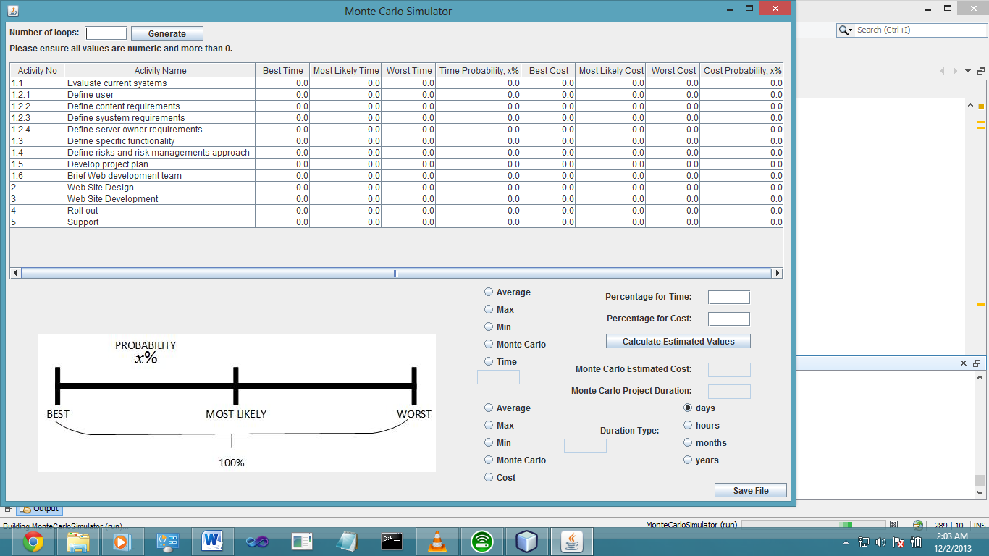

Figure 1: Monte Carlo Simulator with no previous data

Otherwise, jump to step 5.

1. 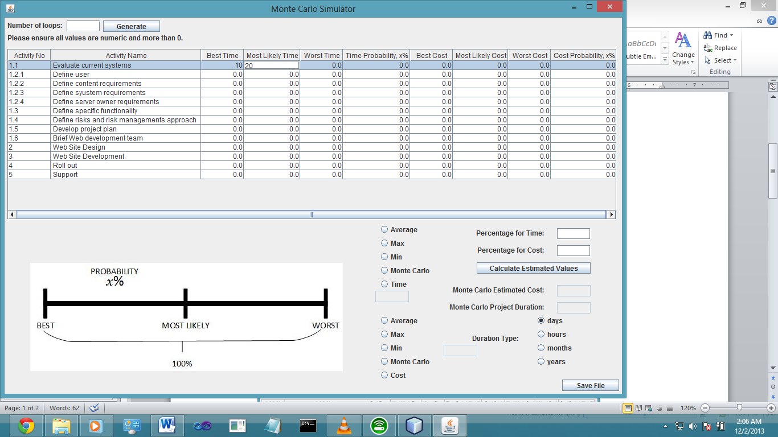Fill up each cell by clicking it and inserting the right values.

Figure 2: Filling up each cell with values

1. Some error messages that may pop up if values entered is incorrect

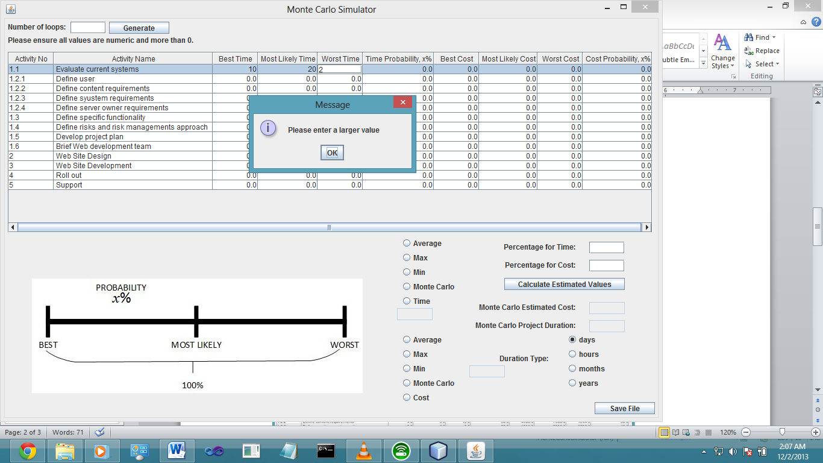

Figure 3: Value entered has to be larger than the previous cell (e.g. Worst time has to be larger than most likely time)

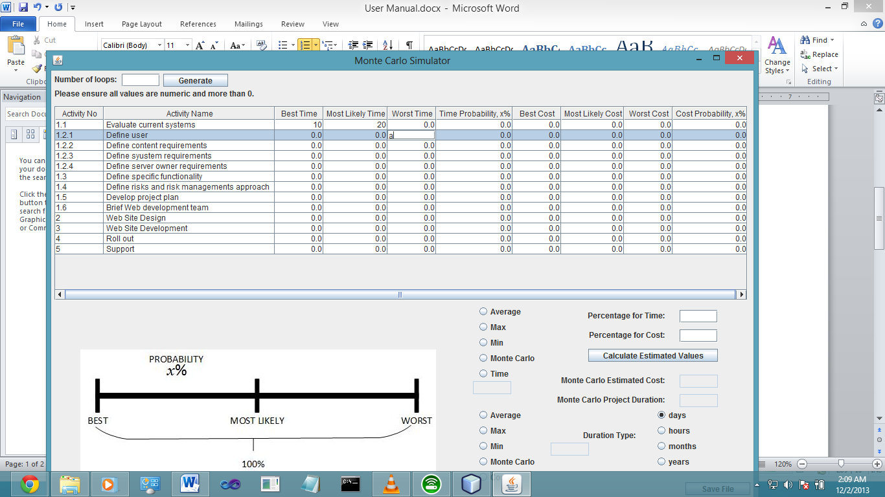

Figure 4: Non-numeric values will not allow the user to leave the cell until a correct numeric value is inserted

1. 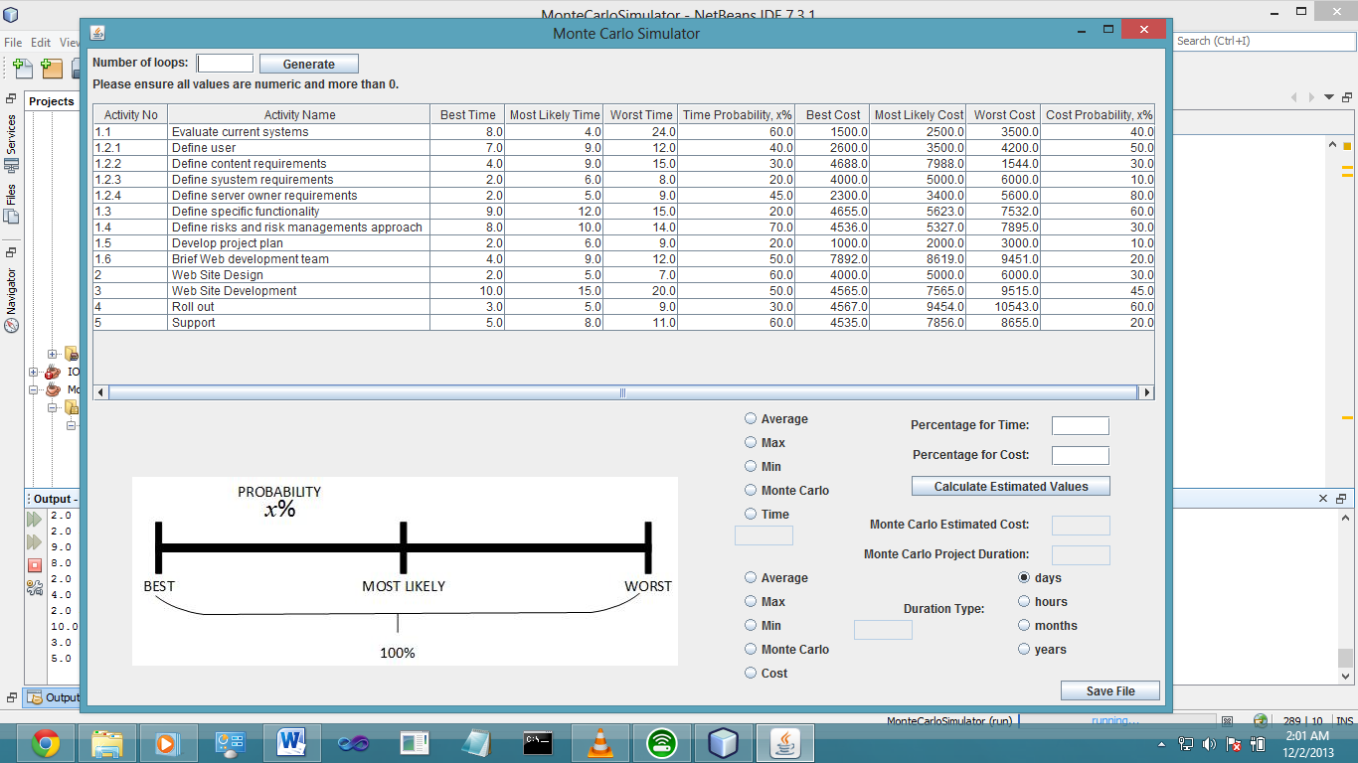The following screen will appear once the user has entered all values or have loaded from previous data. Users can edit values like in steps 3 and 4.

Figure 5: A fully loaded table from text file

1. Next, insert the number of loops for the simulation.

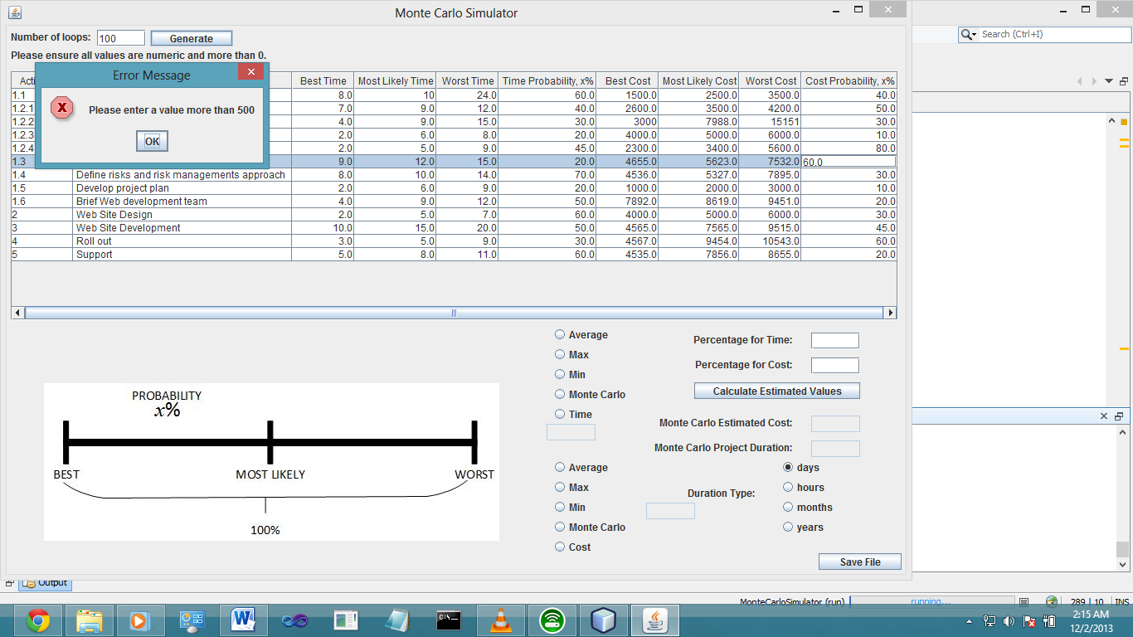The value has to be more than 500 and numeric.

Figure 6: Error message if values are incorrect

1. Click the “Generate” button once number of loops have been inserted.
2. Two graphs: Cost Estimation and Project Duration graphs will be produced. Close the window by clicking on the Close (x) button on the top right.

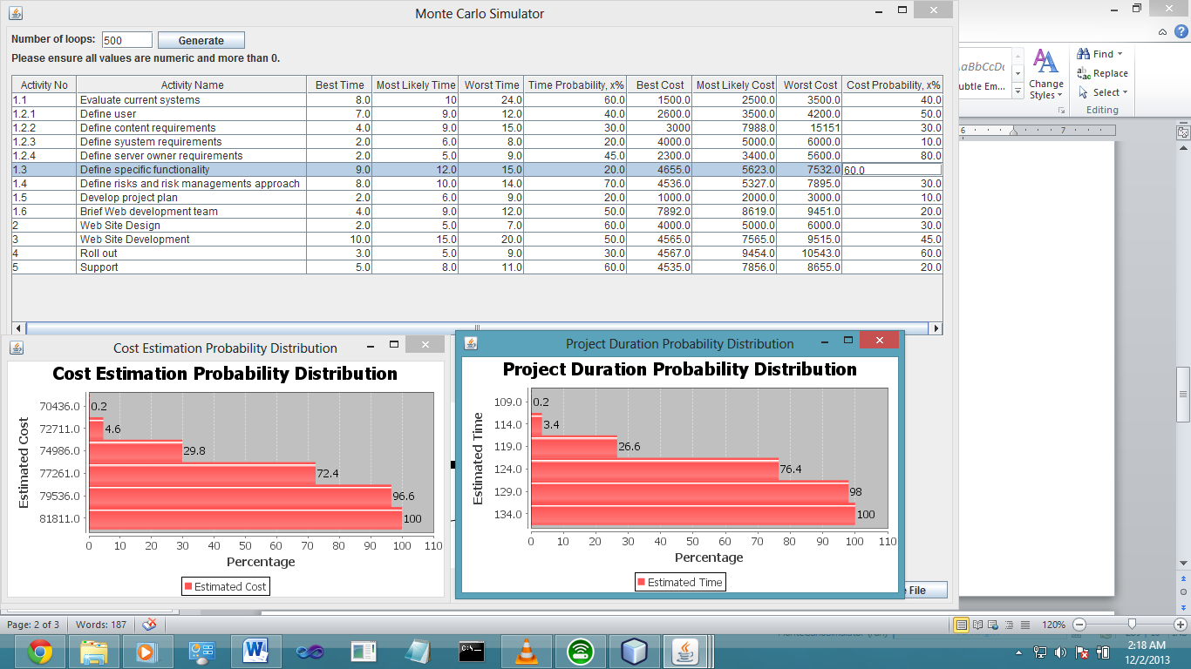

Figure 7: 2 graphs are generated based on data given.

1. To store the precise percentage for comparison and for the project charter, enter only numeric values into the “Percentage for time” and “Percentage for cost” textboxes and click the “Calculate Estimated Values” button.

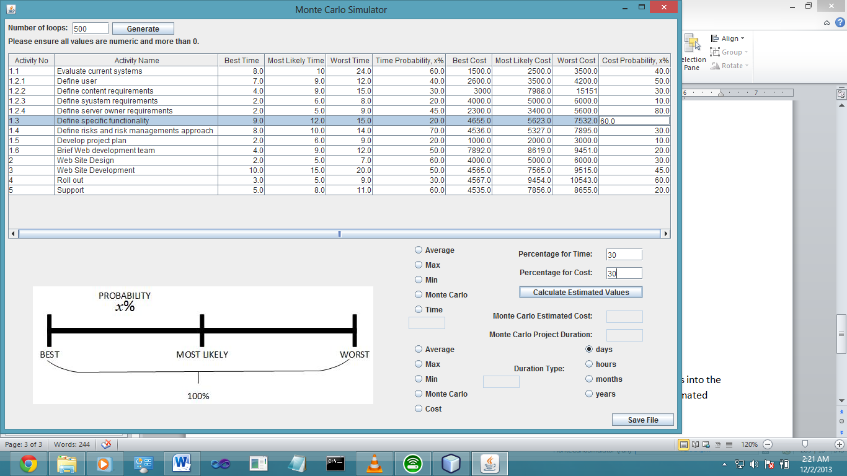

Figure 8: Insert values for percentage for time and cost

1. 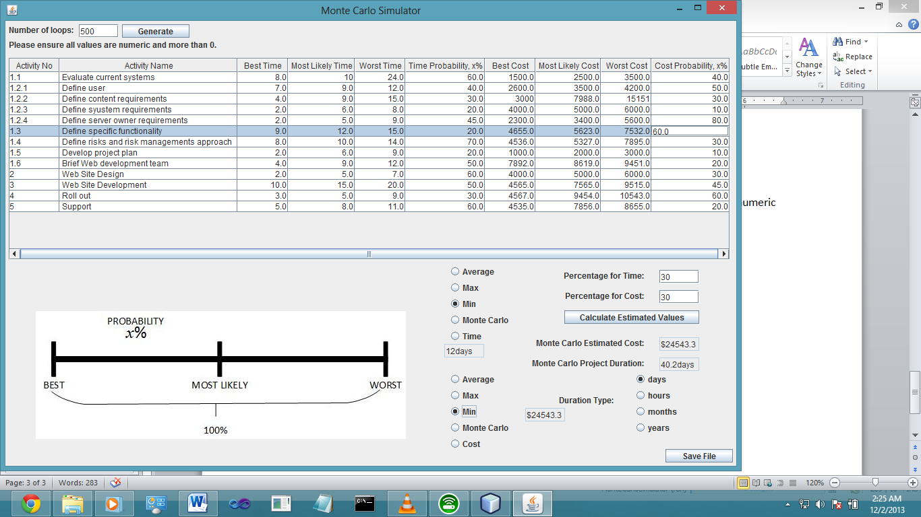The calculated values will be shown in “Monte Carlo Estimated Cost” and “Monte Carlo Project Duration”. Click the radio buttons on the left to choose which values to store and use in the project charter. The values to be stored will be shown in the textarea near to it.

Figure 9: Calculated values to be stored

1. Click the “Save File” button to store all the data into the text file.

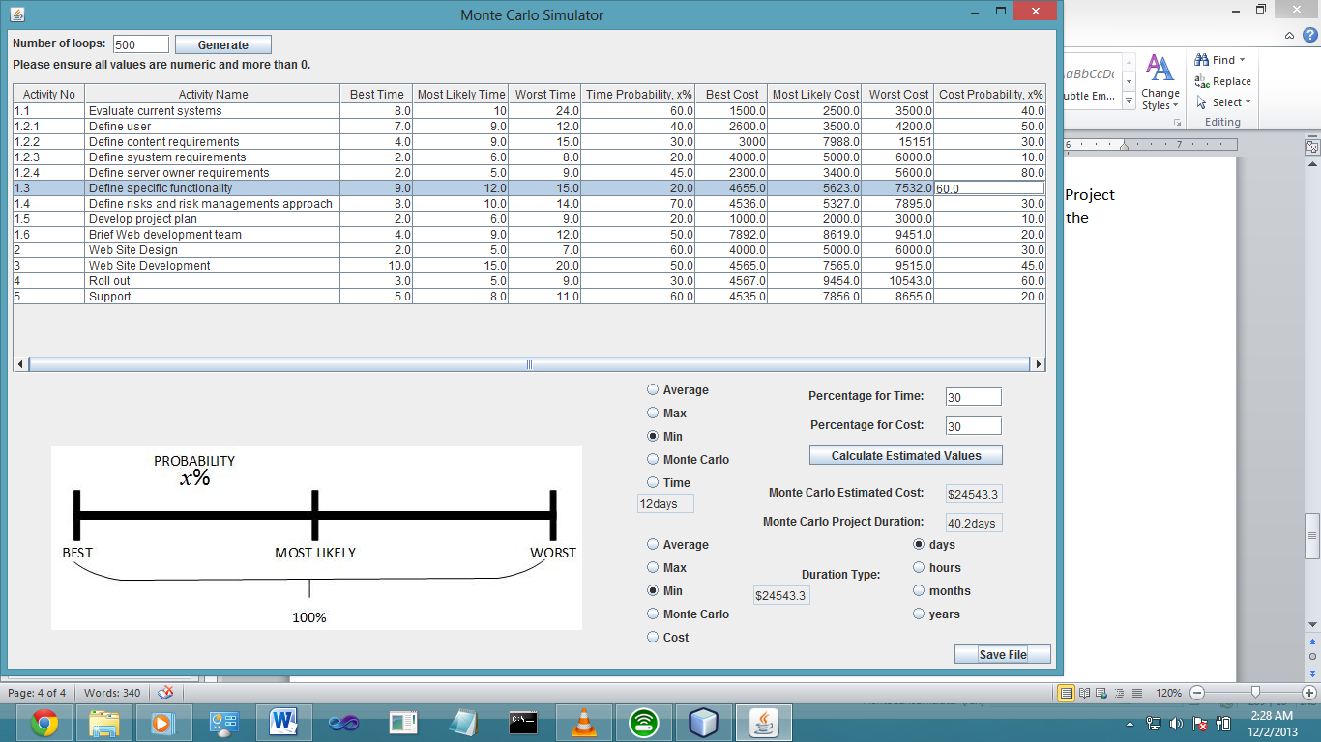

Figure 10: Save file into text file.

**Presentation Slides (Appendix C)**















